HYDROGEOLOGY OF DUTSEN WAI
SHEET125NW, NORTH WESTERN NIGERIA

BY

Victor GANA

DEPARTMENT OF GEOLOGY
AHMADU BELLO UNIVERSITY ZARIA
NIGERIA

OCTOBER, 2015

HYDROGEOLOGY OF DUTSEN WAI
SHEET125NW, NORTH WESTERN NIGERIA

BY
Victor GANA
B.Sc. (Hons) ABU 1999
M.Sc/Scien/04496/09-10

A DISSERTATIONSUBMITTED TO POSTGRADUATE SCHOOL, AHMADU BELLO UNIVERSITY SAMARU, ZARIAIN PARTIAL FULFILLMENT OF THE REQUIREMENTS FOR THE AWARD OF MASTERS OF SCIENCE DEGREE IN GEOLOGY (HYDROGEOLOGY)

DEPARTMENT OF GEOLOGY
FACULTY OF SCIENCE
AHMADU BELLO UNIVERSITY SAMARU ZARIA
NIGERIA

OCTOBER, 2015

DECLARATION

I, Victor Gana, declare that this thesis has been written by me and that it is a record of my own research work. It has not been presented in any previous application for a higher degree.Information derived from published or unpublished work of others has been duly acknowledged in the text.

----------------------- ----------------------- ------------------
Name Signature Date

CERTIFICATION
This Dissertation entitled “HYDROGEOLOGY OF DUTSEN WAI SHEET 125 NW”, NIGERIA by Victor Gana, meets the regulations governing the award of the degree Masters of Science in Geology (Hydrogeology) of Ahmadu Bello University and is approved for its contribution to knowledge and literary presentation.

-------------------------------------- Date: ---------------------
Prof. Krzysztof Schoeneich
Chairman, Supervisory Committee

-------------------------------------- Date: --------------------
Prof. S.A.Alagbe
Member, Supervisory Committee

------------------------------------ Date: ------------------
Dr. H. Hamza
Head of Department of Geology

---------------------------------- Date: ------------------
Prof. K.Bala
Dean, Postgraduate School

ACKNOWLEDGEMENT
I want to thank God the FATHER, SON and HOLY SPIRIT for HIS Grace, strength and wisdom that saw me through the challenges and difficulties of this research work. May HIS name be glorified and exalted forever.
I wish to express my utmost thanks and gratitude to my supervisors Prof. Krzysztof Schoeneich and Prof. S.A.Alagbe for their advice and guidance throughout the period of this work. Iam also grateful to Prof. I. Garba for his contribution. I also appreciate theefforts of Head of Department,Dr H. Hamza, all other lecturers and non-academic staff that have contributed in one way or the other towards the success of this research.
I remain indebted to the management of MevHydrosearch and Engineering Services Ltd Kaduna, especially the Director, Dr. Martin Eduvie for the opportunity given to me to proceed for this program and his other support.My sincere appreciation also goes to Mr. Edwin Emelis on his support, contribution and fatherly advice in the course of this research. My course mates, friends, and the staff of Kaduna State Water Board and all that have helped me in some way during the time I was gathering data, I appreciate the input from you all. I will not forget to appreciate my elder sister Mrs. Rhoda Yisa and all my siblings for their kind support.
Finally, I want to specially thank my wife Mrs. Elizabeth Gana and my children Epaphras and Caleb for their unending patience, prayers, love and support. You were always there to encourage me and I say the LORD GOD will bless you all, in Jesus name.

ABSTRACT

Hydrogeological investigation of topographical sheet 125DutsenWai NW was undertaken. This study area is located on the Crystalline Hydrogeological Province of northern Nigeria covering an area of about 742 km². The area is underlain by undifferentiated gneisses, schists, fine to medium grained granites of Precambrian age, and medium grained Jurassic Younger Granites at DutsenWai Hill.Methodsfor this investigation include; field observation, sampling and laboratory analysis of rocks, measurements of water level in sixty (60) hand-dug wells, sampling of water for laboratory analyses from twenty (20) selected hand-dug wells, and locating boreholes with a satellite navigator. Twenty eight (28) borehole logs, drilled by Parkman/Water Survey and Preussag water supply companies were analyzed. Hydrogeological maps and cross-sections were constructed and aquifer properties were determined from pumping tests done by Parkman/Water Surveys and Preussag for the soft overburden aquifer and the fractured aquifer.Two interconnected water table aquifers were identified and mapped; the soft overburden aquifer with thickness varying between 18 to 56 meters and fractured crystalline aquifer below of average thickness of between 11 to 30 meters. Borehole yields range from 24.48 m³/day to 146.88 m³/day. Specific capacity, calculated from yield and drawdown, ranges from 1.35 m³/day to 36.69 m³/day, while the hydraulic conductivity values vary from 0.023 m/day to 0.629 m/day with average of 0.12 m/day. The calculated transmissivity values computed from Jacob and Babushkin approximate methods range from 0.615 m²/day to 15.057 m²/day and 0.70 m²/day to 19.70 m²/day respectively. These transmissivity values fall between 0.1 to 10 m²/day where the groundwater supply potential of the area is in the range of very low to low transmissivity magnitude. And as such, local and smaller withdrawals can effectively serve the rural populace in the study area since the area is sparsely populated and the distribution is uneven. Yields of the boreholes showed, that none of the boreholes in the study area has yield below the sustainable yield range of around 0.14 l/s (0.5 m³/h) for a hand-pump equipped well and 1.4 l/s (5 m³/h) for submersible pump equipped boreholes. As such, they can be installed with either hand pumps or submersible pumps successfully.The results of the chemical analysis of 20 water samples showed that Ca²⁺ ranges between 0.47 - 16.34 mg/l, Na²⁺ 6.00 – 43 mg/l, K⁺ 1.70 – 25.0 mg/l, Mg²⁺ 4.32 – 7.63 mg/l, Fe²⁺ 0.21 – 6.96 mg/l, S0₄⁻ 0.00 – 6.76 mg/l, N0₃⁻ 7.00 – 35 mg/l, HCO₃⁻ 90 – 420 mg/l, Cl⁻ 0.25 – 2.50 mg/l and TDS concentration between 28- 385 mg/l falls far below the upper limit of the freshwater classification. The Piper’s trilinear diagram shows that the groundwater in the study area is of Na(K) HCO₃ and Ca(Mg) HCO₃ water types, while Schoeller’s semi – logarithmic plots also show the dominance of sodium and Bicarbonate ionic concentration. The Wilcox plot indicates that the measured electrical conductivity values fall within the sodium (alkali) hazard S1 which is low and salinity hazard C1 and C2 between low and medium thus confirming the acceptability of the water for domestic, agricultural and industrial uses. In summary; Water in the study area is of meteoric origin but it is polluted by residential pollution. It is possible that this pollution is limited to the rural settlements while the arable lands between the settlements arenon- polluted or polluted by agricultural activities.

TABLE OF CONTENTS PAGES
Cover page i
Title page ii
Declaration iii
Certification iv
Acknowledgement v
Abstract vi
Table of content vii
List offigures xiii
List oftables xiv
List of plates xv
List of appendices xvi

CHAPTER ONE
1. INTRODUCTION 1
1.1 Background to the study 1
1.2 Aimof the study 2
1.3Specific objectiveof the study 2
1.4Location, extent and accessibility of the study area 3
1.4.1Location and extent 3
1.4.2Accessibility 3
1.4.3Relief and drainage 3
1.4.4 Climate, vegetation and landuse 5

CHAPTER TWO
2. LITERATURE REVIEW 11

CHAPTER THREE
3.MATERIALS AND METHODS ..17
3.1 Desk study 17
3.2. Field work 17
3.2.1 Petrological field studies 18
3.2.2 Hydrogeological field work 18
3.2.2.1Wellwater level measurement 18
3.2.2.2 Wellwater sampling 18
3.2.2.3Borehole mapping 19
3.3 Laboratory work 21
3.3.1 Petrological laboratory analysis 21
3.3.2 Hydrogeological laboratory analysis 21
3.4 Evaluation of acquired data 22
3.4.1Map of configuration water table at the end of rainy season 22
3.4.2Map of configuration water table at the peak of dry season 23
3.4.3Map of the top of the fractured crystalline aquifer 23
3.4.4Map of thickness of the soft overburden aquifer 23
3.4.5Map of thickness of the fractured crystalline aquifer 24
3.4.6Hydrogeological cross section perpendicular to the main watershed 24
3.4.7Hydrogeological cross section parallel to the main watershed 24
3.5Hydraulic properties of aquifers 26
3.5.1 Determination of hydraulic properties 26
3.5.2Transmissivity 26
3.5.2.1 Definition of the term 26
3.5.2.2 Semi – equilibrium cooper – Jacob analysis 26
3.5.2.3Hydraulic conductivity-Babushkin approximate method 27

CHAPTER FOUR
4. RESULTS 28
4.1 Petrology of the area 28
4.1.1Undifferentiated Gneissic Complex 30
4.1.2Metasediments 31
4.1.2.1 Biotite schist 31
4.1.2.2 Quartzite 32
4.1.3 Younger Granites 33
4.1.4 Superficial deposits 35
4.2 Structural features of the area 36
4.3 Mineralogical composition of rock samples 37
4.3.1 Gneisses 37
4.3.2Biotite schist 38
4.3.3Younger Granite 39
4.4 Hydrogeological maps 39
4.4.1Water level maps 39
4.4.2 Thickness maps of soft overburden andfractured crystalline rocks 40
4.4.3Hydrogeological cross-sections 40
4.5Aquifer parameters 40
4.6 Borehole performance 40
4.7Water sample analysis results 43
CHAPTER FIVE
5. DISCUSSION OF THE HYDROGEOLOGICAL FINDINGS 44
5.1Aquifers in the study area 44
5.1.1 Soft overburdenaquifers 44
5.1.2 Fracturedaquifers 44
5.2 Aquifers properties 45
5.3 Borehole performance 46
5.3.1 Borehole yield 47
5.3.2 Specific capacity 47
5.4 Movement of groundwater 47
5.5 Water Quality 48
5.5.1 Physical characteristicsof groundwater in the study area 48
5.5.1.1Temperature 48
5.5.1.2Electrical conductivity 49
5.5.1.3Hydrogen-ion exponent 50
5.5.1.4Total dissolved solids 50
5.5.2 Chemical characteristicsof groundwater in the study area 50
5.5.2.1Sodium and potassium 50
5.5.2.2Calcium and magnesium 51
5.5.2.3 Chloride 51
5.5.2.4Sulphate 51
5.5.2.5Bicarbonate 52
5.5.2.6Nitrate 52
5.5.2.7Iron 52
5.6Waterclassification 53

CHAPTER SIX
6. CONCLUSION AND SUMMARY 57
6.1. Conclusion 57
6.2. Summary 57
6.3 Contribution to knowledge 59
REFERENCES 60
APPENDICES 64

LIST OF FIGURES
FIGURE PAGE
1: Geological map of Kaduna State showing location of the study area 4
2: Drainage map of the study area 5

3: Mean annual temperature at Kauru Town. 1981-84 (4 years period) 6

4: Mean annual rainfall at Kauru Town. 1981-94 (14 years period) 8

5: Mean monthly relative humidity at Kauru Town. 1981-84 (4 years period) 9

6: Mean monthly evaporation at Kauru Town. 1981-84 (4 years period) 10

7: Geological map of the study area published byNassef andOlugboye in 1979 13

8: Field map 17

9a: Geological map of the study area done under the present research 28
9b: Lineament map of the study area 29
10: Rose diagram showing strikes of joints in rocks of the study area 37
11: Map of configuration of groundwater table at the end of rainy season 39a
12: Map of configuration of groundwater table at the end of the dry season 39b
13: Map of the top of fractured crystalline aquifer 40a
14: Map of thickness of the soft overburden 40b
15: Map of thickness of the fractured crystallineaquifer 40c

16: Hydrogeological cross section along profile A-B 40d

17: Hydrogeological cross section along profile C - D 40e
18: Piper trilinear diagram showing variation of milliequivalent percentages
Of major ions in water samples 54

19: Schoeller semi-logarithm plot of groundwater-chemistry data 55
20: Wilcox plot for suitability of water for irrigation 56

LIST OF TABLES

TABLE PAGE
1.1:Temperature data 6
1.2: Rainfall data 7
1.3: Relative humidity data 8
1.4: Evaporation data 9
3.1: Present condition of boreholes drilled by Parkman Water/ Surveys and other
companies as at the time of this research 19
3.2 Simplified borehole logs of DutsenWai Sheet 125 NW 25
4.1: Calculated hydraulic properties of the study area 41
4.2: Calculatedhydraulic conductivity for aquifers in the study area 42
4.3: Result of physico-chemical analysis of some selected water samples in
hand-dug well in the study area 43

5.1: Gheorge standards for transmissivity 45
5.2: Krasny’s standards for groundwater supply 46

5.3: Comparism of statistical analysis of physico – chemical parameters of the
sampled water with previous studies and standards…………….……………………………………49

LIST OF PLATES
PLATE PAGE
I:Folds, joints and veins in gneiss near Dutsen Wai 30
II: Fault occurring in gneiss 31
III:Biotite schist intruded by pegmatite vein 32
IV: Biotite schist intruded by dykes 32
V: Pieces ofquartzscattered around the pegmatite vein 33
VI: DutsenWai Younger Granite inselberg 34
VII: Pegmatite vein occurring in Younger Granite 34
VIII:Aplite dyke occurring in Younger Granite 35
IX: Lateritic mesas around UngwarSako 36

X: Gneiss composed of quartz (Q), biotite (bio) microcline (Mic), and plagioclase (Plag)

withpoikiloblastic inclusion of quartz in biotite 38

XI: Schist composed of quartz (Q), biotite (Bio), orthoclase (Ortho) and plagioclase,

(plag)muscovite in schist showing pink/bluish interference colours at the center 38

XII: Younger Granitecomposed of quartz (Q), orthoclase (Ortho) plagioclase, (plag)

biotite (Bio), and opaque minerals (Op) 39

LIST OF APPENDICES

APPENDIX PAGE
A: Measured strikes of joint of rocks 64
B: Water table measured in hand-dug wells in the study area 64
C: UNEP (2004) Analytical Methods for Environmental Water Quality 66
D: Borehole data 1 to 28 drilled by Parkman/ Water Surveys and Preussag 68

CHAPTER ONE

1. INTRODUCTION

1.1 Background to the study
More than fifty percent of Nigeria is underlain by crystalline rocks, such as gneisses,migmatites and metasediments of Precambrian age. They have been intruded by a series of granitic rocks of late Precambrian to lower Paleozoic age, (Rahaman, 1974). Most of the crystalline areas are covered by residual deposits derived from in-situ chemical weathering, which breaks down the clay minerals in the crystalline rocks, making the rocks porous and permeable. The totalfresh groundwater resources in the northern Nigeria shield where the study area fall in,calculated by Schoeneich 2007, stand at 94,979 million m³both in the overlying saprolite and the underlying fresh, fractured or jointed crystalline rocks. Schoeneich (2007) noted that most of the fresh groundwater about (98.5 %) is located within the sedimentary basins, while the rest(about 1.5 %) is located in the crystallinehydrogeological province.
Acute water shortage is often experienced in the study area in Dutsen Wai; sheet 125 NW, north central Nigeria (Figure 1). Surface water in rivers and streams across the study area is prone to contamination thereby posing a great health danger to the rural populace. These water bodies are often seasonal and they dry up at the peak of the dry season. Rainwater harvesting which is another source of water supply requires good rainfall throughout the year which is scarce in northern Nigeria. Groundwater which occurs in pore space or voids of weathered materials and fracturesin rocksis the only reliable source of water supply available to this populace.Rural drinking water supply problems are linked to the increasing concentration of scattered population that supplies their own drinking water from domestic wells. These wells can only penetrate the upper part of the regolith and the water in these wells cannot meet the need of peak periods. The growth of big villages and smaller ones necessitates the establishment of more sustainable sources through boreholes that can penetrate beyond the upper part of the weathered regolith and through to the underlying fractures. The groundwater resources in these aquifers has not yet been properly tapped and harnessed for domestic and agricultural purposes despite the greater awareness of the problems and prospects of groundwater and its demand in this basement area. Government and private individuals have embarked on intensive exploration and exploitation projects with the aim of utilizing the abundant groundwater potentials for socio-economic development. The difficulties in assessing water for both domestic and agricultural (irrigation) use at the peak of the dry season has prompted the desire of the author to undertake this research work.

1.2Aimof the study

The aim of this study is to contribute to knowledge on the regional hydrogeology of north central Nigeria through hydrogeological mapping of the 1:50,000 Dutsen Wai NW topographical sheet 125.

1.3 Specific objectives of the study

The specific objectives of this study are as follows:
- To produce the geologicaland hydrogeological maps of the study area
- Determine the groundwater movement at end of rainy season and at peak of dry season
- Delineate the various aquifers by producing the map of the thickness of the soft overburden, and the map of the thickness of the fractured aquifer.
- Determinethe hydraulic properties of these aquifers.
- Determine the water quality of the area for both domestic and agricultural purposes.
1.4 Location, extent and accessibilityof the study area
1.4.1 Location and extent
The area under investigation is located on the Basement Complex in the north-western part of Kaduna State, north central Nigeria on topographical sheet of Dutsen Wai 125 NW on a scale of 1:50, 000. It lies between latitudes 10⁰45'N to 11⁰00'N and longitudes 8⁰ 00'E to 8⁰ 15'E and with an area of about 742 Km² shown by the inset in (Figure 1).
1.4.2 Accessibility

This area is located in Kubau Local Government Area of Kaduna State and falls within the Kauru drainage basin. The area is easily accessible through a major road from Zaria to Pambegua road running N-S of the study area, the Kaduna to Pambegua, GarunGwanki to Soba, MararabanKubau to Kubau and Dutsen Wai to Anchau connects most of the villages. Network of footpaths linking the villages and other feeder roads goes all around the study area.

1.4.3 Relief and drainage
The relief of the area is that of a gently undulating erosional surface, except to the eastern part of the study area, at Dutsen Wai town, where the Dutsen Wai hills form a prominent topographic feature elevated 853.44m above sea level. The area is capped by the extensive hardpan lateritic cover, especially in its southern part. Under the ground surface is gritty clay, water saturated from which hand dug wells are serving water to small rural communities. The area is well drained by perennial rivers and seasonal or ephemeral streams (see Figure 2) and the drainage network seems not to be structural controlled. The drainage pattern is mostly dendritic.

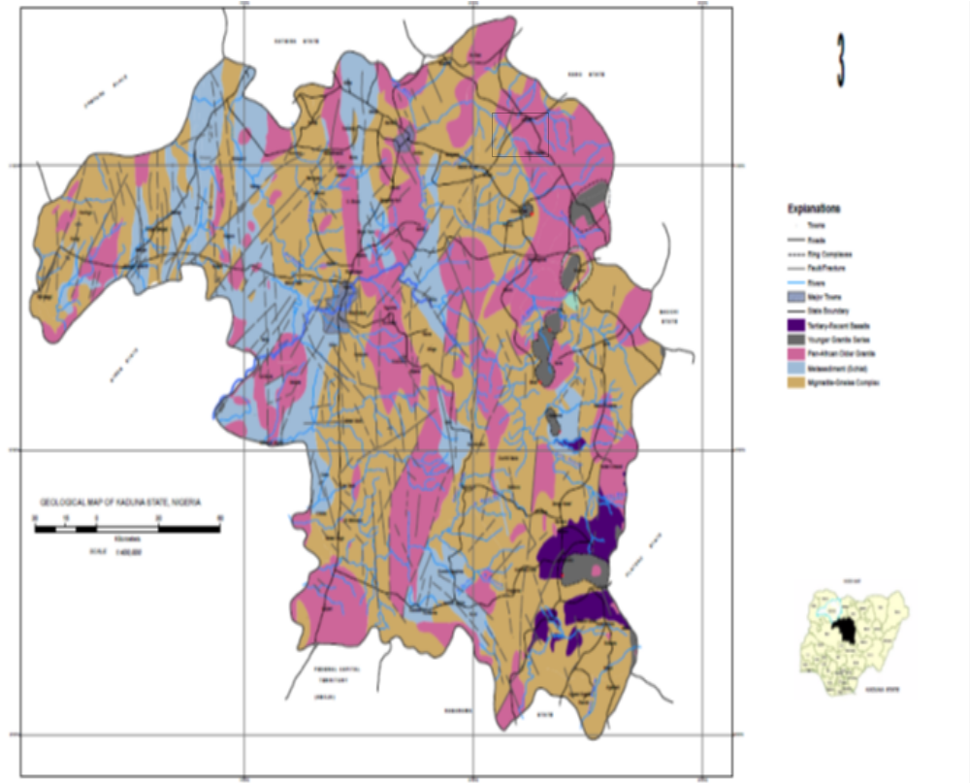Figure 1: Geological map of Kaduna State showing the location of the studyarea(after CACEEM NIG LTD, 2008, modified by the Author)
Study Area

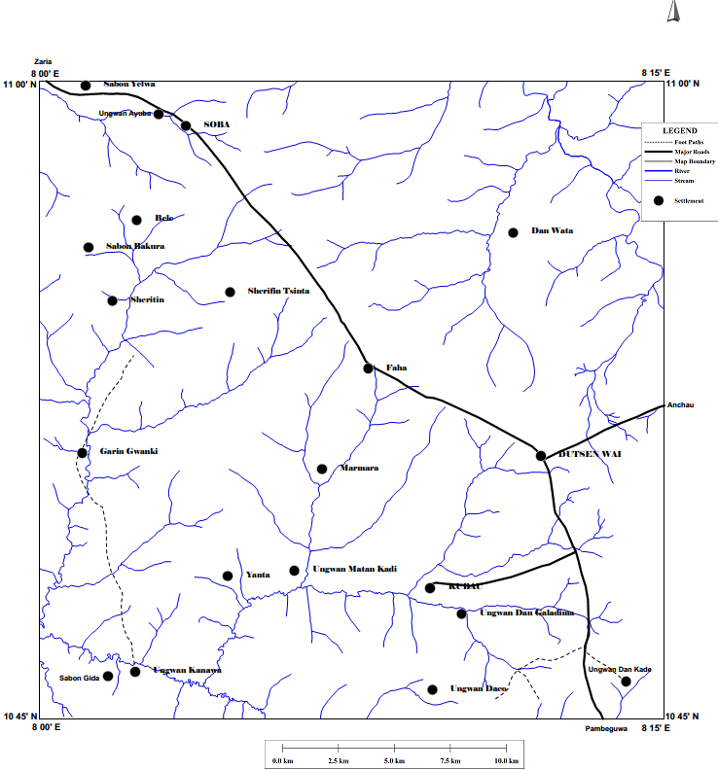 Figure 2: Drainage map of the study area

1.4.4 Climate, vegetation and landuse
The monthly temperature varies between 19.4⁰C and 26.9⁰C in August representing the wet season, and increases to 20.4⁰C and 34.9⁰C at the end of the dry season (see figure below of annual temperature histogram at Kauru town in (Table 1.1 andFigure 3).

Table 1.1: Temperature data at Kauru station (Source: Kaduna State Water Board, 1994)
Year | Jan | Feb | Mar | Apr | May | Jun | Jul | Aug | Sep | Oct | Nov | Dec
1981 | 30 | 34 | 47 | 48 | 34 | 34 | 30 | 33 | 30 | 34 | 34 | 39
1982 | 24 | 35 | 36 | 37 | 34 | 32 | 30 | 30 | 30 | 33 | 33 | 35
1983 | 30 | 37 | 35 | 38 | 38 | 32 | 31 | 30 | 33 | 34 | 34 | 35
1984 | 36 | 36 | 38 | 37 | 35 | 33 | 35 | 32 | 34 | 32 | 35 | 34

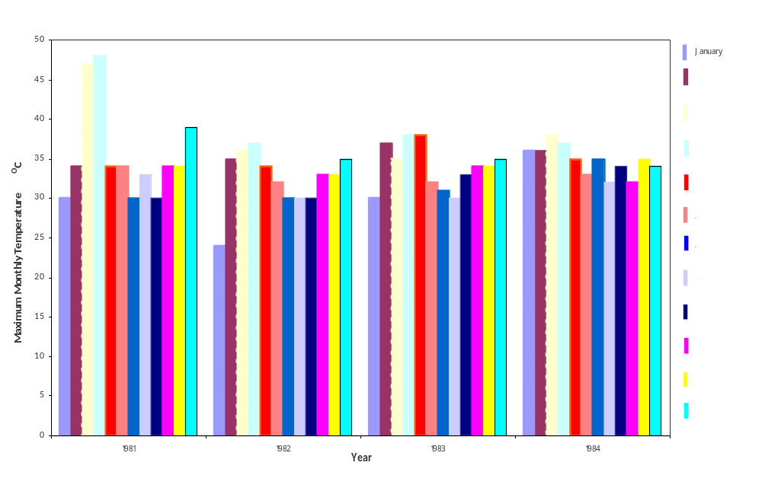

Fig 3: Mean annual temperature at Kauru Town, 1981-84, four-year period. (Source: Kaduna State Water Board, 1994)

Wet season in the area begins in April and ends on October. While dry season begins, on average, in October and last until of April. Dry season is subdivided into cold or harmattan dry period ending late in January, and warm period of dry season in February, March and April (Walter, 1977). Average annual rainfall for fourteen year (14 yrs) records from the meteorological station in Kauru town is 1127 mm. Rainfall, reaches its peak in August with year 1988 having the highest of 621 mm and year 1994 following with a value of 515.4 mm as shown in (Table 1.2andFigure 4).
Table 1.2: Rainfall data at Kauru station (Source: Kaduna State Water Board, 1994)
Year | Jan | Feb | Mar | Apr | May | Jun | Jul | Aug | Sep | Oct | Nov | Dec | An Total
1981 | 0 | 0 | 0 | 0 | 89 | 280 | 287 | 335 | 315 | 77 | 0 | 0 | 1383
1982 | 0 | 0 | 0 | 67 | 85 | 191 | 218 | 383 | 147 | 93 | 0 | 0 | 1184
1983 | 0 | 0 | 0 | 0 | 154 | 148 | 250 | 240 | 214 | 0 | 0 | 0 | 1006
1984 | 0 | 0 | 5 | 65 | 90 | 98 | 214 | 241 | 175 | 64 | 0 | 0 | 952
1985 | 0 | 0 | 22 | 0 | 177 | 310 | 320 | 228 | 266 | 1 | 0 | 0 | 1324
1986 | 0 | 0 | 5 | 24 | 110 | 109 | 210 | 206 | 225 | 43 | 0 | 0 | 932
1987 | 0 | 0 | 19 | 0 | 74 | 0 | 331 | 359 | 176 | 80 | 0 | 0 | 1039
1988 | 0 | 6 | 9 | 90 | 100 | 221 | 229 | 621 | 229 | 15 | 0 | 0 | 1520
1989 | 0 | 0 | 0 | 34 | 155 | 185 | 221 | 264 | 199 | 170 | 0 | 0 | 1228
1990 | 0 | 0 | 0 | 47 | 307 | 189 | 285 | 437 | 403 | 62 | 0 | 0 | 1730
1991 | 0 | 0 | 0 | 50.2 | 133 | 102.8 | 202.6 | 402.4 | 60.7 | 43.3 | 0 | 0 | 995
1992 | 0 | 0 | 35.2 | 118.9 | 79.9 | 181.2 | 172.8 | 223.3 | 142.8 | 29.6 | 10.7 | 0 | 994.4
1993 | 0 | 0 | 30.8 | 3.03 | 152.4 | 35.3 | 429.5 | 21.3 | 0 | 32.1 | 0 | 0 | 704.43
1994 | 0 | 5 | 0 | 38.8 | 44 | 52.5 | 58.8 | 515.4 | 42.1 | 24.2 | 0 | 0 | 780.8

Fig. 4: Mean annual rainfall at Kauru Town during 1981-94 fourteen years period. (Source: Kaduna State Water Board, 1994)
The mean annual relative humidity is 74% for the study area as shown in (Table 1.3 andFigure 5) below.
Table 1.3: Relative Humidity data at Kauru station (Source: Kaduna State Water Board, 1994)
Year | Jan | Feb | Mar | Apr | May | Jun | Jul | Aug | Sep | Oct | Nov | Dec
1981 | 58 | 60 | 64 | 90 | 90 | 90 | 91 | 100 | 91 | 92 | 96 | 29
1982 | 56 | 46 | 83 | 77 | 77 | 96 | 84 | 91 | 92 | 92 | 70 | 21
1983 | 47 | 36 | 64 | 61 | 77 | 91 | 91 | 100 | 84 | 77 | 68 | 56
1984 | 64 | 46 | 64 | 93 | 77 | 94 | 91 | 83 | 91 | 84 | 62 | 28

Fig. 5: Mean monthly relative humidity at Kauru Town. 1981-84, 4-
year period. (Source: Kaduna State Water Board, 1994)

The monthly yearly evaporation record for 4 years from Kauru station of Kaduna State Water Board Hydro- meteorological section is 101.4mm (Table 1.4and Figure 6).
Table 1.4: Evaporation data at Kauru station (Source: Kaduna State Water Board, 1994)
Year | Jan | Feb | Mar | Apr | May | Jun | Jul | Aug | Sep | Oct | Nov | Dec
1981 | 280 | 300 | 349 | 383 | 255.7 | 240.8 | 194.8 | 194.8 | 256.3 | 251.7 | 243.8 | 263.7
1982 | 241.8 | 276.9 | 337.8 | 291.6 | 236.7 | 254.8 | 193.3 | 202.9 | 174.8 | 193.8 | 111.8 | 241.3
1983 | 348.5 | 318 | 348.5 | 317.5 | 296.9 | 194.3 | 215.6 | 163.1 | 196.9 | 213.9 | 213.4 | 225
1984 | 287 | 312.4 | 343.9 | 291.6 | 259.6 | 235.2 | 212.1 | 196.6 | 176 | 174.2 | 220.9 | 226.6

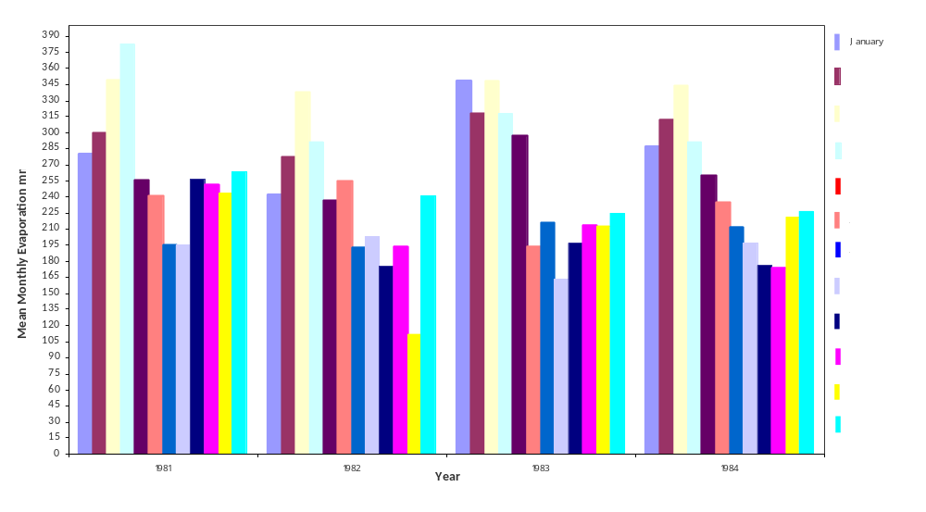 Fig. 6: Mean monthly evaporation at Kauru Town, 1981-84. 4-years period. (Source: Kaduna State Water Board, 1994)

The vegetation of the study area is of the northern Nigeria Guinea Savannah type (Du Preez and Barber, 1965) which is characterized mainly by herbs and grasses with few deciduous widely scattered trees. The herbs and grasses grow very tall in some places although evergreen trees exist mainly along the perennial rivers and streams. Because of the seasonal character of rainfall, the colour of vegetation varies. It is green during the rainy season but becomes yellow or brown in the dry season.
The population of the study area is dominated by Hausa/Fulani and other minor tribes that are indigenes, and other Nigerians. Large settlements in the study area include Dutsen Wai, Kubau and Soba. The rural inhabitants are mainly peasant farmers; hence, the land is subjected to intensive seasonal farming. Irrigation farming is practiced on a small scale along the River Galma and its tributaries. Cereals (maize, sorghum, millet and rice) which are the stable food of the local people are the main type of crop grown in the area. The grassland also supports cattle grazing.

CHAPTER TWO
2.LITERATURE REVIEW
Earlier workers, such as Raeburn et al. (1927), first mapped and described the Dutsen Wai ring complex during their initial surveys of the Nigerian tinfields. They recognized the principal granitic components (explosive breccias, biotite-granites and albite-riebeckite-granite)and gave an account of the distribution of tin mineralization. The granites were re-surveyed by MacLeod and Jacobson in 1960.
Du Preez(1956) in his work on the origin and distribution of Nigerian laterites described two phases of oldest erosional cycles. He stated that the first erosional phase started after the Pan – African Orogeny. After plenty of erosional cycles, a thick weathered mantle was created on a peneplain surface of which the older laterite was developed possibly in the Plio – Pleistocene. According to Barber (1965), this older laterites is said to have plunged in the Northeastern part below the Chad Formation. The second phase of the oldest erosion concentrated on the older laterite reducing the formerly continuous cover on the weathered mantle to discontinuous residual hills with the result of broad depressions in which materials were depositeddiscordantly with the oldest paleomorphorlogy.
Du Preez and Barber (1965), while working on the groundwater distribution in northern Nigeria noted that extractable groundwater by open wells and boreholes is located in the fractured rock and the weathered portion of the basement. They reported that the thickness of the weathered basement varies. They further stated that sufficient weathered material and the degree of saturation are some of the factors that affect the presence of groundwater in the Basement Complex.
Uzoma (1973) carried out a pumping test on a well at the Government Technical Secondary School in Soba and reported a discharge rate of 23.30 liters per minute in the weathered rock aquifer. By using Bolton’s non-steady state approach for water table aquifer, he obtained transmissivity values of approximately 15 m²/d, 4.54 m²/d and 1.5 m²/d (1007 imp. gal /day/ft, 304 imp. gal/day/ft and 102 imp. gal/day/ft).
Nassef and Olugboye (1979) carried out a hydrological and hydrogeological investigation of Galma Basin. This investigation formed part of the Galma River Basin Development Project which was aimed at a systematic and scientific study of the basin with a view of developing the area for agricultural and water supply purposes, by means of irrigation scheme, dam impoundment and borehole drilling. In part of their analyses, they noted that the terrain in and around Soba town (where Uzoma carried out his well test in 1973), being at the geometric center of the basin, is considered typical of the terrain situation in most part of the basin. They however considered Uzoma’s test inconclusive and stated that the ‘’recorded yield of the aquifer may not be the optimum for it, if the well is better developed’’. Hence using Uzoma’swell test data, they recalculated transmissivity using Jacob’s method and obtained 2.795×10⁻⁵ m²/s (2.4m²/d) as apparent transmissivity claiming the average thickness of the aquifer to be 8m, they estimated 0.335×10⁻⁵ m/s (0.289m/d) as the average permeability of the ‘’ weathered rock aquifer underlying Galma River Basin’’. They concluded, however, that since they lacked accurate knowledge of the extent, thickness and lithology of the geologic section, as well as the permeability of the aquifer, their conclusion was tentative.
Nassefand Olugboye(1979) reported that the study area is almost entirely underlain by migmatite, withfine-medium grained biotite granitesoccurring at the north eastern tip and the Younger granites enveloped by the migmatite (Figure 7).
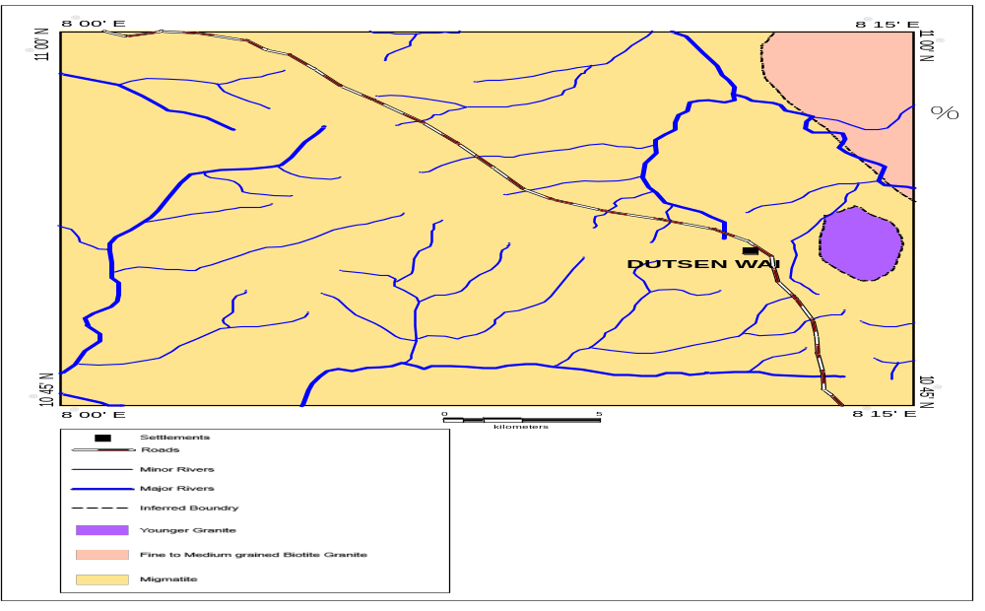
Figure7: Geological map of the study area,Dutsen Wai sheet, 125 NW.(Nassefand Olugboye, 1979).

Plateau State Water Board (1981) carried out studies on the coefficients of total run-off, surface runoff, baseflow and evapo-transpiration at the Werram River gauging station Jos. It reported that, for an area of 216km² the coefficients of these components are 0.72, 0.53, 0.19, and 0.28 respectively.
Inalegwu (1986) studied the hydrology of the ForomRiver upstream of Barakin-Bako, for an area of 161km². He found the coefficients of total run-off, surface run-off, baseflow and evapo-transpiration to be 0.566, 0.408, 0.158 and 0.434 respectively.
Malami (1986) investigated the hydrology of Tilden Fulani river drainage basin on the area of190.5km² and found the coefficients to be 0.52 (total run-off), 0.31 (surface run-off), 0.21 (baseflow), and 0.48 (evapo-transpiration).
Adegoye (1987) carried out a field hydrogeological study of the River Karami (Rahama) catchment area on Dutsen Wai sheet 125 S.E and reported that the catchment area consists of fractured crystalline rocks, covered in most parts by soft overburden. Field permeameter, sieve analysis, falling head permeameters and test pumping methods were used to determine the coefficient of permeability (K) of both the soft overburden and fractured aquifers and found that permeability ranges from 0.377m/day to 6.862m/day. He further reported that the geochemical and bacteriological analysis carried out indicated that the water quality in the aquifers is acceptable for domestic, agricultural and industrial uses.
Ogwuche (1991) worked on the relationship between the coefficients of run-off and the area of the drainage basin on River Karami for hydrological stations at Jengre and upstream Saminaka, mid-stream around Lere and downstream at Kauru with area coverage of about 2738.28 km². She used a topographic map on scale 1:100,000 covering sheets 125, 126, 147 and 168. Using hydrograph separation method, she found the mean annual discharge of 31530910 m³ at Saminaka, 214292130 m³ at Lere, and 812245110 m³ at Kauru with coefficients of run-off in the same order as 0.40, 0.15 and 0.25 respectively. She calculated the potential coefficient of run-off for Jengre which showed inconsistency in the available data and Lere which has data but suspected unreliable. The coefficients found using statistical method are 0.43 at Jengre and 0.37 at Lere, with mean annual discharges of 14251350 m³ and 51726000 m³ respectively.
Ogunjobi (2000) computed aquifer characteristics in the crystalline Basement Complex of northern Nigeria using Galma basin as a case study and concluded that, the transmissivity ranges from 0.22 m²/ day to 42.41 m²/day, the storage coefficient varies between 0.005 and 0.007 and average specific yield varies from 0.024 to 0.06 m³/day within the basin and the result of the analysis indicated that yield is highest where weathered aquifer is thickest and parent rock is coarse.

Solomon (2005) carried out a study of natural radiation levels and distribution of dose rates within the younger granite province of Nigeria toestablish the extent and distribution of various parameters of ionizing radiation across the areausing a combined solid scintillation and gas filled radiation detection techniques. He reported that gross gamma as well as gross alpha/beta radiations were detected and measured within the different rock units and concluded that, radiation levels are high within the younger granites and in parts of the basement areas but low within the basalts. Highest values were found within the Ririwai Sheet 126, attributable to high concentration of radionuclides within both the peralkaline and non-peralkaline granites that constitute the complex.

Olaniyan et al(2010) carried out an assessment of aquifer characteristics of the Galma basin using data from 91 successfully drilled and producing boreholes. They reported that, groundwater in exploitable quantities sufficient for rural water supply was found to occur in the study area in three forms: the river alluvium, the newer basalts, and the weathered zone of the Basement Complex which is most extensive, and often times poorly aquiferous. The further reported that, the aquifer generally has low yield with an average yield of 45.77 l/min (or 65.91m²/day) of water, while higher yields only occur in fractured zones.They concluded that, from statistical evaluation, yield and specific capacity (or productivity) of aquifers are not related to regolith thickness and saturated thickness at the borehole points, and these factors do not play significant role as much as hydraulic characteristics of weathered zone in aquifer productivity.
Ifabiyi (2011) examined the response of groundwater to basin variables in the Upper Kaduna catchmentusing hydrometeorological, geological and landuse data. Moment product correction was used to associate groundwater component and basin parameters, factor analysis was equally used to reduce the 30 basin variables into orthogonal factors; multiple regression was used to establish a relationship with basin variables and groundwater components, while stepwise regression was used to establish a relationship and to reduce the regression model to an orthogonal size. He reported that the result of the multiple regression showed 8 factors namely: length of mainstream, total rainfall, %younger granite, leminiscate ratio, savanna scrubland, % forest, basin scale, and % fadama altogether explained 86.0% of the variance, while for the stepwise regression further showed only 3 factors namely: total rainfall, % forest and % area underlain by Younger Granite explain 76.4% of the variance in groundwater.
Ifabiyi (2012) examined the impacts of basin environment on the hydrograph- time to peak (Tp) in the Upper Kaduna catchment (UKC) using the factor analytical method to reduce the variables to 8 orthogonal factors, which gave a cumulative explanation of 90%. He reported that the multiple regression analysis also showed that the 8 orthogonal factors explained 96.5% in the variance of the explanation of Tp in the Upper Kaduna catchment. He further reported that multiple stepwise regression analysis indicated that percentage of area of the basin forested and percentage of the area of the basin underlain by quartzite dominated the explanation with 87.0% of coefficient of determination.He concluded that the result indicated redundancy in the ability of the basin variables explanation of the time to peak and also showed that although the geology of the UKC favours generation of overland flow, the impact oflanduse and morphometric factors altered runoff and have caused relatively longer Tp with values ranging from 1.94 – 32.26 hours.

CHAPTER THREE
3.MATERIALS AND METHODS

The hydrogeology of DutsenWai and its environs was carried out in four stages, consisting of desk study, field work, laboratory work and evaluation of the field and laboratory data.

3.1 Desk study

The desk study consisted of the assemblage and examination of all available information such as topographic map of Dutsen Wai sheet 125 NW on a scale of 1:50,000, relevant published and unpublished data, from Federal Surveys, Kaduna State Water Board and Kaduna State Agricultural Development Project. After the field work, processing of data collected both in the field and laboratory was done.

3.2 Field work

The field work was carried out at the end of both the rainy season and the end of the dry season. This stage covered a period of abouttwo years (October/November 2012 to October, 2014). The field work involved locating boreholes and hand dug wells,measurement of water levels in hand dug wells, water sampling,petrologic description of outcropping rocks, rock sampling. Field equipment/materials used during the fieldwork included a topographic map, a hand-held Garmin-satellite navigator, bruton compass, measuring tape, geological hammer, sample bag, field note book, combined pH/EC/TDS/Temperature meter model Mi 806, water sample bottles, Heron Instrument Dipper- T 600rT, drawing bucket attached with rope, masking tape and marker.

3.2.1 Petrological fieldstudies
Rock outcrops were mapped, described, and sampled with their coordinates taken and plotted on the field map in Figure 8. Geological boundaries were used in the construction of the geological and lineamentmaps shown in Figures9a and 9b while field data on these outcrops such as strikes ofjoints and faultswere plotted on rose diagram (Figure 10) all of which are presented under chapter four.

3.2.2 Hydrogeological field studies

Hydrogeological field work of the study area was carried out by traversing the network of roads and footpaths to villages and is shown on the map of itinerary and traverse routes with dates of the fieldwork and mapping stations presented under results.
3.2.2.1Well Water level measurement
Water levels and total depths of 60 hand-dug wells in the villages within the study area were measured using Heron Instrument Dipper- T 600rT and their coordinates taken with a hand-held GPS (Garmin).These were located on the map (Figure 8)at the end of the rainy season (October/November, 2012) and the peak of the dry season (March/April, 2013).The measurementdone is shown in (Table 6.1 in Appendix B) as well as the maps produced were interpreted in chapter four.In the course of the field work, the map was also updated by locating new villages with hand-dug wells to achieve a fair distribution of the wells across the study area.
3.2.2.2 Well Water sampling
A total of twenty (20) selected hand-dug wells (Figure 8) from where water levels were measured were sampled using drawing bucket attached with a rope into sampling bottles (1 liter each) sealed and marked with the name of the locations written on each sample between April 29 to 30, 2013. These water samples were taken to Soil science Department IAR-ABU Zaria laboratory, and analyzed between May 2 to 5, 2013.
On-site measurements of pH, electrical conductivity, Total dissolved solids and temperature were done in the field using a portable instrument called pH/EC/TDS/Temperature model Mi 806 combined meter. The values of these physical parameters measured are shown under results.
3.2.2.3 Borehole mapping

A total of 61 existing boreholes drilled by Preussag and Parkman/Water Surveys Nig. Ltd and other companies in the study area were sampled between March/April, 2014 to October, 2014. The detail of the type of boreholes and their present conditions in each location is given inTable 3.1 while their distributions are shown in Figure 8.

Table 3.1: The present condition of boreholes drilled in the study area by Parkman/Water Surveys, Preussag and other companies as at the time of this research
BOREHOLES DRILLED BY PARKMAN/WATER SURVEY AND PRESSAUG BETWEEN 1986 TO 1993 WITH LOGS PRODUCED BY THE AUTHOR |  |  |  |  |  | BOREHOLES DRILLED BY OTHER COMPANIES PRODUCED BY THE AUTHOR WIHOUT LOGS
B/H no |  | LOCATION | LATITUDE (N) | LONGITUDE (E) | PRESENT CONDITIONS | B/H no | LOCATION | LATITUDE (N) | LONGITUDE (E) | PRESENT CON DITIONS
1 |  | Kuli 1 | 10⁰54'.30'' | 08⁰13'.34'' | N/E | 29 | Asuluru | 10⁰45'.47'' | 08⁰08'.59'' | F-H/P
2 |  | TashanIche | 10⁰55'.22'' | 08⁰06'.57'' | N/E | 30 | Randa | 10⁰45'.27 '' | 08⁰08'.34'' | F-H/P
3 |  | KafinKubau | 10⁰47'.48'' | 08⁰06'.36'' | N/E | 31 | Gidandare | 10⁰45'.39'' | 08⁰09'.14'' | F-H/P
4 |  | S/KauranBele | 10⁰55'.56'' | 08⁰02'.28'' | N/E | 32 | U/Makera | 10⁰45'.38'' | 08⁰11'.06'' | F-H/P
5 |  | R/ (Rubawa) | 10⁰57'.12'' | 08⁰00'.55'' | N/E | 33 | U/Bala | 10⁰45'.32'' | 08⁰12'.43'' | F-H/P
6 |  | Shalabari | 10⁰59'.53'' | 08⁰06'.01'' | N/E | 34 | Taparpar | 10⁰47'.10'' | 08⁰12'.54'' | F-H/P
7 |  | Kadage | 10⁰53'.02'' | 08⁰00'.54'' | N/E | 35 | Kubau | 10⁰48'.01'' | 08⁰09'.22'' | F-H/P
Table 3.1 continued
8 | Garu |  | 10⁰51'.12'' | 08⁰00'.59'' | N/E | 36 | Kubau | 10⁰47'.57'' | 08⁰09'.29'' | N/F-H/P, cause not known
9 | SabonGidamaiyashi |  | 10⁰52'.29'' | 08⁰14'.58'' | N/E | 37 | Kubau | 10⁰47'.57 '' | 08⁰09'.33'' | N/F-H/P, pump handle broken
10 | SabonGida |  | 10⁰50'.16'' | 08⁰06'.26'' | N/E | 38 | Kubau | 10⁰48'.01'' | 08⁰09'.31'' | F-H/P
11 | U/matankadi |  | 10⁰48'.03'' | 08⁰06'.00'' | N/E | 39 | M/Kubau | 10⁰48'.46'' | 08⁰12'.54'' | F-H/P
12 | U/Namaiawo |  | 10⁰46'.58'' | 08⁰08'.58'' | N/E | 40 | DutsenWai | 10⁰51'.15'' | 08⁰12'.24'' | F-H/P
13 | M/Kubau 1 |  | 10⁰48'.53'' | 08⁰12'.56'' | N/E | 41 | DutsenWai | 10⁰51'.05 '' | 08⁰12'.20'' | F-H/P
14 | M/Kubau 2 |  | 10⁰48'.58'' | 08⁰12'.58'' | N/E | 42 | DutsenWai | 10⁰51'.25 '' | 08⁰11'.44'' | F-H/P
15 | Ung/Murtala |  | 10⁰47'.46'' | 08⁰09'.20'' | H/P-Pump head removed | 43 | Bidabidi | 10⁰52'.00 '' | 08⁰10'.34'' | N/F-H/P either chain or rubber seal
16 | Wuroko |  | 10⁰46'.10'' | 08⁰06'.23'' | H/P-Pump head removed | 44 | Rahama | 10⁰53'.19'' | 08⁰07'.49'' | N/F-S/BH, Solar pump stolen,
17 | Kuli 2 |  | 10⁰54'.16'' | 08⁰13'.27'' | N/E | 45 | U/Madaki | 10⁰54'.51'' | 08⁰06'.51'' | F-H/P
18 | Dan wata 1 |  | 10⁰56'.35'' | 08⁰11'.46'' | N/E | 46 | Dogondaji | 10⁰55'.59'' | 08⁰07'.30'' | N/F-H/P , broken chain
19 | Dan wata 2 |  | 10⁰56'.23'' | 08⁰11'.29'' | N/E | 47 | Kadage | 10⁰53'.16'' | 08⁰00'.45'' | F-H/P
20 | Kubau |  | 10⁰48'.12'' | 08⁰09'.44'' | N/F-H/P, cause not known | 48 | DanWata | 10⁰56'.25'' | 08⁰11'.36'' | N/F-S/BH, Solar pump stolen,
21 | Danwata 3 |  | 10⁰56'.29'' | 08⁰11'.35'' | N/E | 49 | DanWata | 10⁰57'.10'' | 08⁰12'.02'' | F-H/P
22 | Danwata 4 |  | 10⁰56'.45'' | 08⁰11'.43'' | N/E | 50 | DanWata | 10⁰57'.12'' | 08⁰12'.02'' | F-H/P
23 | Rahama |  | 10⁰53'.30'' | 08⁰07'.48'' | N/E | 51 | DanWata | 10⁰56'.30'' | 08⁰11'.21'' | F-H/P
24 | Ang.Dan Isa |  | 10⁰56'.32'' | 08⁰05'.31'' | N/E | 52 | Daniya | 10⁰57'.27'' | 08⁰11'.33'' | N/F-H/P, broken chain
25 | B.YSharafai |  | 10⁰56'.31'' | 08⁰02'.29'' | N/E | 53 | D/Hausawa | 10⁰57'.27'' | 08⁰11'.33'' | N/F-H/P , broken chain
Table 3.1 continued
26 |  | SabonBakura | 10⁰56'.17'' | 08⁰01'.16'' | N/E | 54 | Dorayi | 10⁰55'.03'' | 08⁰09'.43'' | N/F-H/P, broken chain
27 |  | Sharafai | 10⁰54'.36'' | 08⁰01'.43'' | H/P-Pump head removed | 55 | Marmara | 10⁰50'.52'' | 08⁰06'.12'' | N/F-H/P, broken chain
28 |  | Marmara | 10⁰5'1.05'' | 08⁰06'.10'' | H/P-Pump head removed | 56 | Dankaura | 10⁰46'.13'' | 08⁰03'.23'' | F-H/P
 |  |  |  |  |  | 57 | Garu | 10⁰50'.12'' | 08⁰01'.36'' | N/F-H/P, cause not known
 |  |  |  |  |  | 58 | Garu | 10⁰50'.40'' | 08⁰03'.10'' | N/F, cause not known
 |  |  |  |  |  | 59 | Kagandama | 10⁰50'.36'' | 08⁰03'.10'' | F-H/P
 |  |  |  |  |  | 60 | Kagandama | 10⁰50'.52'' | 08⁰03'.11'' | F-H/P
Note: Fmeans functioning borehole, N/F means not functioning borehole, H/P means handpump borehole,
S/BH mean solar borehole, N/E means nolonger existing borehole

3.3 Laboratory work
3.3.1 Petrological laboratory analyses

Thin sections of the rocks sampled were prepared at the Thin Section Laboratory of the Geology Department, Ahmadu Bello University, Zaria. Each of the thin section slide was observed under a petrological microscope and described as shown in plates X, XI and XII under the results.

3.3.2 Hydrogeological laboratory analyses
Analysis of the collected water sampled from study area for their major cation and anion components was carried out in the Soil science Dep’t IAR-ABU Zaria laboratory. The major ions analyzed and the methods used in analyzing them are as follows: sodium (Na⁺) and potassium (K⁺) were analyzed by Flame Photometry, calcium (Ca²⁺) and magnesium (Mg²⁺) were determined by Atomic Absorption Spectrometry (AAS) and Fe²⁺ was determined by Spectrophotometry. Photometric method was used to determine sulphate ${(SO}_{4}^{2-})$ and nitrate $({NO}_{3}^{-})$ using H18200 multiparameter Bench photometer.Chloride, (${Cl}^{-}$), was analyzed by argentometric method that is silver nitrate titration, using potassium chromate as indicator while phenolphthalein/methyl orange titrimetric method was used to analyze bicarbonate $({HCO}_{3}^{-})$ and carbonate $\left({CO}_{3}^{2-}\right).$Total Dissolved Solids (TDS) weremeasured using combined pH/EC/TDS/temperature model meter Mi 806 in the field.
The descriptions, principles and procedures of the methods used are presentedin (Table 6.2 in Appendix C) in accordance with the procedures described by UNEP (2004).The result of the laboratory analysis and the parameters measured on-site are shown in Table 4.3.
3.4Evaluation of acquired data
The field dataevaluated for hand dug wells and existing data of the boreholes drilled by Parkman/Water Surveys and Preussag in the study area were plotted on topographical base map to prepare the following hydrogeological maps: (1)Map of configuration of groundwater table at the end of rainy season, (2)Map of configuration of groundwater table at the end of dry season, (3)Map of the top of the fractured crystalline aquifer, (4) Map of thickness of the soft overburden aquifer, (5)Map of thickness of the fractured crystalline aquifer, (6) Hydrogeological cross–section perpendicular to the main watershed and (7) Hydrogeological cross-section parallel to the main watershed.

3.4.1Map of configuration of groundwater table at the end of rainy season
Map of configuration of groundwater table at the end of rainy seasonwas prepared using elevations of water table, in hand-dug wells, measured by the Author in October and November 2012. October and November are already outside of the rainy season, which according to Walter (1977) ends on 10th of October (in year of mapping, 2012, rainy season ended on 10th of October). Thus, mapping started on 10th of October because earlier the mapped area, which is mostly swampy in the wet season was hardly accessible. Elevations of the measured hand-dug wells were interpolated from the topographical 1:50,000 base map and results of the field work were presented in Table 6.1. Lines of directions of groundwater flow were drawn perpendicularly to the groundwater table contours.
3.4.2Map of configuration of groundwater table at the peak of dry season
Map of configuration of groundwater table at the peak of dry season is based on measurements of depth to the water table done in March and April 2013. Although, according to Walter, 1977, dry season in the mapped area ends on 20th April, yet measurements of water table in hand dug wells carried out between 20th of April and 30th of April are still representative for the dry season, because everywhere in Northern Nigeria rising of groundwater table starts with about two weeks of delay after onset of rains. Lines of directions of groundwater flow were drawn perpendicularly to the groundwater table contours, and results of the field work were presented in Table 6.1 in Appendix B.
3.4.3 Map of the top of the fractured crystalline aquifer
The geologic logs of 28 boreholes drilled in the study area by Parkman/Water Surveys and Preussag between 1986 and 1993 (KADP, 1991) in Appendix D provided information on relief of the top of the fractured rocks (Table 3.2). This information was used to produce the map of the top of the fractured crystalline rocks. Elevations above sea level of the bottom of the soft overburden were plotted against the borehole locations on a base map and this was contoured along the elevations and discussed under results.
3.4.4 Map of thickness of the soft overburden aquifer
This map was prepared bysuperimposing a topographical base map on the map of top of the fractured crystalline aquifer and where the surface contours and that of the top of the fractured crystalline aquifer had contact; the difference was marked on the topographical map. Points of equal thicknesses were contoured to produce the map of soft overburden.
3.4.5 Map of thickness of the fractured aquiferaquifer
This map was produced by plotting the elevations of the bottom of fractured basement obtained by adding the thicknesses of the soft overburden and fractured basement (Table 3.2). This was then deducted from the elevations of boreholes read from the Nigerian Surveys topographical map on scale 1:50,000. Contours were interpolated between the boreholes.
3.4.6 Hydrogeological cross-section perpendicular to the main watershed
These were constructed from all the generated maps in section 3.4.1 to 3.4.5. It was done by drawing equal length of line of cross-sections A-B perpendicular to the watershed and C- D parallel to the watershed on all the maps. The beginning and the end of the line of cross- section was indicated on a plane sheet, after which the plane sheet was placed on the cross-section profiles on all the maps to mark out each contour value on the sheet. The contour values were used to graduate a vertical axis while the horizontal axis was drawn using line of the cross – section, on another plane sheet. Points of the contour values were marked out from the vertical axis, and finally hydrogeological cross sections were drawn across profiles AB as shown under results.
3.4.7 Hydrogeological cross-section parallel to the main watershed
This hydrogeological cross section C-D was constructed from the maps of the water table as indicated in section 3.4.1 and 3.4.2, map of top of the fractured crystalline aquifer in section3.4.3, map of thickness of the soft overburden in section 3.4.4, and map of thickness of the fractured crystalline aquifers in 3.4.5.
Table3.2:Simplified borehole data of Dutsen Wai sheet 125 NW, 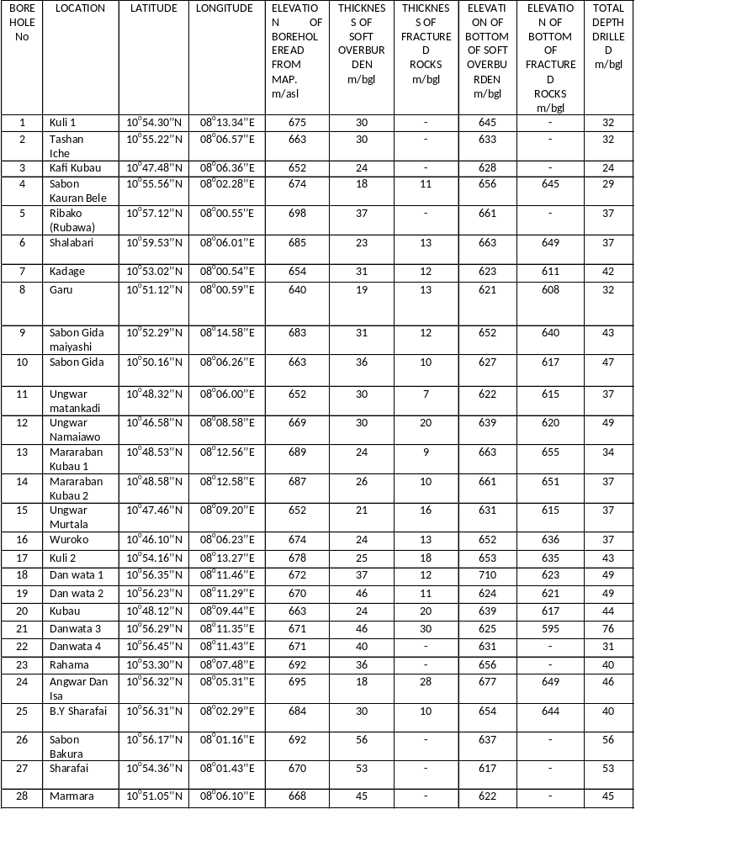3.5 Hydraulic properties of aquifers
3.5.1 Determination of hydraulic properties
The determination of aquifer hydraulic properties through pumping test has become a standard step in the evaluation of groundwater resources potential.
From the logs (Appendix D), single-well pumping of each of the wells was done at a constant, predetermine rate for three hours, and the drawdown was calculated from the difference between the dynamic and static water levels for the time intervals.
The hydraulic characteristic of an aquifer depends on its ability to transmit and store water and can be assessed by the determination of three main quantities. These are the coefficients of transmissivity, hydraulic conductivity and specific capacity.
3.5.2Transmissivity
3.5.2.1 Definition of the term
Transmissivity is a measure of the ease with which the full thickness of the aquifer transmits water (Barcelona et al, 1985). The coefficient of transmissivity of an aquifer is the rate at which water flows through a vertical strip of the aquifer 1 meter and extending through the full saturated thickness, under a hydraulic gradient of 1 (100 percent). The coefficient of transmissivity was calculated by using the product of field coefficient of permeability (K) and saturated thickness of the aquifer (b); and can be written as:
T= Kb…………………eqn (1)where T = transmissivity in m²/day.
K = coefficient of permeability (m/day)
b = saturated thickness of the aquifer (m)
3.5.2.2 Semi–Equilibrium Cooper- Jacob Analysis
A simplified method of analyzing constant-rate data was proposed by Cooper and Jacob (1946) based on the modification of Theis (1935) and involves plotting the time- drawdown data on semi-logarithmic graph paper. The method was developed for confined aquifers only but it can be applied to unconfined conditions provided that the drawdown is small compared to the saturated thickness of the aquifer. The Cooper- Jacob equation is:
T = 2.30Q/4∏∆S………eqn (2)
Where T is transmissivity (in m²/d), Q is the discharge rate (in m³/d) and ∆s is the slope of the straight-line-drawdown graph over one log cycle on the time axis. In these semi-logarithmic graphical methods, the slope of the straight line was used in the equation and is taken to be the difference in the drawdown over one log cycle. The values of slope were substituted in the equation above from where the transmissivities were calculated.
3.5.2.3Hydraulic conductivity - Babushkin approximate method
Babushkin (1954) developed a method for the determination of permeability of anisotropic rocks by pumping test. For an unconfined aquifer in the study area, the coefficients of permeability or hydraulic conductivities were calculated from the pumping rate, drawdown, length of screen, and radius of borehole and presented under results in (Table 4.2) using Babuhkin approximate method formular.
The Babushkin formula is expressed as:
K = 0.366*Q/ Ls Log {(1.32L)/rw}..eqn (3) where K = hydraulic conductivity (m/day).
Q = discharge of the borehole (m³/day).
L = length of screen (m)
s = drawdown (m).
rw = radius of borehole (m).
Since the relation between hydraulic conductivity and transmissivity is given by
T = Kb, the values of transmissivities were also computed in (Table 4.1).

CHAPTER FOUR
4. RESULTS
This chapter presents the results of the interpretedgeological and hydrogeological data,acquired in the field and laboratory analysis results of water and rock samples.
4.1 Petrologyof the area
The study area is underlain by undifferentiated gneiss which covers more than half of the study area, schist occurring at the northern part, fine to medium grained biotite OlderGranites of Upper Precambrian age occurring at the northeastern tip and the medium grained Younger Granites of Upper Jurassic age occurring as inselbergs. These are presented inFigures 8 and 9a.
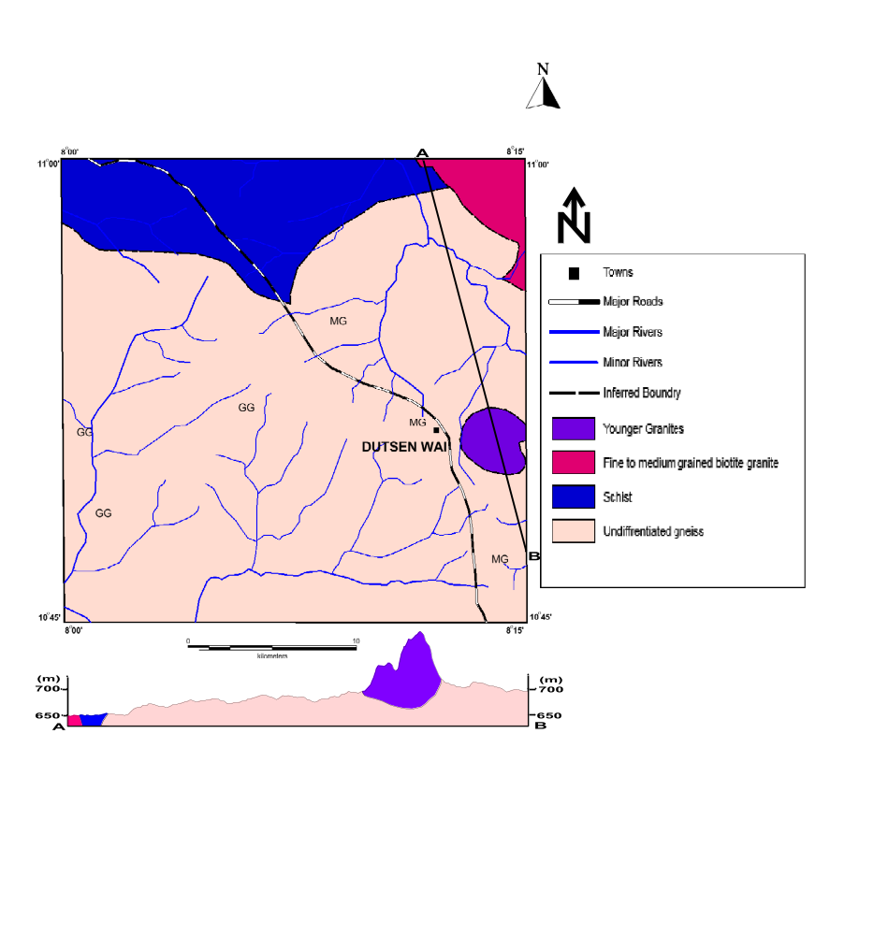

Figure 9a: Geological map of the study area done under the present research.
In area of petrology, shown in geological map in Figure 9a, the result of this present study differs from that which was reported by Nassefand Olugboye (1979), in (Figure 7). Where it was shown that more than half of the study area is covered by migmatite, but in the present study, that portion is covered by undifferentiated gneiss and schist. Knowledge of the petrology is important in this hydrogeological study because it gives information about thickness of the soft overburden and fractured rocksas shown by the lineament map of the study area in Figure 10 below.
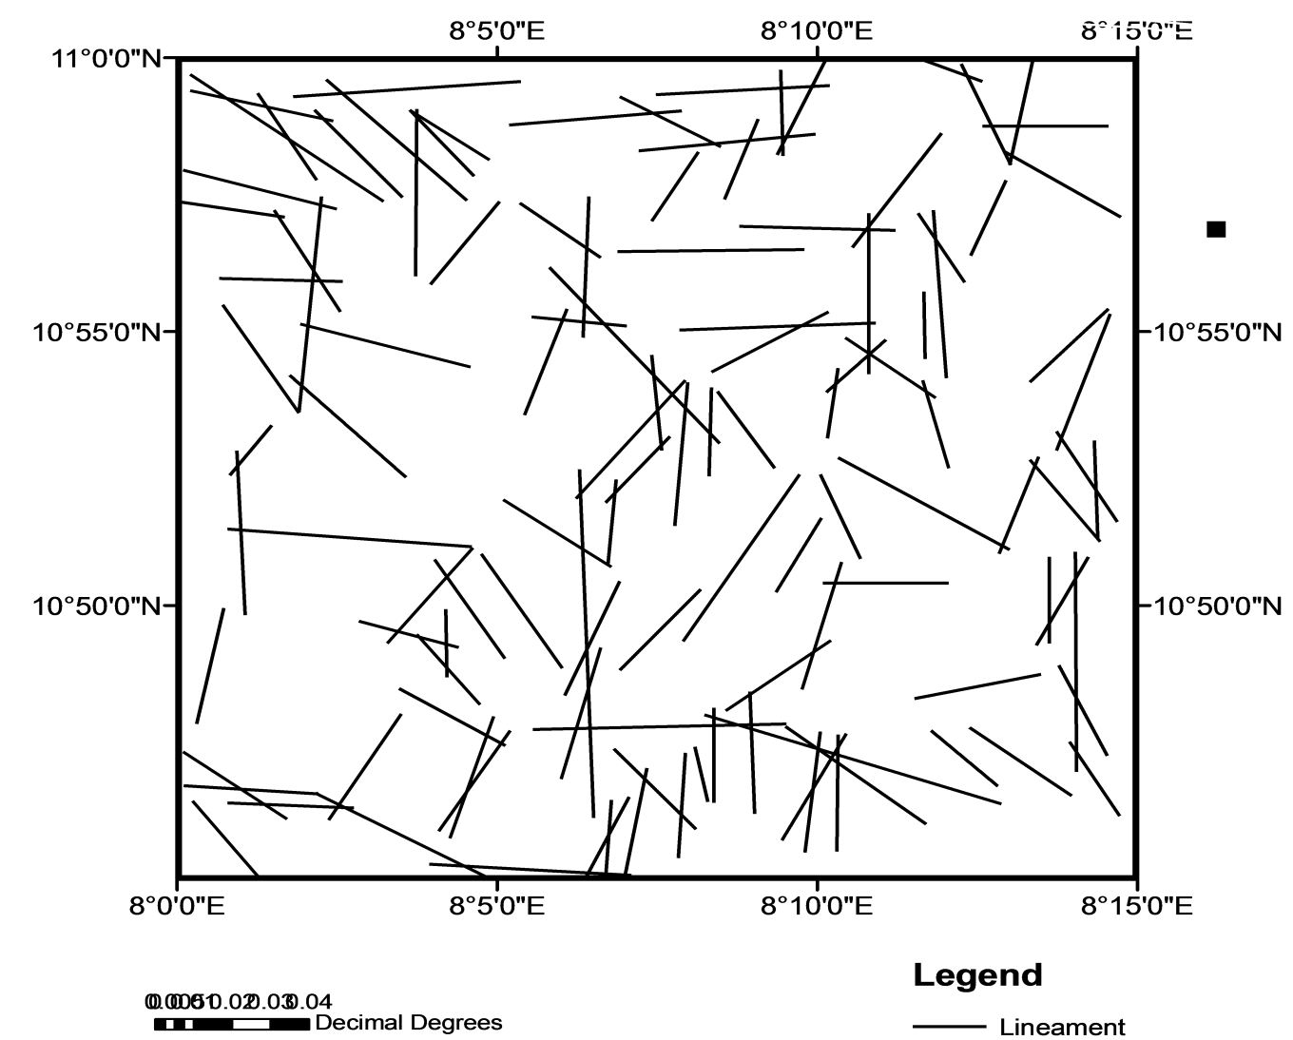
Figure 9b: Lineament map of the study area

4.1.1Undifferentiated Gneissic Complex
The gneisses are exposed at the back of GarunGwanki village towards the eastern border (Plate I) at the location 2, coordinates (N10⁰ 50' 57.9'', E08⁰ 00' 10.6'' on Figure 8). Gneiss also has a contact with the Younger Granites around Dutsen Wai town where it is exposed at the road side, coordinates (N10⁰ 51' 36.1'' and E08⁰ 13' 09.3'') (see Figure 8, location 3). On the geological map in Figure 9, gneiss covers almost half of the study area. Gneisses are foliated on the surface but not extensively and have granitic composition in some part (Plate I). Field examination showed that these rocks are light coloured and fine to-medium grained.
They are composed of quartz, feldspar and biotite, with biotite being the highest constituent. Fractures such as joints, fold, quartz veins and aplite dykes were found running in the north-south, east west and inclined directions. There is presence of sets of joint running north-south and east- west (Plate I). Field observation shows the alternate light and dark bands and they are medium grain. These rocks are composed of quartz; feldspars, biotite, muscovite and other mafic minerals.
At location 5, (N10⁰ 51' 20.4'', E08⁰ 12' 39.3''), they are coarse grained with the presence of aplitedyke running at 191⁰and faults dipping at 45⁰ (Plate II).
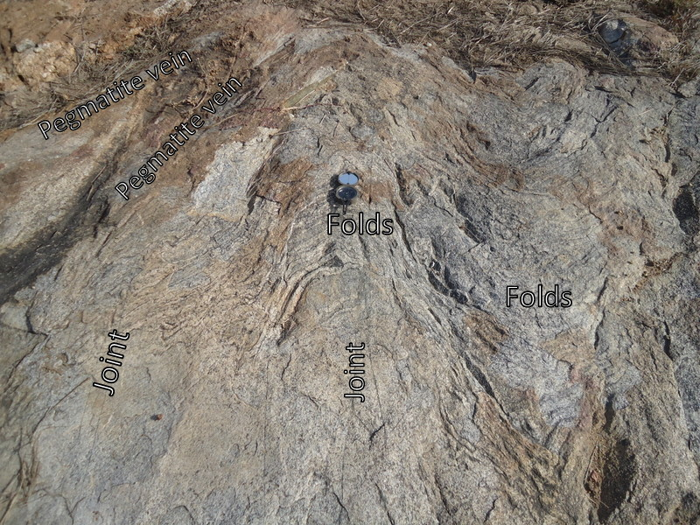Plate I: Fold, joints and veins in gneiss near Dutsen Wai. (N10⁰ 51' 36.1' and E08⁰ 13' 09.3'')

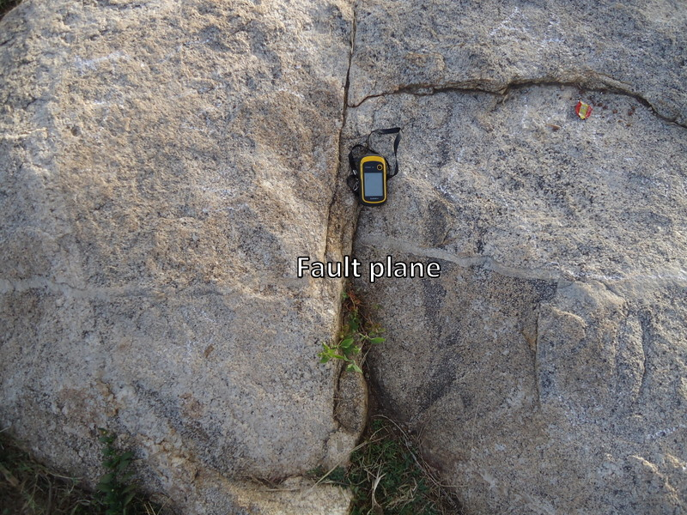
Plate II: Fault occurring in gneiss(N10⁰ 51' 20.4'', E08⁰ 12' 39.3'')

4.1.2 Metasediments
The metasediments are mainly biotite schists and quartzites. The schists are mostly weathered, well foliated and grayish-brown. In some other locations, the schist has been intruded by pegmatite and quartz veins (Plate III).
4.1.2.1 Biotite schist
These rocks are exposed at the northern part of the study few kilometers from Soba town at location 1, (N11⁰ 00' 00'', E08⁰ 04' 09''). Field examinations showed that they are dark coloured and are fine grain. These rocks have been intruded by pegmatite veins (Plate III) anddykes, with the dykestrending in the north – south and east – west directions. The thickness of thedykes trending in the north – south about 1.4 metres while that of the east – west direction is about 0.3 metres (Plate IV).
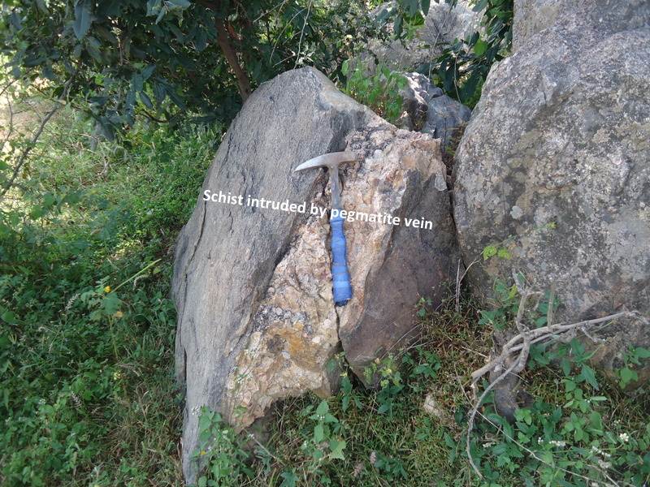
Plate III: Biotite schist intruded by pegmatite vein(N11⁰ 00' 00'', E08⁰ 04' 09'')

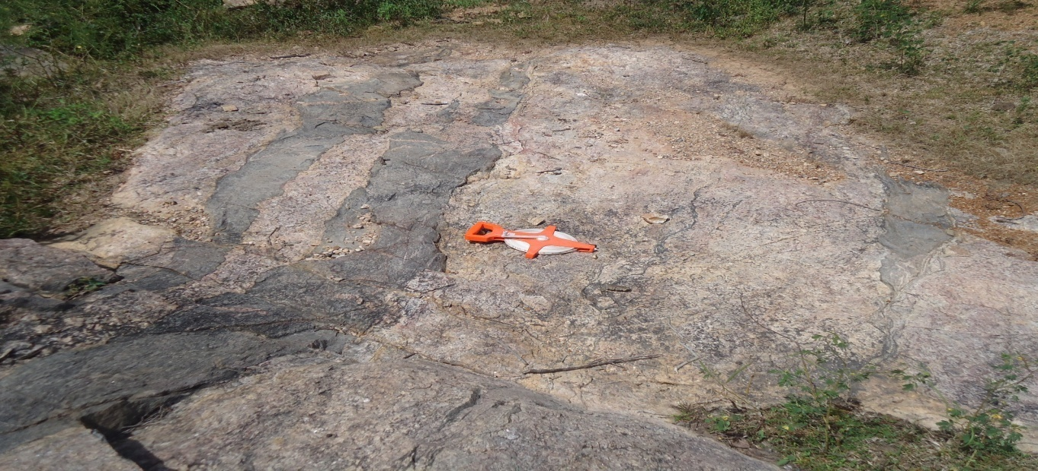
Plate IV: Biotite schist intruded by dykes(N11⁰ 00' 00'', E08⁰ 04' 09'')

4.1.2.2 Quartzite
These are the other members of the metasediments, covering the northern portion where the schist occurs to south portion of the mapped area (Plate V). Theyoccur as dyke in a tabular pluton trend generally in the N - S direction in conformity with the schist in the location 6, (N10⁰ 46' 04'', E08⁰ 09' 15'') and scattered in many parts of the southern portion of the study area.
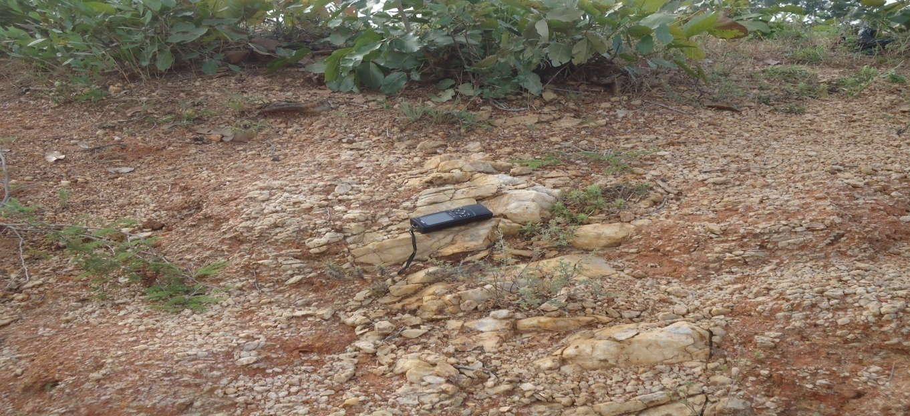
Plate V: Pieces of quartz scattered around the pegmatite vein (N10⁰ 46' 04'', E08⁰ 09'15'')

4.1.3 Younger Granite
The Younger granite in this study area is shown by the Dutsen Wai complex. The Dutsen Wai complex is located at about 20 km north east of Pambegua town off Pambegua - Zaria road. The complex forms distinct topographic features and is generally brownish in colour (Plate VI). Lithological units within this complex include biotite granite, biotite microgranite and arfvedsonite-albite granite (as described by MacLeod and Jacobson in 1960). The rock is generally medium to coarse grained but fine grained portions can equally be seen / observed at location 4, (N10⁰ 51' 30.4'', E08⁰ 13' 27.4''). Minerals in the studied rock include feldspars, quartz and biotite. Joints trend in the N - S and E- W direction while pegmatite veins and aplite dykes trend in the N- S direction with following strikes; 340⁰, 312⁰ and 330⁰ (PlatesVI, VII and VIII).
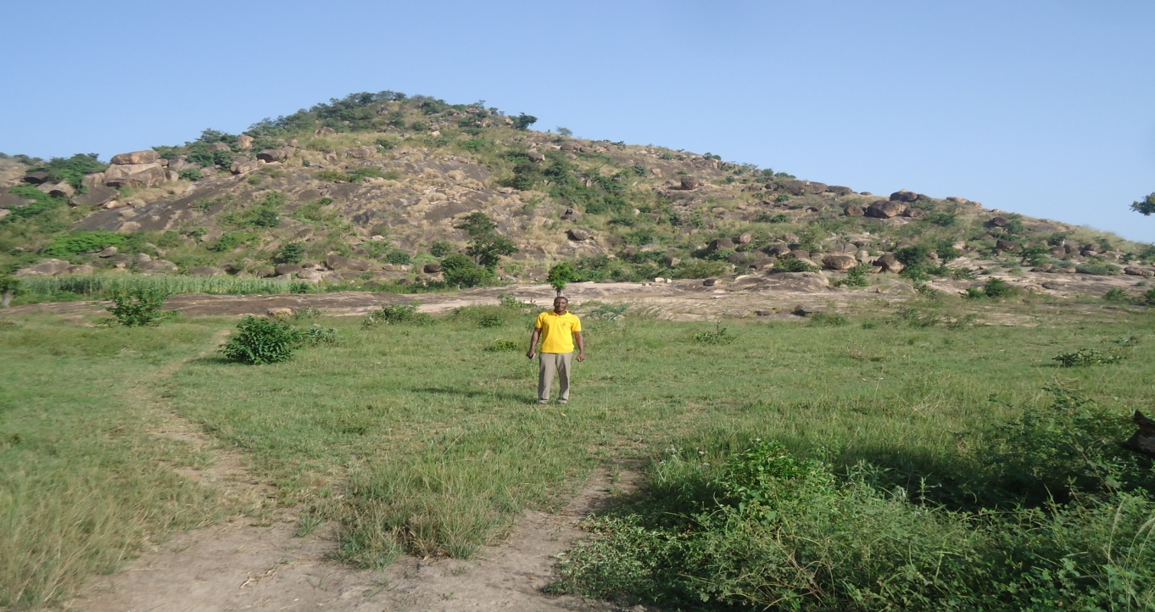
Plate VI: Dutsen Wai Younger Granite inselbergs (N10⁰ 51' 30.4'', E08⁰ 13' 27.4'')

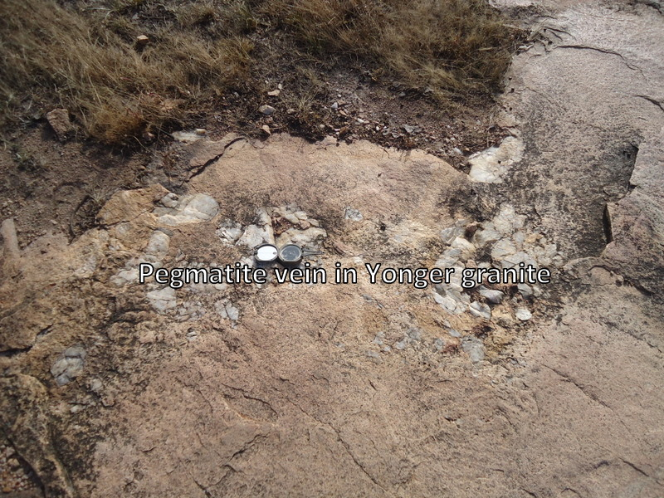
Plate VII: Pegmatite vein occurring in Younger Granite(N10⁰ 51' 30.4'', E08⁰ 13' 27.4'')

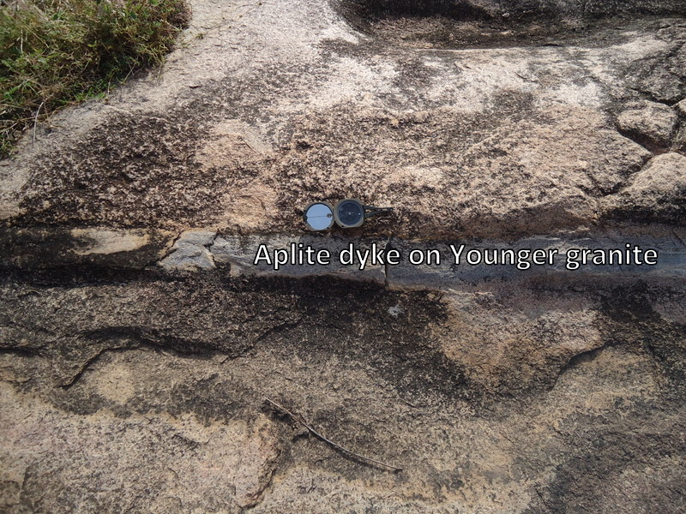
Plate VIII: Aplite dyke occurring in Younger Granite(N10⁰ 51' 30.4'', E08⁰ 13' 27.4'')

4.1.4 Superficial deposits
In areas where fresh bedrocks are not exposed, decomposed weathered bedrock are overlain by varied thicknesses of laterites, weathered clayey zones. The laterite covers the top of the remnants of some pediment low flat – topped lateritic mesas (Plate IX). The lateritic cover isa thin layer of ironstone believed to be erosion remnants of a lateritic sheet on an extensive peneplain and are possibly of Pliocene age, according to Du Preez (1956). The laterites are dark brown to reddish and sometimes yellowish in colour, hard crusted and gravelly. These layers are followed by the weathered clayey zone. The stream alluvial deposits found in the study area are mostly derived from the weathering of basement rocks. They are fine to coarse grained sand, silts, clays and unconsolidated gravels made up of quartzites and laterites. In river Likarbu, white colored alluvium was found and brown to brownish red sands, silts and clays were seen along the river valley, with gravelly texture in few places. These alluvium deposits are often saturated with water and where thick enough, like some points in river Likarbu, they constitute good aquifers in the area for fadama farming in the dry season.

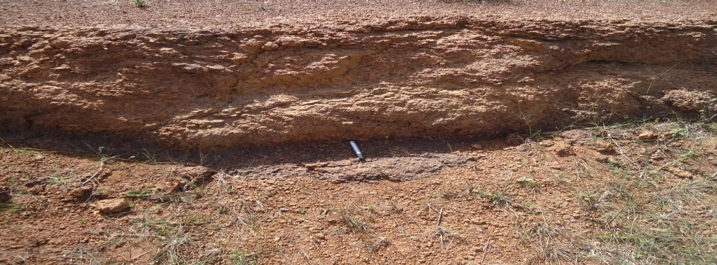

Plate IX: Lateritic mesas around Ungwar Sako

4.2Structural features of the area
The structural patterns observed in the study area are foliation, joints, folds and faults.
Foliations were observed on the gneissic surface but not extensive with the main foliation trend E – W directions (Plate I).
Isoclinal folding and fault zone were observed on gneisses (Plates I and II) respectively.
Joints were observed in all the rock types striking in the N – S majorly and E- W directions. Sets of joints occur in gneiss as seen in Plate I. Most of the joints are open joints while some are in-filled with quartz and feldspars forming veins of pegmatite (Plates I, and VII). The values measured in the field (Appendix A) were plotted on the rose diagram (Figure 10) withthe dominant structural trend being in the north –south direction, followed by the northeast – southwest direction.

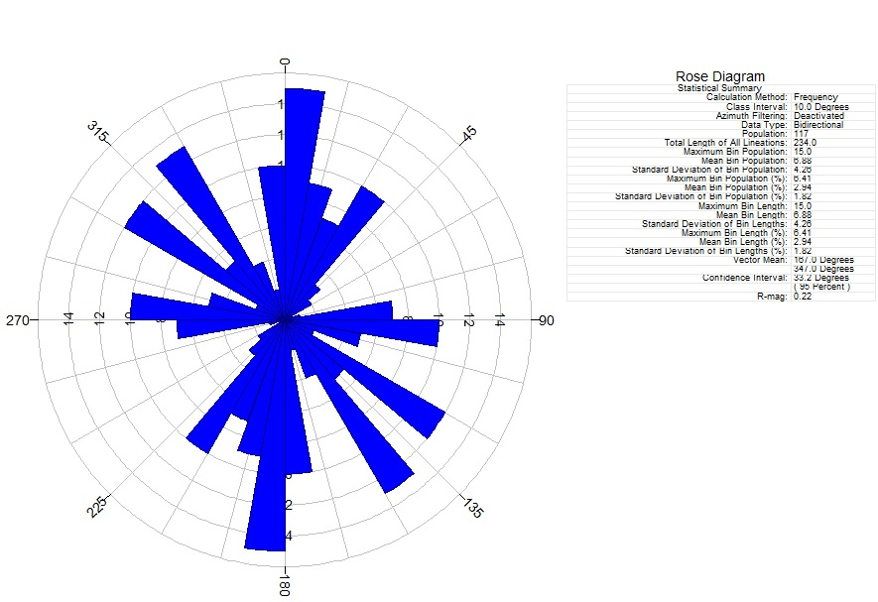
Figure 10: Rose diagram showing strikes of joints in rocks of the study area.

4.3 Mineralogical composition of rock samples
The microscopic analysis of these rock types revealed the various minerals that constitute these rocks and their optical characteristics.

4.3.1 Gneisses
In thin-section, (Plate X) the rock shows quartz to be about 45%, microcline 10%, plagioclase 20%, biotite 5% and opaque minerals 5%. There are poikiloblastic inclusions of quartz in biotite. The felsic minerals are anhedral in shape with microcline showing cross – hatched twinning. Brownish- green grains of biotite with strong pleochroism were also observed. Most of them has been chloritised forming green ragged flakes which shows the effect of strain on the rock during metamorphism which has been found to be in-homogeneous.
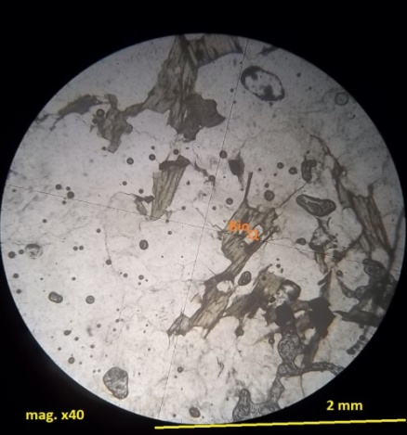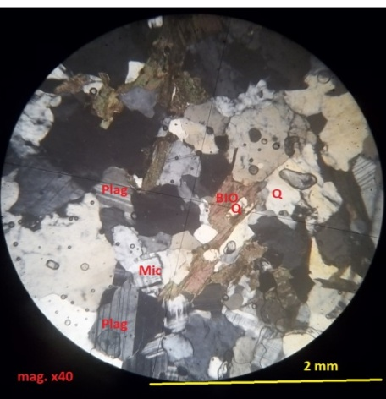
PPL XPL
Plate X: Gneiss composed of quartz(Q) biotite, (Bio), microcline(Mic) and plagioclase (Plag),with poikiloblastic inclusion of quartz in biotite

4.3.2Biotite schist
In thin – section, quartz is about 45%, biotite 35%, plagioclase 28% and muscovite is less than 3% (Plate XI) and has pink/blue interference colour at the center. Biotite crystals were observed to cut perpendicular and parallel to the C –axis. Plagioclase feldspars are altered to perthite due to weathering after metamorphism.
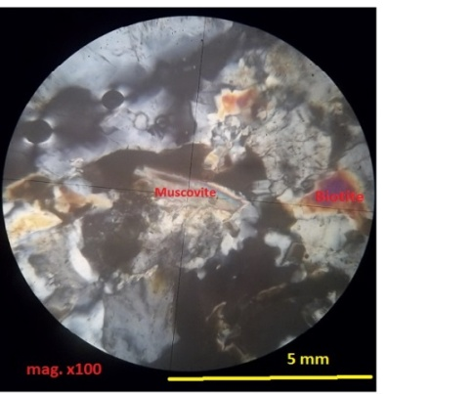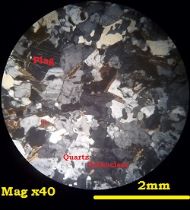
PPL XPL
Plate XI: Schist composed of quartz (Q), biotite (Bio) orthoclase (Orth) andplagioclase (Plag).muscovite in schist showing Pink/bluish interference colours, at thecenter
4.3.3 Younger Granite
In thin – section, quartz seems to dominant mineral with about 50%, biotite 25%, plagioclase 10%, orthoclase 10% and opaque minerals 5% (Plate XII). Brownish- green grains of biotite with strong pleochroism were also observed. Most of them has been chloritised forming green ragged flakes which shows the effect of strain on the rock during metamorphism which has been found to be in-homogeneous.
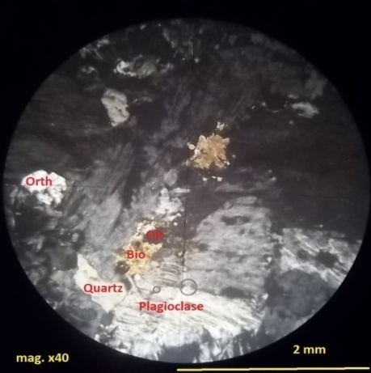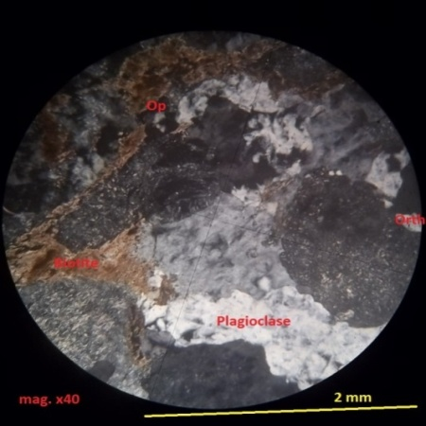
PPLXPL
Plate XII: Younger Granite composed of quartz (Q), orthoclase (Orth), plagioclase (Plag)biottite (Bio)and opaque minerals (Op). Brownish – green grains of biotite with strong pleochroism in Younger Granite

4.4Hydrogeological maps
Various hydrogeological maps prepared from the evaluation of acquired data from the aquifers in the study area are presented in figures 11 to 17.

4.4.1 Water level maps
These maps shows configuration of the water table, in meters above sea level, as well as directions of the groundwater flow at the end of rainy season and at the peak of dry season(Figures 11 and 12).

4.4.2 Thickness maps of soft overburden and fractured crystalline rocks
These maps shows the various thicknesses of the soft overburden and fractured crystalline rocks as well as the top of fractured crystalline rocks (Figures 13, 14 and 15).

4.4.3 Hydrogeological cross – sections
The cross –sections AB is perpendicular to the watershed while CD is parallel to the watershed depicting the thicknesses of the soft overburden and fractured crystalline rocks as well as the rainy and dry season water tables (Figures 16 and 17).

4.5Aquifer parameters
The transmissivity values calculated for the study area from both the Cooper- Jacob and Babushkin methods (Tables 4.1 and 4.2) show a very strong correlation in their values indicating some degree of efficacy of both methods in determining transmissivityvalues for low-period pumping test. The calculated transmissivity, T, values of the aquifers range from 0.615 at Kubau to 15.057 m²/day at UngwarMurtala, with an average value of 8.24 m²/daywhile the hydraulic conductivity values vary from 0.023 m/day to 0.629 m/day with average of 0.12 m/day.

4.6 Borehole performance
Borehole yields range from 24.48 m³/day to 146.88 m³/day. Specific capacity, calculated from yield and drawdown, ranges from 1.35 m³/day to 36.69 m³/day (Table 4.1)

Table 4.1: Calculated hydraulic parametersin the study area using Cooper- Jacob (1946)
graphical method
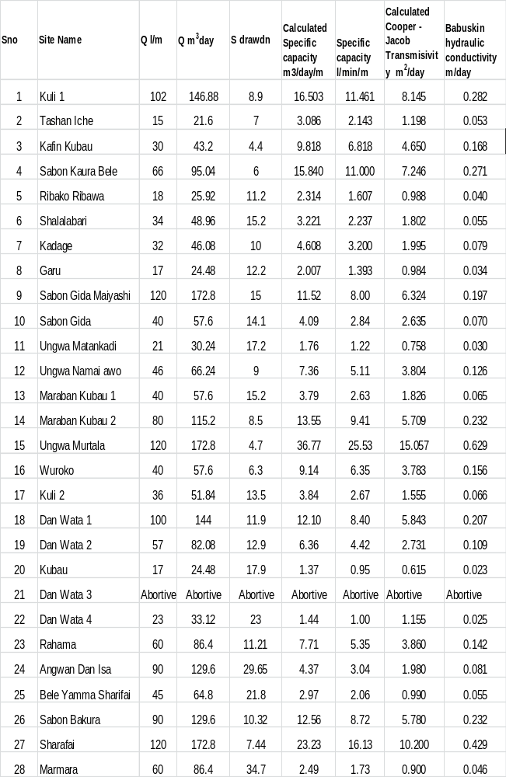
Table 4.2: Calculated hydraulic conductivity for aquifers in study area using Babushkin
approximate method
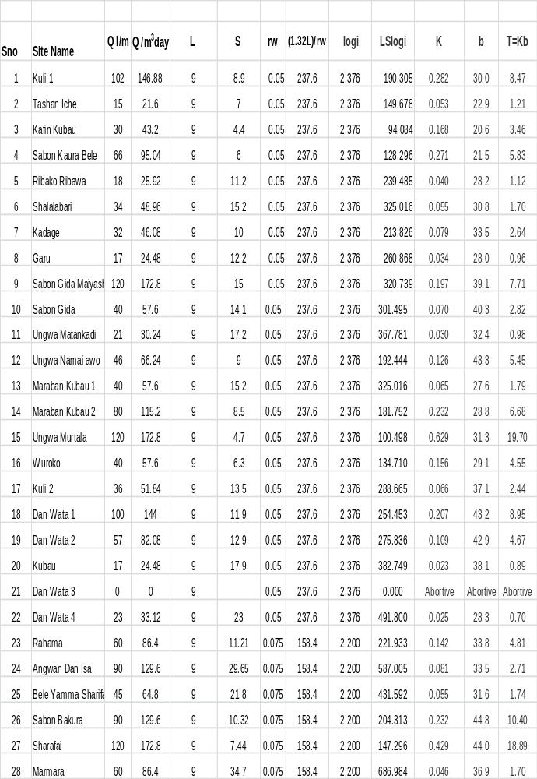

4.7 Water sample analysis result
The result of physico – chemical analysis of the water samples is presented in milligram per liter and other units (Table 4.3).
TABLE 4.3: Results of physico-chemical analyses of some selected water samples from hand-dug wells in the study area.
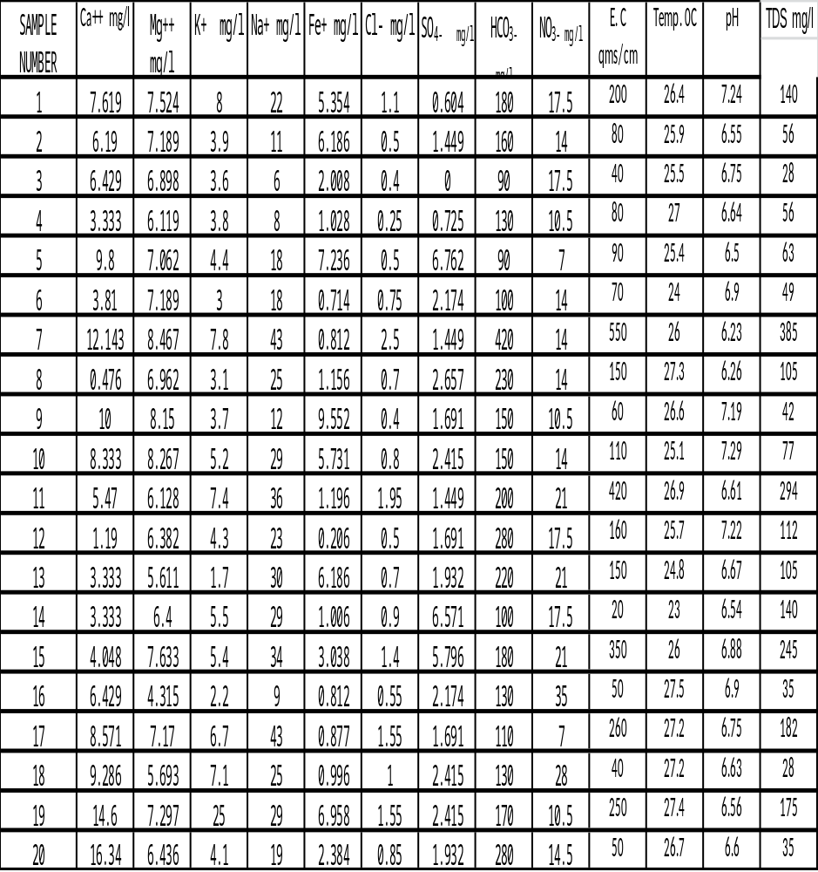Source: (Laboratory: Soil science Dept. IAR-ABU, ZARIA. Date of sampling: 29/04/2013. Date of analysis: 02/05/2013)

CHAPTER FIVE
5. DISCUSSION OF THE HYDROGEOLOGICAL FINDINGS
5.1 Aquifers in the study area
Two interconnected water table aquifers were identified and mapped; these are the soft overburden aquifer and fractured crystalline aquifer.

5.1.1. Soft overburden aquifers
The weathered overburden aquifer has thicknesses ranging between 18 to 56 metres as shown in the map of thickness of the soft overburden (Figure 14) and cross sections A-B and C-D (Figures 16 and 17). The thicknesses are quiet substantial across the study area but thin out as it approaches the outcrops. All hand dug wells and boreholes number 1, 2, 3, 5, 22, 23, 26, 27 and 28 (Table 3.2) tap from this aquifer with the boreholes utilizing the thickness to have sustainable yields that make them produce water throughout the year. On the other hand, the hand dug wells penetrated just a portion of the overburden with the highest depth of 18 meters. Most wells dry up at the peak of dry season when the water table fall to the bottom of the well leaving a very small water column as shown in (Table 3. 1).
The map of thickness of the soft overburden is very useful for hydro-geophysicist as it will aid in interpretation of geophysical curves, since geophysical interpretations are predictive and is depended on the experience of the hydro- geophysicist. It will help drillers to have an idea of the number of working casings, blank casings and screen they will require to complete a hole.

5.1.2. Fractured crystalline aquifers
Beneath the weathered zone is the fractured zone presented in the map of the thickness of fractured aquifer (Figure 15). In this zone, groundwater is controlled by the secondary features of rock deformation of the fissure system, cracks and joints as shown in Figures 16 and 17. The fractured basement in the study area varies in thicknesses between 11.5 metres to 30 meters and is thicker beneath the watershed (Figure 16). These fractures contribute to the sustainability of borehole number’s 4, 6, 7, 8, 9, 10, 11, 12, 13, 14, 15, 16, 17, 18, 19, 20, 21, 24, and 25 that also tap the soft overburden aquifer.
The map of fractured crystalline aquifer shows that the study area has been affected by multiple tectonic events and the rocks often display a complex pattern of ductile folds and brittle fracturing according to (Greenbaum, 1992). It is widely accepted that the brittle fracturing is the main cause ofhydrogeologically promising fracture zones in hard rock area.

5.2 Aquifer properties
The general objective of well hydraulics and yield analysis are to have a better understanding of the aquifer system, quantification of the hydraulic characteristics and assessment of both the optimum yield and the condition or the efficiency of the well.The calculated transmissivity, T, values of the aquifers range from 0.615 at Kubau to 15.057 m²/day at UngwarMurtala, with an average value of 8.24 m²/day. However, since low values are characteristic of crystalline aquifers, high values may be ascribed to the occurrence of prominent and cross-cutting fractures in the Basement rocks.
It may be necessary to relate aquifer performance in the study area to the scale provided by Gheorge (1978)and Krasny (1993) standards (Tables 5.1 and 5.2) below.
Table 5.1: Gheorge standards for transmissivity
TRANSMISSIVITY RANGE | TRANSMITTING POTENTIAL
T greater than 500m²/day | High potential
T between 50 - 500m²/day | Moderate potential
T between 5 - 50m²/day | Low potential
T between 0.5 - 5m²/day | Very low potential
T less than 0.5m²/day | Negligible potential
Table 5.2: Krasny’s standards for groundwater supply
T (m²/day)  Ranges  1000  100  10  1  0.1 | Designation of transmissivity magnitude | Groundwater supply potential
T (m²/day)  Ranges  1000  100  10  1  0.1 | Very high | Withdrawals of great regional importance.
T (m²/day)  Ranges  1000  100  10  1  0.1 | High | Withdrawals of lesser regional importance.
T (m²/day)  Ranges  1000  100  10  1  0.1 | Intermediate | Withdrawals for local water supply (small communities, plants etc).
T (m²/day)  Ranges  1000  100  10  1  0.1 | Low | Smaller withdrawals for local water supply (private consumption etc).
T (m²/day)  Ranges  1000  100  10  1  0.1 | Very low | Withdrawals for local water supply with limited consumption.
T (m²/day)  Ranges  1000  100  10  1  0.1 | Imperceptible | Sources for local water supply are difficult (if possible) to ensure.

By comparison of the transmissivity results of this study with Gheorge (1978) standards (Table5.1), it shows low potential because there T values fall between 0.5- 5 m² /day and very low potential with T values less than 0.5 m²/day. Also, by considering Krasny’s standards (Table 5. 2), the calculated T values in this study falls between 0.1 to 10 m²/day where the groundwater supply potential of the area is in the range of very low to low transmissivity magnitude. Therefore, local and smaller withdrawals can effectively serve the rural populace in the study area since the area is sparsely populated and the distribution is uneven. The transmissivities values based on Gheorge’s and Krasny standards conclusively demonstrate the general hydrogeological understanding of the study area and constitute comparatively poor aquifers. This finding agrees with the conclusion of Du Preez and Barber (1965), who had earlier described the crystalline rock areas as poor groundwater regions.
5.3Borehole performance
The result of the yield and drawdown in table 4.2 determined the performances of the boreholes as indicated by their discharge-drawdown ratio or specific capacities.
5.3.1 Borehole yield
According to Boeckh (1992), a commonly accepted definition of a successful borehole is a sustainable yield of around 0.14 l/s (0.5 m³/h) for a hand-pump equipped well and 1.4 l/s (5 m³/h) for submersible pump borehole.
The yields of the boreholes drilled by Parkman/Water Surveys and Preussag in the area range from 15 at TashanIche to 120 l/min at SabonGidaMaiyashi, with an average of 45.77 l/min. The low values are typical of Basement rocks which are naturally poor aquifers, while the high values are believed to reflect the degree of fracturing of the parent bedrock. None of the boreholes in the study area has yields below this sustainable yield range and so they can be installed with either hand pumps or submersible pumps successfully.

5.3.2 Specific capacity
Specific capacity generally gives a better indication of aquifer performance than yield since it also reflects aquifer transmissivity and thickness (Uma and Kehinde, 1994). The range of calculated values for the area is from 1.352 m/day at Kubau to 23.830 m²/day at SabonBakura with an average value of 4.45 l/min/m. These values could also be attributed probably to the variations in degrees of fracturing, grain-size and texture of the bedrocks and of the regolith.

5.4Movement of groundwater
The water table is the upper limit of the zone of saturation. The water table level is important in predicting the productivity of wells and accounting for fluctuations in the levels of wells. Comparing the amplitude of fluctuation with the total depth of the hand-dug wells, the water columns are small in some wells and very small in others, leading to the drying up of the wells at the peak of the dry season (Table 6.1 in Appendix B). The depth of the water table is highly variable in the study area and range from 0.3 feet (0.1m) to 11.9 feet (3.6 m) in the rainy season between 13 feet (4 metres) to 36.7 feet (11.2 metres) in the dry season. Since its configuration varies seasonally as shown in Figures 11 and 12. Therefore, the elevations mapped and studied in detail shows that the water level in wells coincides with the water table and as such, the maps revealed that the water table is rarely leveled (Figures 16 and 17). Instead, its shape is usually a subdued replica of the surface topography, reaching its highest elevations beneath the watersheds and then descending toward valleys into streams as shown by arrows indicating the directions of flow (Figures 11 and 12).

5.5 Water quality
5.5.1 Physical characteristics of groundwater in the study area
The result of the data generated on the physical characteristics of the groundwater in the study area are presented and discussed below.

5.5.1.1 Temperature
Cool water is generally more palatable than warm water and temperature will impact on the acceptability of a number of other inorganic constituents and chemical contaminants that affects taste. High temperature enhances the growth of microorganisms and may increase taste, odour, colour and corrosion problems.
The temperature of water samples measured on the spot range between 24⁰C and 27.4⁰C with average mean of 26⁰C. These values relatively keep ionization and dissolution at low level.
Drinking water standards are based on two criteria: (1) the presence of objectionable tastes, odors, or colors, and (2) the presence of substances with adverse physiological effects.

TABLE 5.3: Comparism of statistical analysis of physico – chemical parameters of the sampled water with previous studies and standards.
PARAMETERS | RANGE | MEAN | W.H.O STANDARD  2011 |  | NIGERIAN STANDARD  2007 | WATER FROM NIGERIAN CRYSTALLINE COMPLEX  Schoeneich and Garba 2010
PARAMETERS | RANGE | MEAN | Acceptance  Level | Maximum  Permssible | Maximum Allowable  Limits | Average Extremes
TEMPERATURE ºC | 24.0 -27.4 | 26.08 | - | - | Ambient
P^{H} | 6.23 -7.29 | 7.079 | 6.5 | 8.5 | 6.5- 6.8 | 6.9 6.3 – 8.2
TDS | 28 -385 |  |  |  |  | 80 20 – 150
EC (µS/cm) | 20 –550 | 97 |  | 1480 | 1000
BICARBONATE (mg/l) | 90 - 420 | 22.7 | 500 | 1000 | - | 35 5 -80
CHLORIDE (mg/l) | 0.25 – 2.50 | 0.943 | - | 250 | 250 | 5 2 -20
IRON (mg/l) | 0.21 – 6.96 | 3.172 | 0.3 | 1.0 | 0.3 | 0.5 0 – 1.5
SULPHATE (mg/l) | 0.00 – 6.76 | 2.40 | 200 | 400 | 100 | 2 0 - 5
NITRATE (mg/l) | 7.00 – 35.0 | 16.3 | 0.3 | 10 | 50 | 2 0 – 5
MAGNESSIUM (mg/l) | 4.32 – 7.63 | 6.845 | - | - | 0.20 | 5 3 – 6
CALCIUM (mg/l) | 0.47 – 16.34 | 7.037 | 75 | 200 | - | 15 2.5 – 40
POTASSIUM (mg/l) | 1.70 – 25.0 | 5.795 | 10 | 15 | - | 4 1.5 – 30
SODIUM (mg/l) | 6.00 – 43 | 25.4 | - | 200 | - | 6 1.5 - 30

5.5.1.2 Electrical conductivity
The conductivity values of the water samples measured in microµS/cm on the spot. The electrical conductivity values ranges from 40 to 550µS/cm which is less than the maximum permissible levelof WHO (2011) and Nigerian drinking water standard (2007).

5.5.1.3 Hydrogen-ion exponent (pH)
The range of measured pH is from 6.23 to 7.29. With a mean value of 7.097 which shows that the water is neutral to slightly alkaline and falls within the WHO and Nigerian standard allowable levels.The pH of water is a measure of the concentration (activity) of H⁺ ions. Sources of acidity in natural groundwater include low pH rain and snow, dissolved CO₂, solution of volcanic gases or gaseous discharges in geothermal areas, and the oxidation of sulfide minerals and ferrous iron (USDA, 2007).

5.5.1.4 Total Dissolved Solids
The TDS concentration values in the study area range between 28 and 385 mg/l which is less than the WHO desirable level.Total dissolved solids in a water sample include all solid material in solution, whether ionized or not. It does not include suspended sediment, colloids, or dissolved gases.
The palatability of water with a TDS level less than 600 mg/l is generally considered to be good; drinking water becomes significantly unpalatable at TDS levels greater than about 1000 mg/l.

5.5.2 Chemical characteristics of groundwater in the study area
5.5.2.1 Sodium (Na⁺) and Potassium (K⁺)
The sodium ion concentration in the water varies from 6.0 to 60 mg/l with a mean value of 25.4, and are less than the maximum permissible level (Table 6).
Common source of potassium are the products formed by the weathering of orthoclase, microcline, biotite, leucite, and nepheline in igneous and metamorphic rocks. Potassium concentration range from 1.70 to 25 mg/l with location 19 having concentration of 25 mg/l.This value is higher than the WHO standard limit; it might have been acquired from the interaction with the gneiss in the area.
The primary source of most sodium in natural water is from the release of soluble products during weathering of plagioclase feldspars. Less important sources of sodium in natural waters are minerals nepheline, sodalite, stilbite, natrolite, jadeite, arfvedsonite, glaucophane, and aegirite. The minerals are locally abundant in some igneous and metamorphic rocks, but are quantitatively of minor importance in comparison with the feldspar (Foster, 1942).
5.5.2.2 Calcium (Ca⁺⁺) and Magnesium (Mg⁺⁺)
The calcium and magnesium concentrations range between 0.47 to 16.34 mg/l and 4.32 to 7.63 mg/l respectively, and they both fall within the WHO permissible limits.In igneous and metamorphic rocks, weathering also releases calcium from such minerals as apatite, wollastonite, fluorite, and various members of the feldspars, amphibole, and pyroxene groups. While the common sources of magnesium is similar to that of calcium and can be obtained through weathering of igneous and metamorphic rocks from olivine, hornblende and augite, serpentine, talc, diopside, and tremolite (Hall, 1963).
5.5.2.3 Chloride (Cl⁻)
The concentration of chloride varies between 0.25 to 2.50 mg/l and small in concentration, which falls below the WHO and Nigerian drinking water standard.Sodalite and apatite are the only common minerals in igneous and metamorphic rocks which contain chloride as an essential constituent; although micas, hornblende, and natural glass may also contain significant amounts. Liquid inclusions in rocks and minerals are another source of chloride from igneous rocks.
5.5.2.4 Sulphate (SO₄⁻⁻)
The concentration of sulfate is very small ranging between 0.00 to 6.76 mg/l with a mean value of 2.40 mg/l, and it falls within the WHO and Nigerian drinking water standard acceptance limits.Despite a relatively large amount of sulfur, mostly in the form of sulfates in water and in sedimentary rocks, sulfur is only a minor constituent of igneous rocks (Junge, 1963).
5.5.2.5 Bicarbonate (HC0₃⁻)
The concentration of bicarbonate range between 9 to 80 mg/l and all the values falls within the WHO standards.Most bicarbonate and carbonate ions in groundwater are derived from the carbon dioxide in the atmosphere, carbon dioxide in the soil, and solution of carbonate rocks.

5.5.2.6 Nitrate (No₃⁻)
Nitrate concentration in the water samples ranges from 7.0 to 35 mg/l and most values are greater than 10 mg/l except in locations 5 and 17. These high values might be due to agricultural activities and the use of agricultural chemicals such as fertilizers, insecticides and pesticides in the study area. However, the values are less than Nigerian drinking water standard maximum allowable limits.Although igneous rocks contain small amount of soluble nitrate or ammonia, most nitrate in natural water comes from organic sources or from industrial and agricultural chemicals (Waring, 1949).

5.5.2.7 Iron (Fe⁺⁺)
The concentration of iron range between 0.21 to 6.96 mg/l with a mean of 3.17 mg/l with locations 4, 6, 7, 12, 16, 17, and 18 falling within the WHO and Nigerian standards, but the rest locations have concentrations higher. This might probably be as a result of the thick lateritic iron pan which may have extended through reasonable depth of the hand-dug wells formed during weathering and releasing the above mentioned mineral into the water. Abundant sources of iron exist in the earth’s crust. Some of the important minerals and mineral groups which may contain large amount of iron are pyroxenes, amphiboles, magnetite, pyrite, biotites and garnet. The weathering of these minerals releases large quantities of iron which usually are converted to the relatively insoluble and stable iron oxides (Hem, 1959). The concentration of ferrous ions in groundwater is probably limited by the solubility of ferrous carbonate, but it still range between 1 and 10 ppm if the pH is between 6.0 and 8.0, and if the bicarbonate concentration is relatively low.

5.6 Water classification
The water classification in the study area is based on the classification system suggested by Gorrell (1958) which considers the total concentration of the main dissolved solids. The total dissolved solids ranges according to Gorrell (1958) as follows: Freshwater ranges from 0 – 1000 mg/l, brackishwater from 1000 – 10,000 mg/l, salty water from 10,000 – 100,000 mg/l and brine greater 100,000 mg/l
The TDS concentration based on the above classification falls far below the upper limit of the freshwater classification and considered as freshwater.
The Piper’s (1944) trilinear diagram (Figure 18) shows that the groundwater here contains dominant cations Na and anions HCO₃ and it falls within group M and can be called a Na(K) HCO₃water type and group O which is the Ca(Mg) HCO₃ water type and belongs to freshwater. The interpretation is based on (Back and Hanshaw, 1965) water types below:
A - Calcium type,B- sodium orpotassium type,C- magnesiumtype, D- no dominanttype,E- bicarbonate type,F- chloride type,G- sulfate type,H- no dominant, I=Ca + Mg type, J =HCO₃ + CO₃ type, K=Na + K type, L=Cl + SO₄type, M =Ca(Mg) HCO₃type,N=Ca(Mg), l = SO₄type,O=Na(K) HCO₃type,P=Na(K) Cl(SO₄) type.
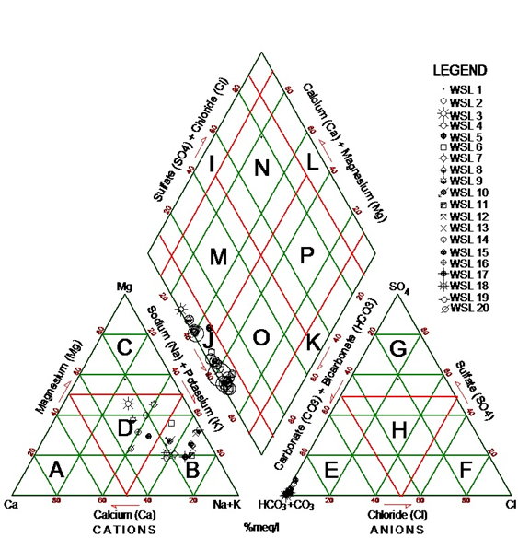
Figure 18: Piper trilinear diagram showing variation of milliequivalent percentagesof major ions in water samples.

Using Schoeller’s (1955) semi – logarithmic diagram, an attempt have been made to subdivide the water into groups according to the various ionic concentrations (Fig. 19). On the average, the water belongs to the same group. On the whole, the ionic concentration of the groundwater here is typical of crystalline and magmatic rock regions.
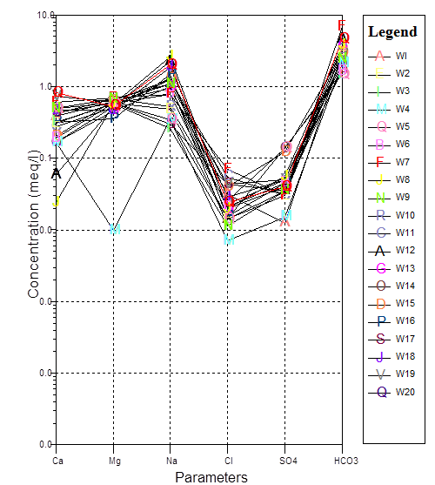
Figure19: Schoeller semi-logarithm plot of groundwater-chemistrydata.

The salinity hazard from Wilcox diagram (Wilcox, 1955) plot in Figure 20 indicates that the measured electrical conductivity values falls within the sodium (alkali) hazard S1 which is low and salinity hazard C1 and C2 between low and medium. This makes the water fit for both drinking and irrigation purposes in the study area.
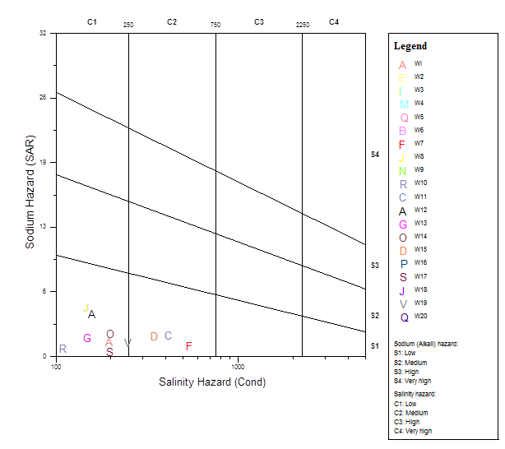
Fig. 20: Wilcox plot for suitability of water for irrigation.

CHAPTER SIX
6.CONCLUSION AND SUMMARY
6.1 Conclusion
This study reveals that the rocks in the area have undergone relativelydeep weathering, typical of a metamorphic terrain and fracturing producing various thicknesses of the soft overburden and fractured crystalline aquifers.
The depth of the water table is highly variable in the area and from the elevations mapped and studied in detail; the water level in wells coincides with the water table. Its shape is usually a subdued replica of the surface topography, reaching its highest elevations beneath the watersheds and then descending toward valleys into streams.
The range of the hydraulic properties of the aquifers showed that the aquifers have excellent transmitting abilities and yield potentials. Hence, the groundwater development potential of the area is high.
The result of water analysis showed the water in the study area is of meteoric origin and is potable for both domestic and agricultural use based on the W.H.O and Nigeria drinking water standards.However, base on the previous findings by (Schoeneich and Garba 2010) on water from Nigerian Crystalline Complex, it is slighly polluted probably by residential pollution and agricultural activities.
6.2 Summary

The hydrogeology of Dutsen Wai area and its environs was carried out in four stages, consisting of desk study, field work, laboratory work and evaluation of the field and laboratory data. The desk study consisted of the assemblage, examination and processing of all available information from topographic map of Dutsen Wai sheet 125 N.W on a scale of 1:50,000, relevant published and unpublished materials, andfield data.

The field work was carried out both - at the end of the rainy season and the end of the dry season. The field work involved locating boreholes and hand dug wells, measurement of water levels in hand dug wells, water sampling for analysis, petrologic description of outcropping rocks and rock sampling for analysis.
The laboratory work involved the preparation and analysis of thin sections of rock samples as well as physico-chemical analyses of water samples.
The study area is underlain by undifferentiated gneiss which covers more than half of the study area, schist occurring at the northern part, fine to medium grained biotite Older Granites of Upper Precambrian age occurring at the northeastern tip and the medium grained Younger Granites of Upper Jurassic age occurring as inselbergs.
Recharge to the area is by direct infiltration from rainfall water which is favoured by the other climatic factors.
Two interconnected water table aquifers were identified and mapped; the soft overburden aquifer with thickness varying between 18 to 56 meters and fractured crystalline aquifer below average thickness of between 11 to 30 meters. Borehole yields range from 24.48 m³/day to 146.88 m³/day. Specific capacity, calculated from yield and drawdown, ranges from 1.35 m³/day to 36.69 m³/day while the hydraulic conductivity values vary from 0.023 m/day to 0.629 m/day with average of 0.12 m/day. The calculated transmissivity values computed from Jacob and Babushkin (1954) approximate methods range from 0.615 m²/day to 15.057 m²/day and 0.70 m²/day to 19.70 m²/day respectively. These transmissivity values fall between 0.1 to 10 m²/day where the groundwater supply potential of the area is in the range of very low to low transmissivity magnitude. Therefore, local and smaller withdrawals can effectively serve the rural populace in the study area since the area is sparsely populated and the distribution is uneven. Yields of the boreholes showed that none of the boreholes in the study area has yield below the sustainable yield range of around 0.14 l/s (0.5 m³/h) for a hand-pump equipped well and 1.4 l/s (5 m³/h) for submersible pump equipped boreholes. As such, they can be installed with either hand pumps or submersible pumps successfully.

The results of the chemical analysis of 20 water samples showed that Ca²⁺ ranges between 0.47 - 16.34 mg/l, Na²⁺ 6.00 – 43 mg/l, K⁺ 1.70 – 25.0 mg/l, Mg²⁺ 4.32 – 7.63 mg/l, Fe²⁺ 0.21 – 6.96 mg/l, S0₄⁻ 0.00 – 6.76 mg/l, N0₃⁻ 7.00 – 35 mg/l, HCO₃⁻ 90 – 420 mg/l, Cl⁻ 0.25 – 2.50 mg/l and TDS concentration between 28- 385 mg/l falls far below the upper limit of the freshwater classification. The Piper’s trilinear diagram shows that the groundwater in the study area is of Na(K) HCO₃ and Ca(Mg) HCO₃ water types, while Schoeller’s semi – logarithmic plots also show the dominance of sodium and bicarbonate ionic concentration. The Wilcox plot indicates that the measured electrical conductivity values fall within the sodium (alkali) hazard S1 which is low and salinity hazard C1 and C2 which is between low and medium thus confirming the acceptability of the water for domestic, agricultural and industrial uses. In summary; Water in the study area is of meteoric origin based on (Gorell, 1985; Piper, 1944; Schoeller, 1955; and Wilcox, 1955).

6.3 Contribution to knowledge
This study has contributed to knowledge in the following ways;
- Produced the geological and hydrogeological maps of the study area
- Determined the groundwater movement at end of rainy season and at peak of dry season
- Delineated the various aquifers by producing the map of the top of the fractured crystalline rocks, map of the thickness of the soft overburden and the map of the thickness of the fractured aquifer.The hydraulic properties of these aquifers were alsodetermined.
- Determined the water quality of the area for both domestic and agricultural purposes.

REFERENCES:
Adegoye, M. (1987).Hydrogeology of RiverKarami (Rahama) catchment area onDutsen Waisheet 125 S.E. Unpublished M.Sc Thesis, Ahmadu BelloUniversity, Zaria. 67p

Babushkin, J. (1954). Method for determination of permeability of anisotropic rocks bypumping test.Journal of U.S Geolsurvy.Wat. Sup.paper 679-A.

Back, W andHanshaw,.B (1965) Advances in hydro-science. In:chemical geohydrology,vol 2. Academic Press, New York, p 49Coleman ML, Shepard TJ, Durhan JJ,Rouse JD, Moore GR (1982)Reduction of water with zinc for hydrogen isotopeanalysis. AnalChem 54:993–995

Barber, W. (1965). Pressure water in the Chad Formation, Borno and Dikwa Emirates N.E. Nigeria.(G.S.N. Bulletin No. 35). 45p

Barcelona, M.J, Gibb, J.P, Helfrich, J.A, Garske, E.E. (1985). Practical guide forGroundwaterSampling. Illinois State Water Survey Contract report 374. Las Vegas,NV: U.S.Environmental Monitoring and Support Laboratory. 94p.

Boeckh, E. (1992). An exploration strategy for high- yield boreholes in West AfricanCrystallineBasement. In: E.P Wright, W.G Burgess (eds), Hydrogeology ofCrystalline BasementAquifers in Africa, Geol. Society Special Publ, no. 66, pp.87-100.

CACEEM, (2008). Kaduna State geological (solid minerals) survey project.

Cooper, H.H, and Jacob, C.E. (1964). A generalized graphical method for evaluatingFormationConstants and summarizing well field history. Transactions ofAmerican GeophysicalUnion, 27, 526-534.

Du Preez, J.W (1956). Origin, classification and distribution of Nigerian laterites, Proc.Int. W. Afr. Conf. III, Ibadan, 223 – 34.

Du Preez, J.W and Barber, W. (1965).The distribution and chemical quality ofgroundwater in Northern Nigeria.Bull. 36. Geological Survey of Nigeria, 93p

Federal Survey of Nigeria (1966). Topographical series 1:50,000, sheet 125 NW Dutsen Wai

Foster, M.D, (1942). Base exchange and sulfate reduction in salty groundwaters along Atlanticand Gulf coasts: Am. Assoc. Petroleum Geologists Bull., vol. 26, pp. 838-851.
Gheorge, A. (1978). Processing and Synthesis of Hydrogeological Data.Abacus Press,TumbridgeWells, Kent.122-136.

Gorrell, H.A, (1958). Classification of formation waters based on sodium chloridecontent: Amer. Assoc. Petroleum Geologists Bull., v. 26, pp. 838-851.

Greenbaum, D. (1992).Remote Sensing Techniques for Hydrogeological Mapping in Semiand Basement Terrains.Britv Geol. Sur. Tech. Rept. WC/92/28, 48 p.

Hall, F.R, (1963).Calculated chemical composition of some sulfate-bearing waters:Int.Assoc. Sci.Hydrology Pub. No. 64.7-15.

Hem, J.D. (1959). Study and interpretation of chemical characteristics of natural waters:U.S Geol. Survey Water – Supply Paper 1473, 269pp.

Inalegwu, J. (1986). Hydrology of the Forom River upstream of Barikin-Bako.Unpublished ThesisDepartment of Geology, Ahmadu Bellow University Zaria.58p

Ifabiyi, I.P. (2011). Response of groundwater to basin variables in the Upper Kaduna catch
ment. Global.Journal of Human Social Science.Vol. 11. Pp. 22 -30

Ifabiyi, I.P. (2012).Hydrograph time to peak (TP) and basin physiography in the Upper Kaduna River catchment, Nigeria. Int. journal of geology and environmental Sciences. Vol. 2 (1) pp. 83 – 96.

Junge, C.E., (1963). Air chemistry and Radioactivity: New York, Academic Press, 382p.

Kaduna State Water Board (1994).Hydro-meteorological data.Unpubl. Report KSWB,Kaduna. 200p

Krasny, J. (1993). Classification of Tranmissivity Magnitude and Variation.Groundwater: Journal of Association of Groundwater Scientists and Engineers. Vol. 24, 44-65

MacLeod, W.N., and Jacobson, R.E., (1960). Geology of the Liruei, Banke and adjacent YoungerGranite Ring-Complexes.Bull. Geol. Surv. No. 33. 60p

Malami, U.S. (1986). Hydrogeological investigation of Tilden Fulani River DrainageBasin.UnpublishedB.Sc Thesis.Department of Geology, Ahmadu BelloUniversity, Zaria. 54p

Nassef, M.O. and Olugboye, M.O. (1979).The Hydrology and Hydrogeology of GalmaBasin.Unpublished Fed.Dept. Wat.Res. File Report. 45p

Nigerian Drinking WaterStandard (2007).Nigerian Standard for Drinking Water Quality.approved byStandard Organisation of Nigeria, NIS 554p.

Ogunjobi, M. (2000). Quantification of aquifer parameters in the Crystalline BasementComplex of Galma basin as a case study Northern Nigeria, Unpublished Ph.Dthesis, Ahmadu Bello University, Zaria 60p.

Ogwuche, I.A. (1991). The relationship between the coefficient of run-off and the area ofdrainage basin: A case study of River Karami Basin in Kaduna State.Unpublished B.Sc Thesis, Department of Geography and Planning, University ofJos. 56p

Olaniyan, I.O., Agunwamba, J.C., and Ademiluyi, J.O. (2010). Assessment of aquifer charac
teristics in relation to water supply in part of Northern Nigeria. Vol. 2 (3), pp 22– 27.

KADP (1991).Parkman Nigeria Ltd/Water Surveys Nigeria Ltd KADP 400 Borehole project.Unpubl.Report, KADP, Kaduna. 425p

Plateau State Water Board (1981). River Gauging Station Werram River at Hoss Station 18:05:1966 – 31 :12 : 1980. Plateau State Hydrological Bulletin No 2 Vol 1. Published by Plateau State Water Board Jos.

Piper, A.M. (1944).A graphical procedure in the geochemical interpretation of water analyses.Transactions of the American Geophysical Union, 25, 914-928.

Rahaman, M.A. (1974). Review of basement geology of southwestern Nigeria. In:Geology ofNigeria, Kogbe, C.A (ed), Elizabethan Publ. Co. Lagos. PP. 41-58.

Rauburn, C., Bain, A.D., and Russ, W., (1927).The tinfields of Zaria and Kano province. Bull. Geol.Surv. Nigeria, 11. 23-29

Renick, B.C., (1925). Base exchange in groundwater by silicates as illustrated in Montana: U.S.Geol. Survey Water-Supply Paper 520-D, PP. 53-72.

Schoeller, H. (1955).Geochimie des eauxsouterrains application aux eaux des gisements De petrole: Paris, Revue de L’InstitutFrancais de petroleet An. De conbustiblesLiquids, 213 p.

Schoeneich, K. (2007).Water Budget for River Basin Development Authorities in Nigeria.Borno Journal of Geology, V. 4, (2), 64 – 73.

Schoeneich, K. and Garba, M.L. (2010).Geol 405 Hydrogeology handout, Department of Geology, Ahmadu Bello University, Zaria.48 p

Solomon, A.O (2005). A study of natural radiation levels and distribution of doserates within the younger granite province of Nigeria. Unpublished Ph.Dthesis, University of Jos, 141 pp.

Theis, C.V. (1935). The relation between lowering of the piezometric surface and the rate andduration of discharging of a well using groundwater storage. Amer.GeophysicalUnion Trans. 16, 519-524.

Uma, K.O. and Kehinde, M.O. (1994). Potentials ofregolith aquifers in relation to water supplies to rural communities: A case study from parts of Northern Nigeria. Journal of Mining and Geology, 30 (1): 97-109.

United Nation Environmental Programme (2004).Analytical Methods for Environmental Water Quality.United Nations Environment Programme Global EnvironmentMonitoring system/WaterProgramme and International Atomic Energy Agency,Burlington, Ontario, L7R 4A6 Canada. 161p

United State Department of Agriculture (USDA) (2007).Technical Guide to Managing Groundwater Resources.Forest Service, FS-881, USA. 245p

Uzoma, J. U. (1973). Pumping test in well No. 21 Technical Secondary School Soba, Zaria province Unpublished Geol. Surv. Nig. Report No. 1513. 18p

Walter, M.W. (1977). The length of the rainy season in Nigeria.Agricultural Meteorology, V. 18. 30p

Waring, F.G., (1949). Significance of nitrate in water supplies: Am. Water Works Assoc. Jour. 41.147p.

Wilcox, L.V,. (1955). Classification and use of irrigation waters: U.S Dept. Agr. Circ. No.969, 19 p.

World Health Organization (WHO) (2011).Guideline for Drinking Water Quality, Internationalstandards for drinking water.Vol. 4.Geneva WHO 130P.

Appendix A: Measured strikes of Joints

Strikes of joints in gneisses

13⁰,18⁰, 23⁰,25⁰, 30⁰,32⁰,35⁰, 45⁰,50⁰, 130⁰145⁰,170⁰, 175⁰, 168⁰, 235⁰,270⁰,and 342⁰.

Strikes of joints in Younger Granite

32⁰, 80⁰,82⁰,100⁰,109⁰, 117⁰, 134⁰,152⁰, 155⁰,155⁰,270⁰,330⁰, 330⁰,333⁰,, and 342⁰

Appendix B:Table 6.1: Water levels measured in hand-dug wells in the study area
 |  | COORDINATES |  |  | END OF RAINY OCT/NOV, 2012 |  | PEAK OF DRY SEASON MARCH/APRIL 2013
WELL NO | LOCATION | LATITUDE (N) | LONGITUDE (E) | Elevation of well (m) asl read from map | Depth to water Table (m) b.g.l | Elevation of water Table (m) a.s.l | Depth to water Table (m) b.g.l | Elevation of water Table (m) a.s.l | Total Depth of wells (m) |  | Amplitude of seasonal fluctuatuation (m) | Water column  In wells (m)
1 | SabonYelwa | 10⁰59'33.9'' | 8⁰01'39.4'' | 671 | 1.5 | 669 | 10 | 660 | 12 |  | 6.7 | 2.7
2 | Yelwa | 10⁰58'51.6'' | 8⁰01'11.2'' | 664 | 1.7 | 663 | 9 | 655 | 12 |  | 7.4 | 4.5
3 | Soba | 10⁰59'08.1'' | 8⁰03'11.8'' | 674 | 1.0 | 673 | 7 | 667 | 7 |  | 5.7 | 1.0
4 | SabonBakura | 10⁰56'17.0'' | 8⁰01'16.5'' | 692 | 1.5 | 690 | 7 | 685 | 9 |  | 5.8 | 3.3
5 | Bele | 10⁰56'31.0'' | 8⁰02'29.0'' | 684 | 1.8 | 682 | 6.2 | 684 | 9.2 |  | 4.4 | 4.9
6 | GidanDogo | 10⁰52'06.3'' | 8⁰0044.8'' | 652 | 3.6 | 649 | 10 | 642 | 6.7 |  | 6.4 | 0.3
7 | S/Tsinta | 10⁰54'36.5'' | 8⁰01'43.1 | 667 | 0.9 | 667 | 7.5 | 660 | 13.7 |  | 2.0 | 7.2
8 | G/Gwanki | 10⁰50'59.9'' | 8⁰00'53.0 | 646 | 3.0 | 643 | 10 | 636 | 18 |  | 7.0 | 11.2
9 | U/Kanawa | 10⁰45'57.4 | 8⁰01'59.2'' | 646 | 0.2 | 646 | 9.1 | 637 | 10.9 |  | 9.0 | 2.0
10 | SabonGaru | 10⁰50'14.7'' | 8⁰01'32.9'' | 652 | 2.1 | 650 | 7.6 | 645 | 10.9 |  | 5.5 | 5.5
11 | Danisa | 10⁰56'32.3'' | 8⁰05'31.0'' | 695 | 1.2 | 694 | 6.7 | 688 | 10.8 |  | 5.5 | 5.4
12 | T/Nabargi | 10⁰55'36.7'' | 8⁰06'16.2'' | 710 | 2.7 | 707 | 5.5 | 705 | 11 |  | 2.8 | 8.4
13 | D/Iyasiyawa | 10⁰57'57.9'' | 8⁰12'36.1'' | 652 | 2.4 | 650 | 7.2 | 645 | 7.2 |  | 4.8 | 2.4
14 | U Kwassu | 10⁰47'32.6'' | 8⁰04'27.0'' | 640 | 3.0 | 637 | 6.7 | 633 | 8.2 |  | 3.7 | 4.6
15 | U/Dakand | 10⁰46'14.6'' | 8⁰14'30.1'' | 702 | 0.5 | 702 | 3.9 | 699 | 4.9 |  | 3.4 | 4.5
16 | Yenta | 10⁰48'12.2'' | 8⁰04'26.7'' | 655 | 2.1 | 653 | 6.2 | 649 | 6.7 |  | 4.0 | 2.7
17 | U/Matankadi | 10⁰48'25.8'' | 8⁰06'06.4'' | 647 | 2.1 | 644 | 8.8 | 637 | 9.8 |  | 6.7 | 3.0
18 | Marmara | 10⁰51'05.2'' | 8⁰06'09.9'' | 664 | 2.4 | 662 | 5.7 | 659 | 7.2 |  | 3.3 | 4.3
19 | RiminLaami | 10⁰51'39.1'' | 8⁰06'38.8''E | 678 | 2.4 | 676 | 7.3 | 670 | 10.3 |  | 5.5 | 4.9
20 | Kwinte | 10⁰48'16.1'' | 8⁰08'43.9'' | 658 | 0.2 | 658 | 4.9 | 653 | 5.5 |  | 4.7 | 0.8
21 | Kubau | 10⁰48'02.4'' | 8⁰10'00.2'' | 668 | 0.2 | 667 | 5.5 | 662 | 6.1 |  | 5.3 | 0.8
22 | Gambo Farm | 10⁰54'01.9'' | 8⁰07'20.5'' | 698 | 1.0 | 697 | 4.6 | 693 | 9.4 |  | 3.6 | 5.9
23 | Rahama | 10⁰53'30.4'' | 8⁰07'48.4'' | 695 | 0.5 | 694 | 4.9 | 690 | 5 |  | 4.5 | 0.7
24 | Dorayi | 10⁰54'24.0'' | 8⁰08'45.9'' | 693 | 2.2 | 691 | 9.4 | 684 | 11.9 |  | 7.3 | 4.6
25 | Lemo | 10⁰54'24.1'' | 8⁰08'46.0'' | 687 | 2.4 | 685 | 7.3 | 679 | 10.3 |  | 5.5 | 4.9
26 | Bawada | 10⁰49'39.2'' | 8⁰08'46.0'' | 687 | 0.5 | 687 | 5.5 | 682 | 7 |  | 5.0 | 2.0
27 | Hawan Kari | 10⁰52'17.4'' | 8⁰10'00.4'' | 703 | 1.6 | 701 | 5.5 | 697 | 7.8 |  | 3.9 | 3.8
Table 6.1 continued
28 | M/Kubau | 10⁰48'30.3'' | 8⁰12'44.0'' | 689 | 1.8 | 687 | 5.5 | 683 | 15.8 |  | 3.7 | 12.2
29 | DutsenWai 1 | 10⁰51'22.9'' | 8⁰11'42.9'' | 692 | 0.09 | 692 | 4.6 | 687 | 5.7 |  | 4.4 | 1.2
30 | DutsenWai 2 | 10⁰50'55.6'' | 8⁰12'42.9'' | 693 | 1.5 | 692 | 7.3 | 686 | 8.2 |  | 5.8 | 5.5
31 | DanWata | 10⁰56'12.2'' | 8⁰11'32.5'' | 672 | 1.7 | 670 | 7.3 | 665 | 7.4 |  | 5.6 | 1.8
32 | Maiyashi | 10⁰52'14.0'' | 8⁰14'34.1'' | 689 | 0.09 | 689 | 4.0 | 685 | 4 |  | 3.9 | 3.1
33 | Y/DanWata | 10⁰57'08.5'' | 8⁰13'02.4'' | 660 | 5.5 | 654 | 11.2 | 648 | 11.2 |  | 5.8 | 5.6
34 | Asuluru | 10⁰45'45.9'' | 8⁰08'58.9'' | 674 | 2.0 | 671 | 6.0 | 668 | 7 |  | 5.8 | 1.3
35 | Randa | 10⁰45'22.3'' | 8⁰08'29.0'' | 675 | 1.7 | 673 | 5.5 | 670 | 7.3 |  | 4.1 | 3.2
36 | Gidandare | 10⁰47'41.0'' | 8⁰09'15.3'' | 660 | 1.8 | 658 | 5.5 | 654 | 6.7 |  | 4.1 | 2.8
37 | U/Makera | 10⁰46'36.5'' | 8⁰11'05.9'' | 675 | 0.5 | 675 | 5.4 | 670 | 6 |  | 4.7 | 1.5
38 | U/Bala | 10⁰45'32.1'' | 8⁰13'02.4'' | 678 | 0.3 | 668 | 5.6 | 672 | 7.6 |  | 5.5 | 2.1
39 | Taparpa | 10⁰47'06.6'' | 8⁰12'52.5'' | 654 | 2.2 | 652 | 6.1 | 647 | 7.6 |  | 4.2 | 3.4
40 | Kubau | 10⁰47'57.0'' | 8⁰09'27.2'' | 642 | 0.2 | 641 | 5.5 | 636 | 6.2 |  | 5.3 | 0.9
41 | M/Kubau | 10⁰48'45.9'' | 8⁰12'53.9'' | 675 | 1.8 | 673 | 5.5 | 670 | 13.7 |  | 3.4 | 10.3
42 | Dutsenwai 3 | 10⁰51'13.5'' | 8⁰12'24.0'' | 686 | 1.4 | 684 | 4.6 | 681 | 9.1 |  | 3.0 | 6.0
43 | U/Kabalu | 10⁰52'35.4'' | 8⁰09'03.2'' | 698 | 2.5 | 688 | 7.3 | 691 | 7.6 |  | 4.9 | 4.3
44 | Rahama | 10⁰53'18.4'' | 8⁰07'48.7'' | 698 | 0.6 | 693 | 5.4 | 688 | 6.2 |  | 4.6 | 1.4
45 | U/Madaki | 10⁰54'54.2'' | 8⁰06'46.9'' | 681 | 3.1 | 678 | 7.6 | 674 | 8.1 |  | 4.5 | 4.0
46 | Soba | 10⁰59'03.9'' | 8⁰04'05.5'' | 678 | 1.3 | 677 | 5.4 | 673 | 7.3 |  | 4.0 | 3.5
47 | Soba | 10⁰59'19.6'' | 8⁰02'54.5'' | 687 | 1.0 | 667 | 4.9 | 663 | 7.3 |  | 3.9 | 3.8
48 | Dogondaji | 10⁰55'58.7'' | 8⁰07'29.1'' | 693 | 2.3 | 691 | 5.5 | 687 | 6.4 |  | 3.1 | 3.0
49 | Tauga | 10⁰56'37.0'' | 8⁰09'29.9'' | 695 | 1.7 | 693 | 6.0 | 689 | 7.8 |  | 4.4 | 4.0
50 | DanWata | 10⁰56'23.7'' | 8⁰11'35.2'' | 667 | 1.7 | 666 | 7.3 | 660 | 7.1 |  | 5.4 | 1.6
51 | Daniya | 10⁰58'01.6'' | 8⁰12'32.2'' | 655 | 2.5 | 653 | 7.2 | 648 | 7.3 |  | 4.2 | 3.0
52 | D/ Hausawa | 10⁰57'31.1'' | 8⁰11'31.7'' | 664 | 2.2 | 662 | 6.7 | 658 | 7.2 |  | 4.0 | 2.5
53 | Akuru | 10⁰58'35.1'' | 8⁰11'51.2'' | 647 | 0.7 | 647 | 5.4 | 642 | 6.7 |  | 4.4 | 2.4
54 | Dorayi | 10⁰55'05.3'' | 8⁰09'11.6'' | 683 | 2.3 | 680 | 8.1 | 675 | 9.1 |  | 5.5 | 3.6
55 | H/Makarfi | 10⁰50'16.5'' | 8⁰06'17.2'' | 669 | 2.1 | 667 | 7.2 | 663 | 7.7 |  | 4.9 | 2.6
56 | Wawarafi | 10⁰49'09.1'' | 8⁰05'15.0'' | 669 | 1.8 | 667 | 6.0 | 663 | 7.2 |  | 4.0 | 2.7
57 | Garu | 10⁰50'39.9'' | 8⁰01'19.9'' | 640 | 2.0 | 638 | 7.6 | 632 | 8.7 |  | 5.4 | 3.0
58 | Kagandama | 10⁰5'58.1'' | 8⁰03'09.9'' | 678 | 1.7 | 676 | 6.1 | 672 | 7.2 |  | 4.7 | 2.2
59 | N/Garu | 10⁰50'22.8'' | 8⁰02'51.0'' | 654 | 1.7 | 652 | 5.5 | 648 | 7.6 |  | 4.0 | 4.2
60 | Kadage | 10⁰53'35.1'' | 8⁰00'18.0'' | 671 | 1.1 | 676 | 5.8 | 671 | 7.8 |  | 4.3 | 3.6

Appendix C:Table 6.2: Analytical Methods for Environmental Water Quality (After UNEP 2004)
PARAMETERS | METHOD DESCRIPTION | UNITS
ELECTRICAL CONDUCTANCE | pH/EC/TDS/Temperature model Mi 806 combined meter.  Specific Conductance of a solution is the ability of the solution to carry electric current and has some relationship to the Total Ionic Concentration of the solution.  The specific conductance is measured by a conductivity meter with Pt electrodes and is equilibrated to 25ºC before the sample measurement is made. The conductivity meter is calibrated on a per use basis. | µS/cm
TOTAL DISSOLVED SOLIDS | pH/EC/TDS/Temperature model Mi 806 combined meter.  The Total Dissolved Solids (TDS) is measured through a calibrated conductivity meter. The resolution is 3 significant digits or 1 mg/L and the range varies between 0 and 19900 mg/L. | mg/l
TEMPERATURE | pH/EC/TDS/Temperature model Mi 806 combined meter.  Both atmospheric and water temperature are measured upon sample collection. The water temperature is measured by immersing meter into the water or by measuring the temperature immediately after collection. | ºC
pH | pH/EC/TDS/Temperature model Mi 806 combined meter.  The temperature of a sample is stabilised at 25ºC. The above meter was used for pH determination. The sample aliquot is read at 25ºC. | pH Units
BICARBONATE | Titration method  20ml of water sample was pipetted into 100 ml conical flask, and few drops of phenolphthalein indicator were added. A pink colour will appear and is titrated slowly with 0.02N H₂SO₄ from a burette until the pink colour disappeared. The volume of 0.02N H₂SO₄ used for CO₃ recorded. Into the same flask was added few drops of methyl orange and titrated with 0.02N H₂SO₄ to reddish end point. Calculation:  Mg/LC HCO₃= 2*Phenolpthalithalein*N of H₂SO₄*1000  mls of aliquote taken  Mg/L HCO₃= Titre – Phenolpthalein *N of H₂SO₄ *1000  . | mg/l  HCO₃
NITRATE | Colourimetry  A sample is filtered in the field through a 0.45 µm membrane filter and preserved at 4ºC. The sample aliquot is passed through a coil, filled with cadmium filings, to reduce the nitrates to nitrites. The resulting nitrites, plus the original nitrites, are then reacted with sulphanilamide to form a diazo compound. This compound is then reacted with N-(1-naphthyl) ethylene-diamine-di-hydrochloride to form an azo dye. The azo dye colour intensity, proportional to the nitrate + nitrite concentration, is determined colourimetrically at 520 nm and compared to identically-prepared standard and blank solutions. | mg/l N  NO₃
SODIUM | Flame Photometry  The sample is collected and preserved in a polyethylene bottle at 40ºC. A sample aliquot is mixed with lithium nitrate and passed into the burner of a flame photometer equipped with filters to isolate the spectral lines of sodium. The intensity of light produced is proportional to the concentration of sodium in the sample and compared to identically-prepared standard and blank solutions, using propane and air flame. The method detection limit is 0.1 mg/L. | mg/l Na
MAGNESIUM | Atomic Absorption Spectrometry – direct aspiration  A sample is collected and preserved in the field at 4ºC. The shaken sample aliquot is mixed with a LaCl₃solution and aspirated in an air-acetylene reducing flame. The absorbance is measured spectrometrically at 285.2 nm and compared to identically-prepared standard and blank solutions. The method detection limit is 0.001 mg/L. | mg/l Mg
Table 6.2 continued
SULPHATE | Turbidimetric Method  A sample is filtered in the field through a 0.45 µm membrane filter and preserved at 4ºC. The sulphate in a sample aliquot is precipitated in a hydrochloric acid medium with barium chloride. The absorbance of the barium sulphate suspension is measured by a photometer and the sulphate concentration is compared to a calibration curve from identically-prepared standard and blank solutions.  Interference: Colour and/or suspended matter in large amounts, silica in concentration greater than 500 mg/L will interfere. Organic matter may also interfere. The method detection limit is 1 mg/L.
CHLORIDE - DISSOLVED | Silver Nitrate Titration  A sample is filtered in the field through a 0.45 µm membrane filter and preserved at 4ºC. If a sample aliquot is highly coloured, add Al(OH)₃suspension, mix, let settle and filter; if sulphide, sulphite or thiosulphate is present, add H₂O₂and stir for one minute. The pH of the sample should be between 7 and 10 (if not, adjust with diluted sulphuric acid or sodium hydroxide). Titrate with a standardised silver nitrate solution, using potassium chromate as an indicator, to a pinkish yellow end point and compare to identically-prepared standard and blank solutions. Interference: Bromide, cyanide and iodide interfere as equivalent chloride concentrations; soluble reactive phosphorusin excess of 25 mg/L precipitates as silver phosphate; iron greater than 10 mg/L masks the end point. Calculation: mg/L Cl = (A – B) x N x 35.450  mL sample  A = mL of titrant for sample  B = mL of titrant for blank  N = normality of silver nitrate  (mg/LNaCl = mg/L Cl x 1.65).  The method detection limit is 5 mg/L. | mg/lCl
POTASSIUM | Flame Photometry  A sample is preserved in the field at 4ºC. The sample aliquot is mixed with a lithium nitrate solution, as an internal standard, and passed through the burner of a flame photometer equipped with interference filters isolating the spectral lines of potassium. The intensity of light produced is proportional to the amount of potassium present in the sample and is compared to identically-prepared standard and blank solutions, using propane and oxygen flame. The method detection limit is 0.1 mg/L. | mg/l K
CALCIUM | Atomic Absorption Spectrometry  A sample is preserved in the field at 4ºC. A LaCl3 solution is added to the sample aliquot, mixed and aspirated. The absorbance is measured spectrometrically at 422.7 nm, and compared to identically-prepared standard and blank solutions. The method detection limit is 0.002 mg/L. | mg/lCa
TOTAL IRON | Spectrophotometry  A sample is preserved in the field with nitric acid. The sample aliquot is digested with nitric acid, mixed with HCl, followed by hydroxylamine hydrochloride (NH₂OH.HCl) solution (reducing ferric to ferrous ions). This solution is mixed with TPTZ (2,4,6-tripyridyl-s-triazine) solution and buffered at pH 4.75. The absorbance of the resulting violet colour is measured spectrometrically at 588 nm and compared to identically-prepared standard and blank solutions. Interference: Precipitable organic compounds.  The method detection limit is 0.001 mg/L. | mg/l Fe

APPENDIX D: Borehole data (BD) 1 to 28 drilled by Parkman/Water Surveys and Preussag. (BD 1)

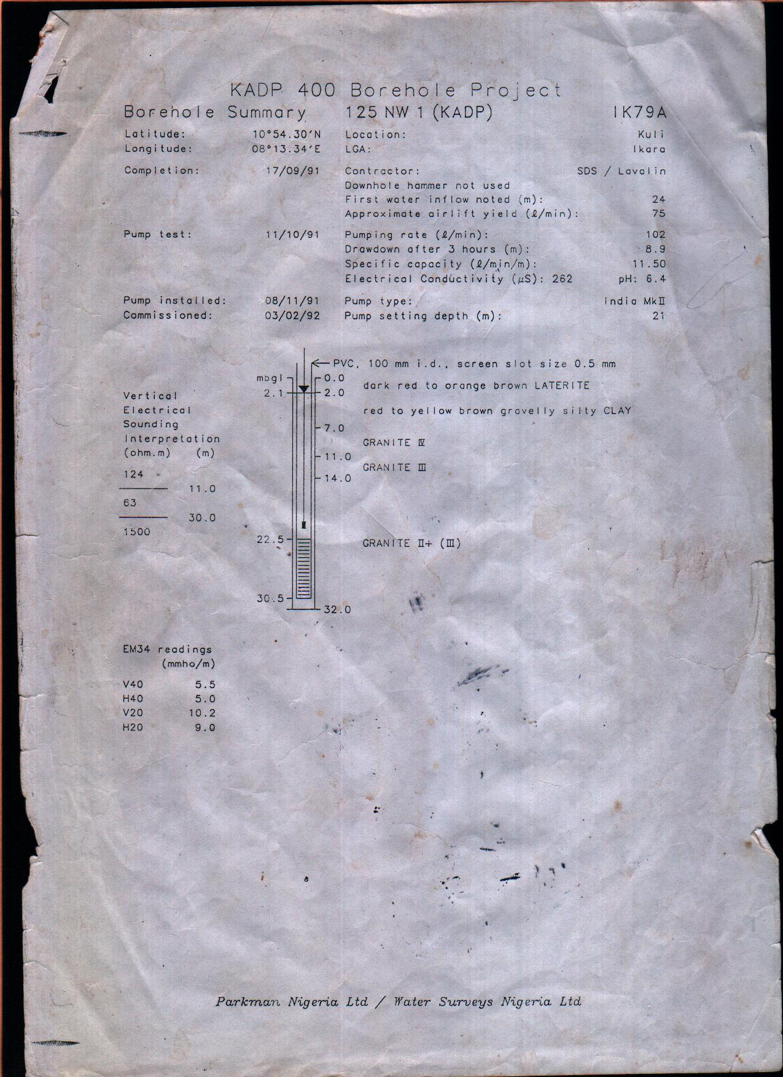
(BD 2)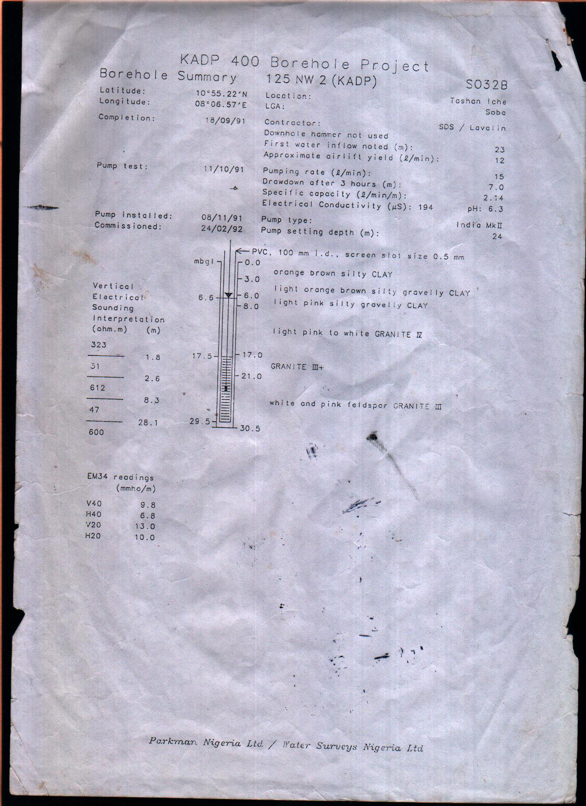
(BD 3)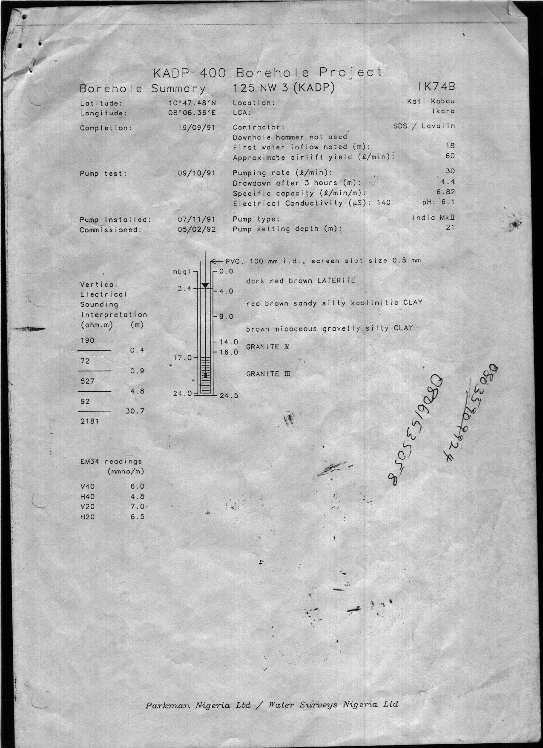
(BD 4)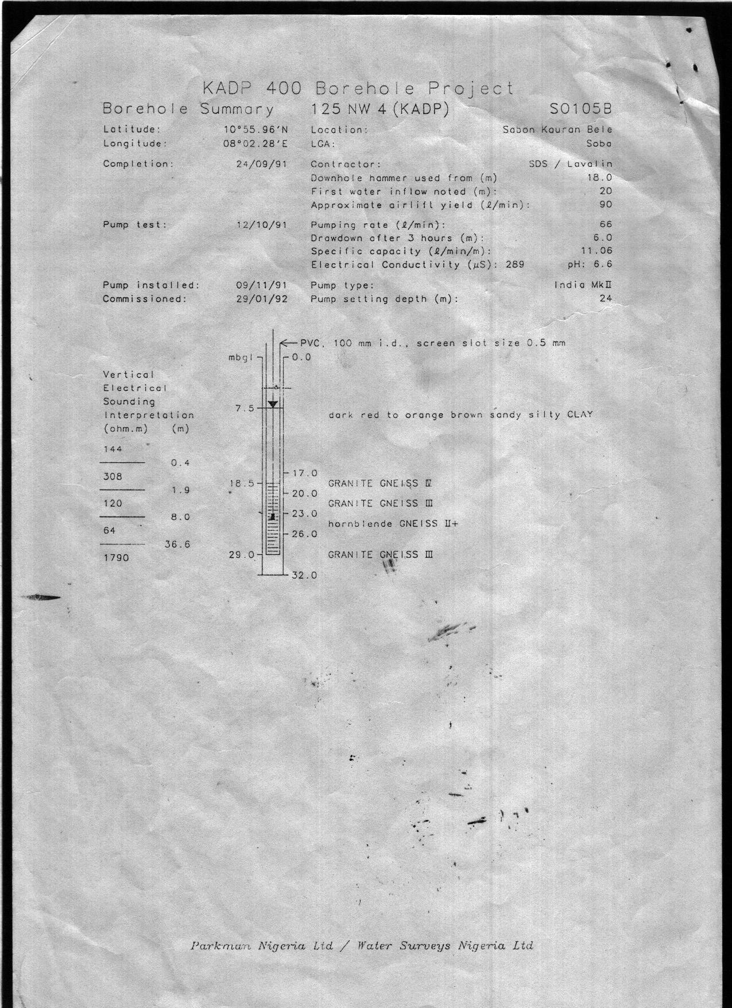(BD 5)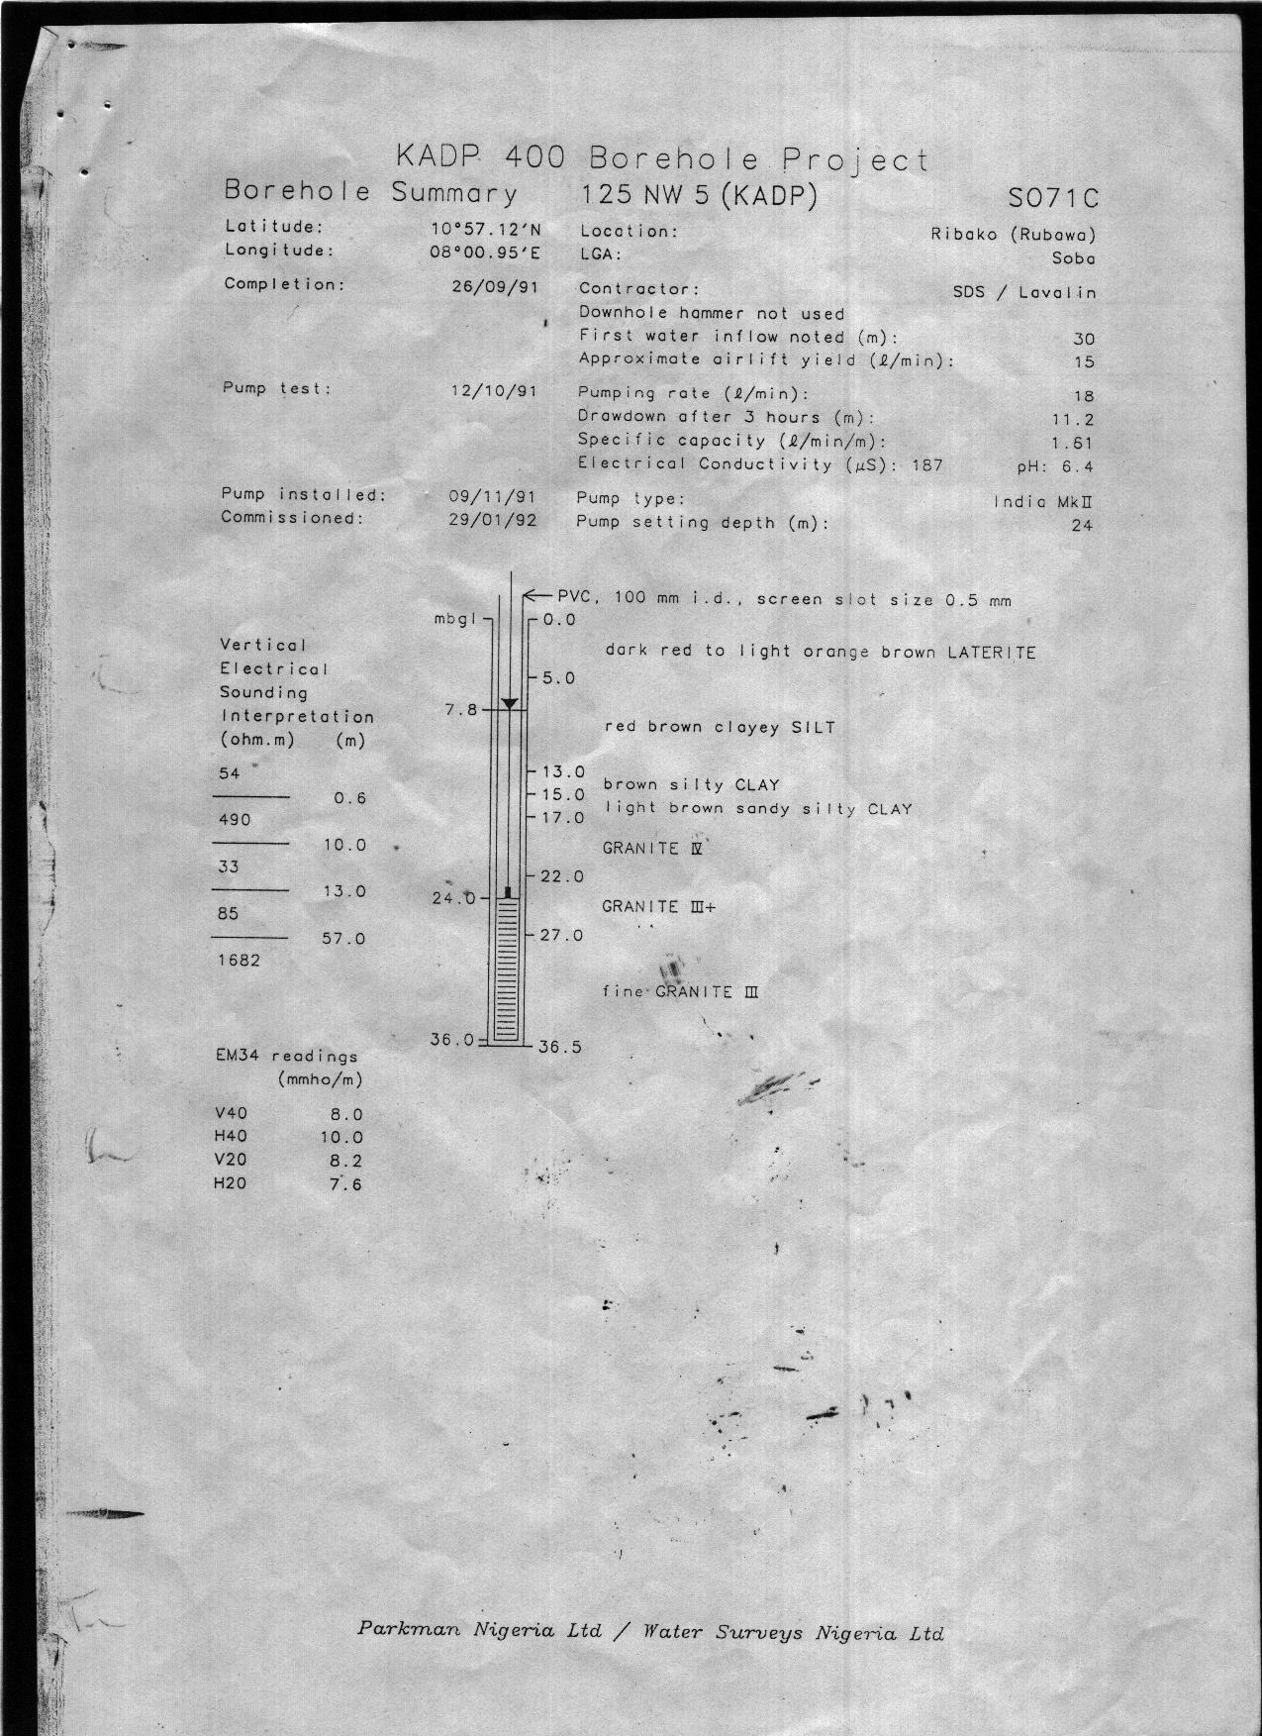
(BD 6)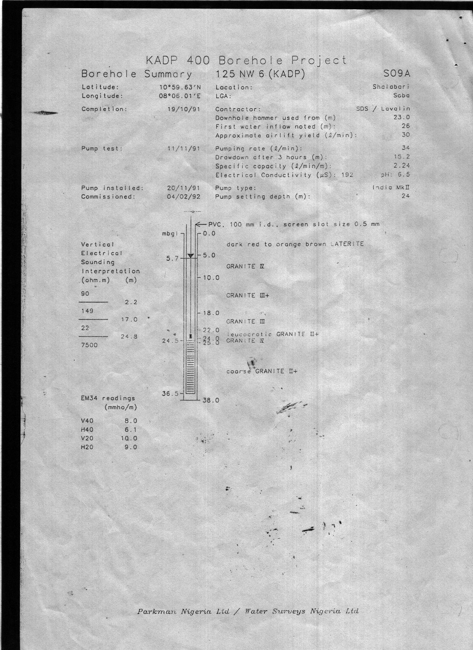
(BD 7)
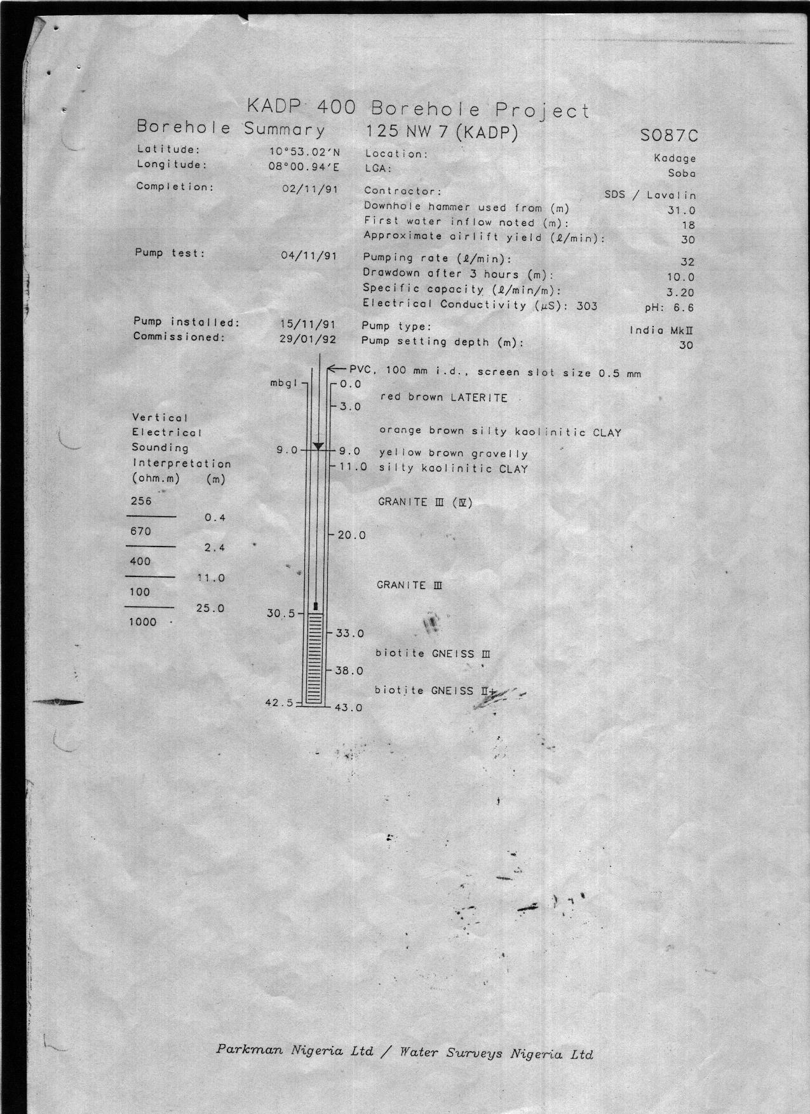

(BD 8)
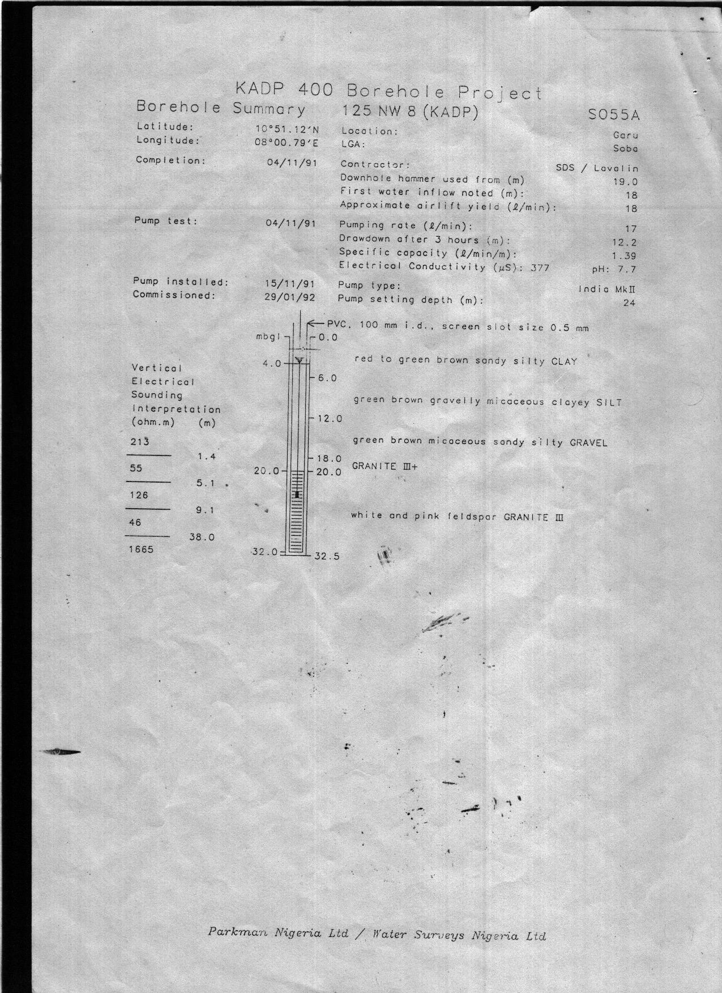

(BD 9)
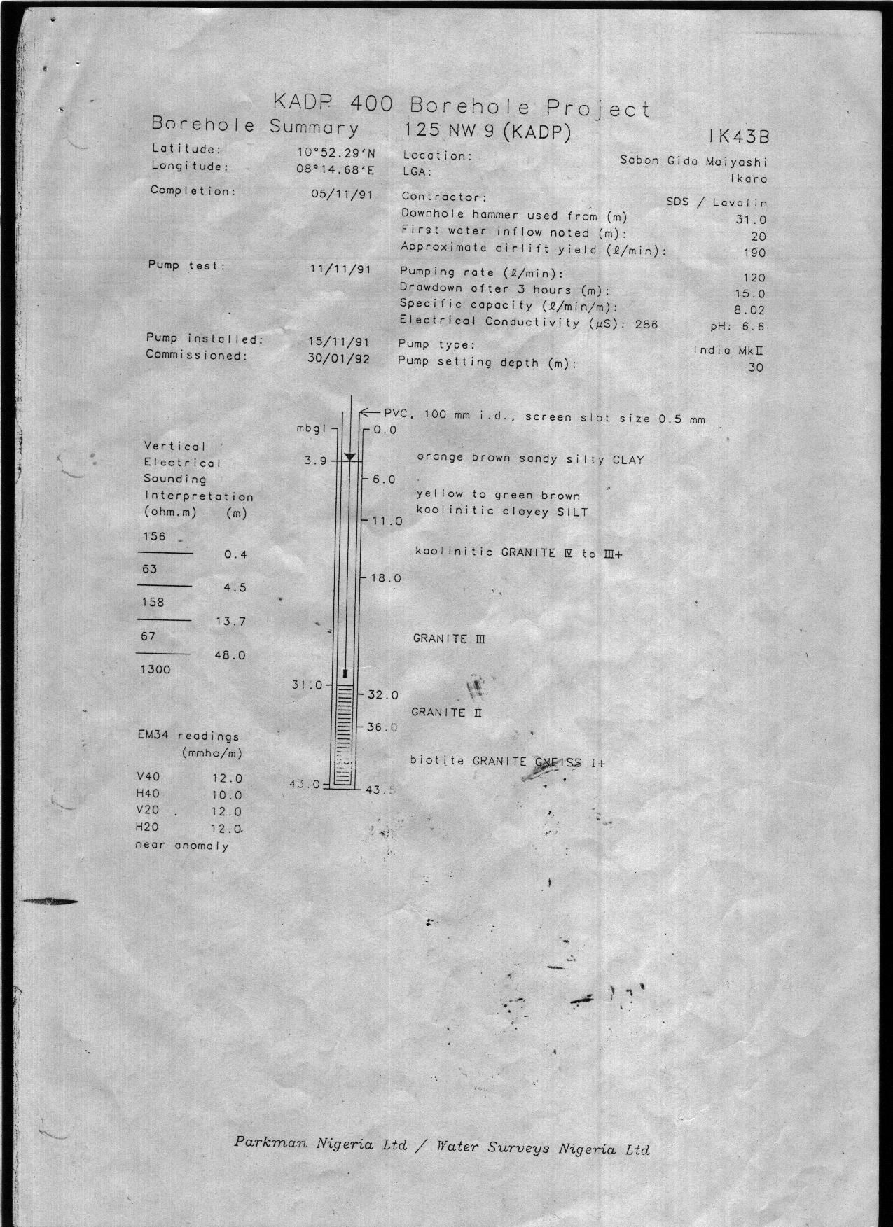
(BD 10)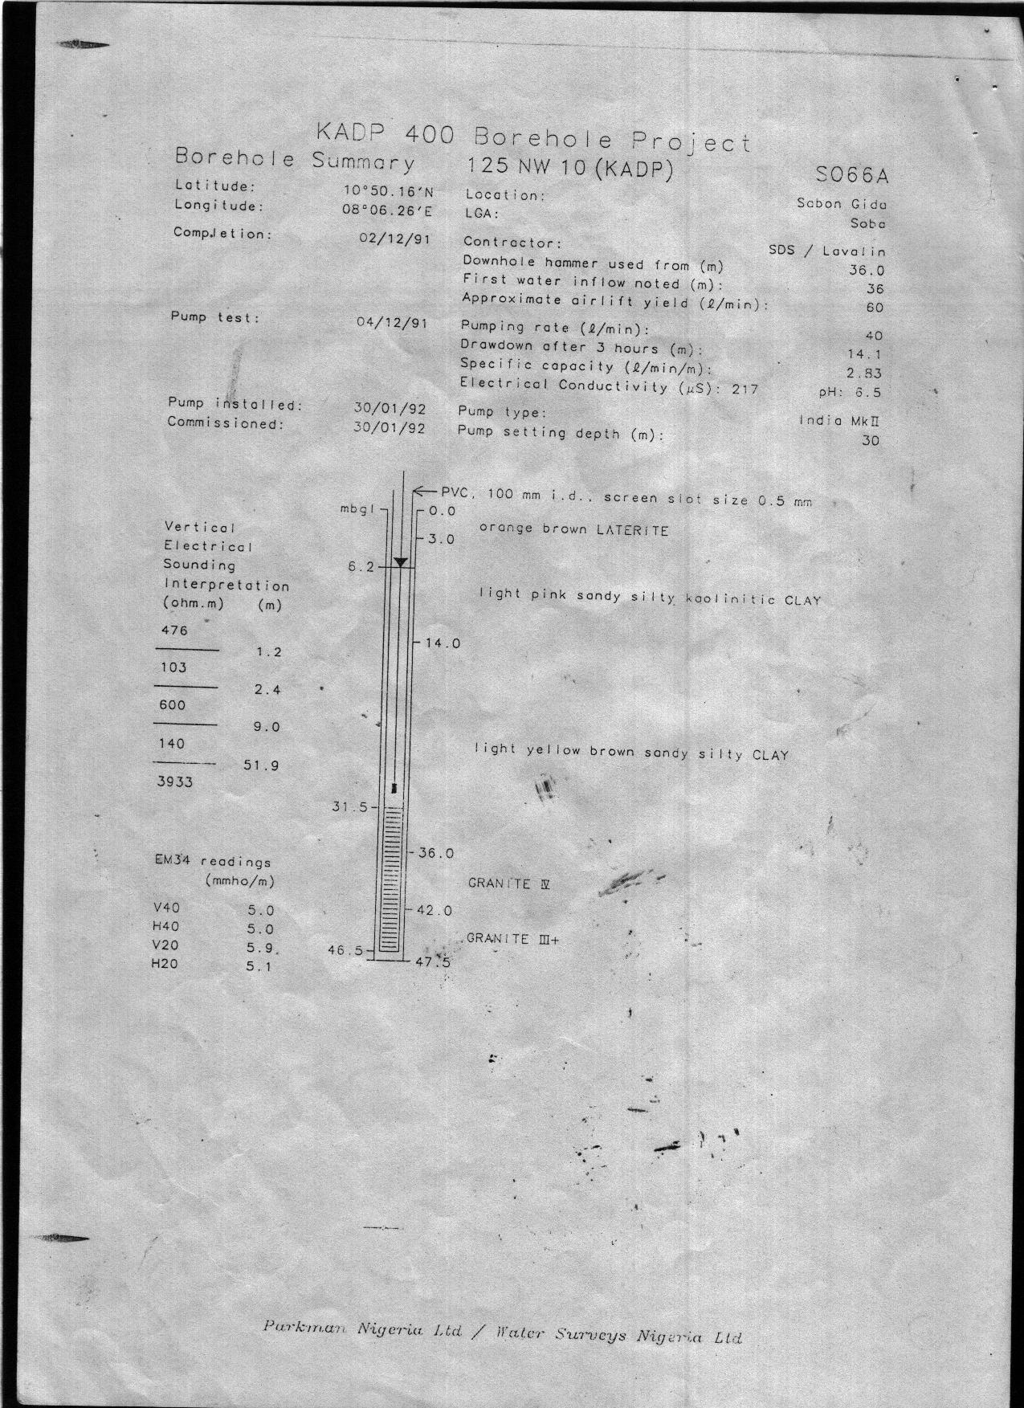
(BD 11)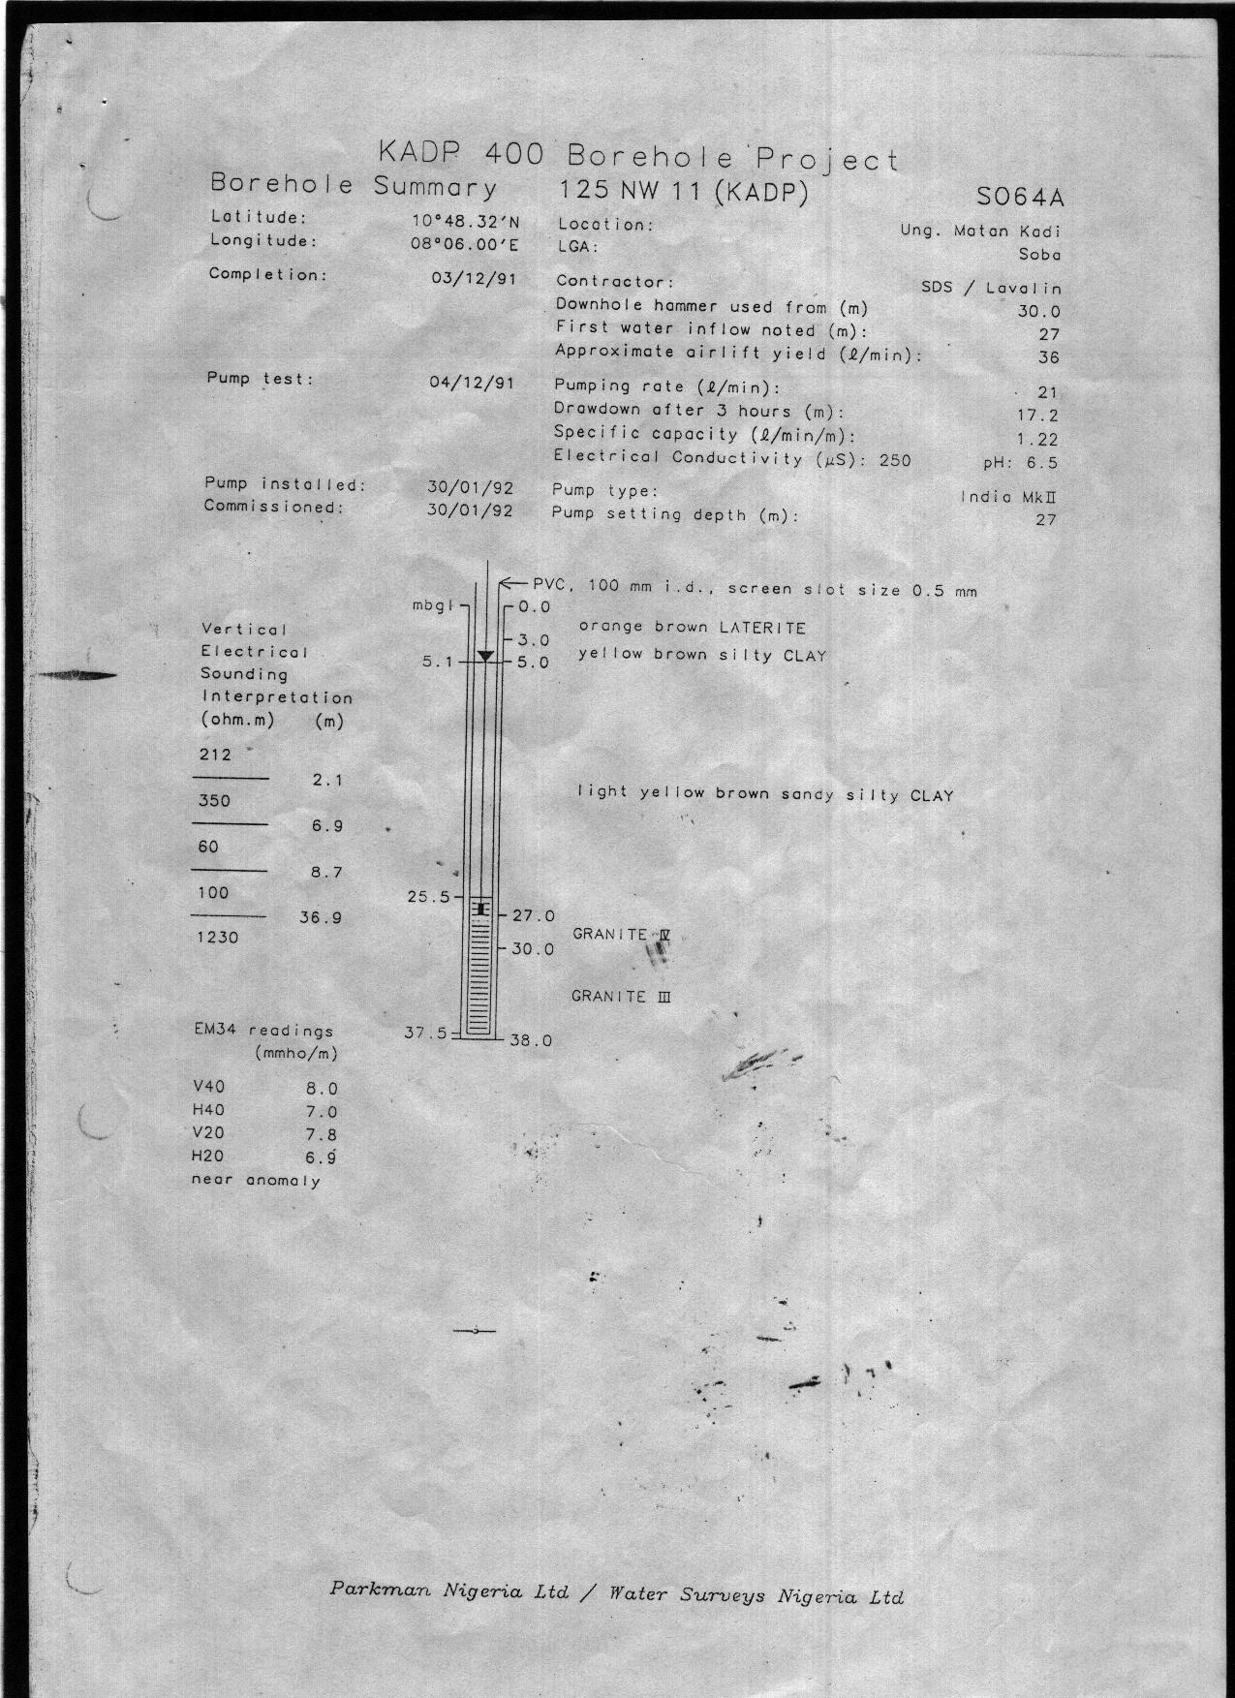
(BD 12)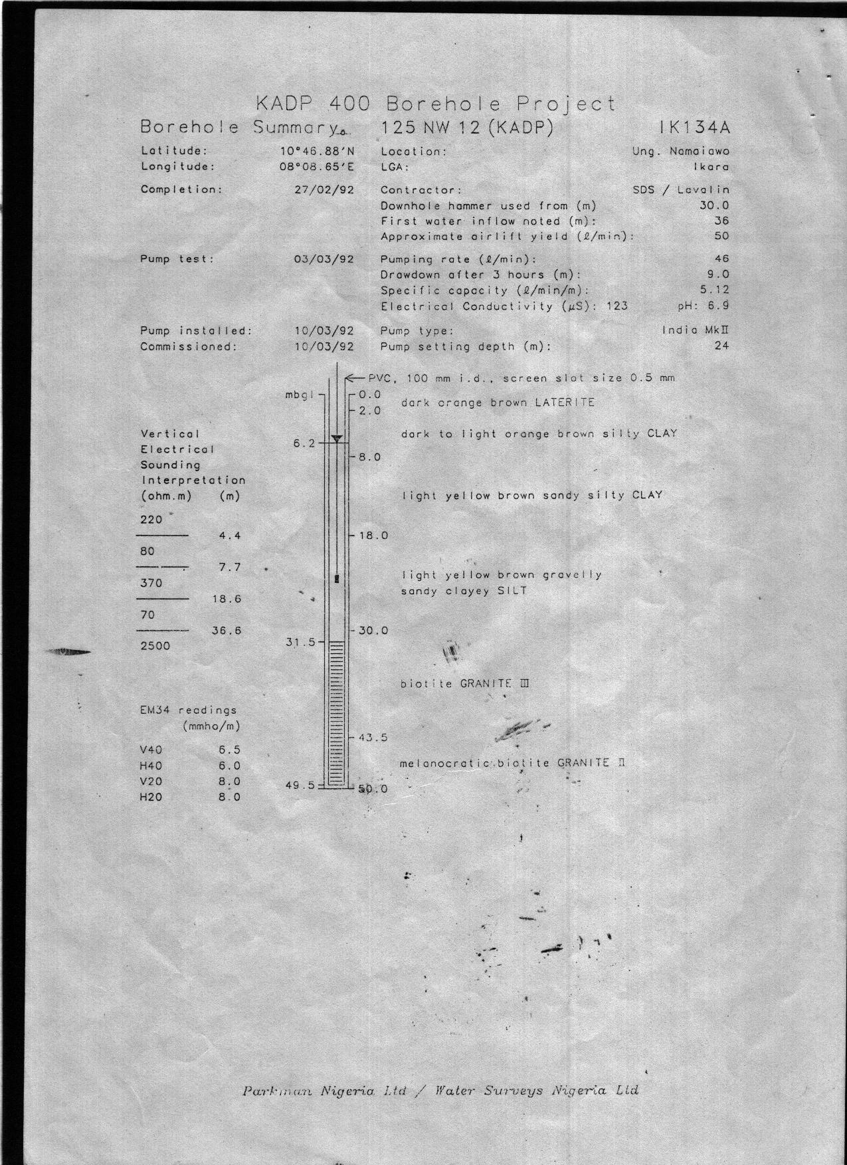
(BD 13)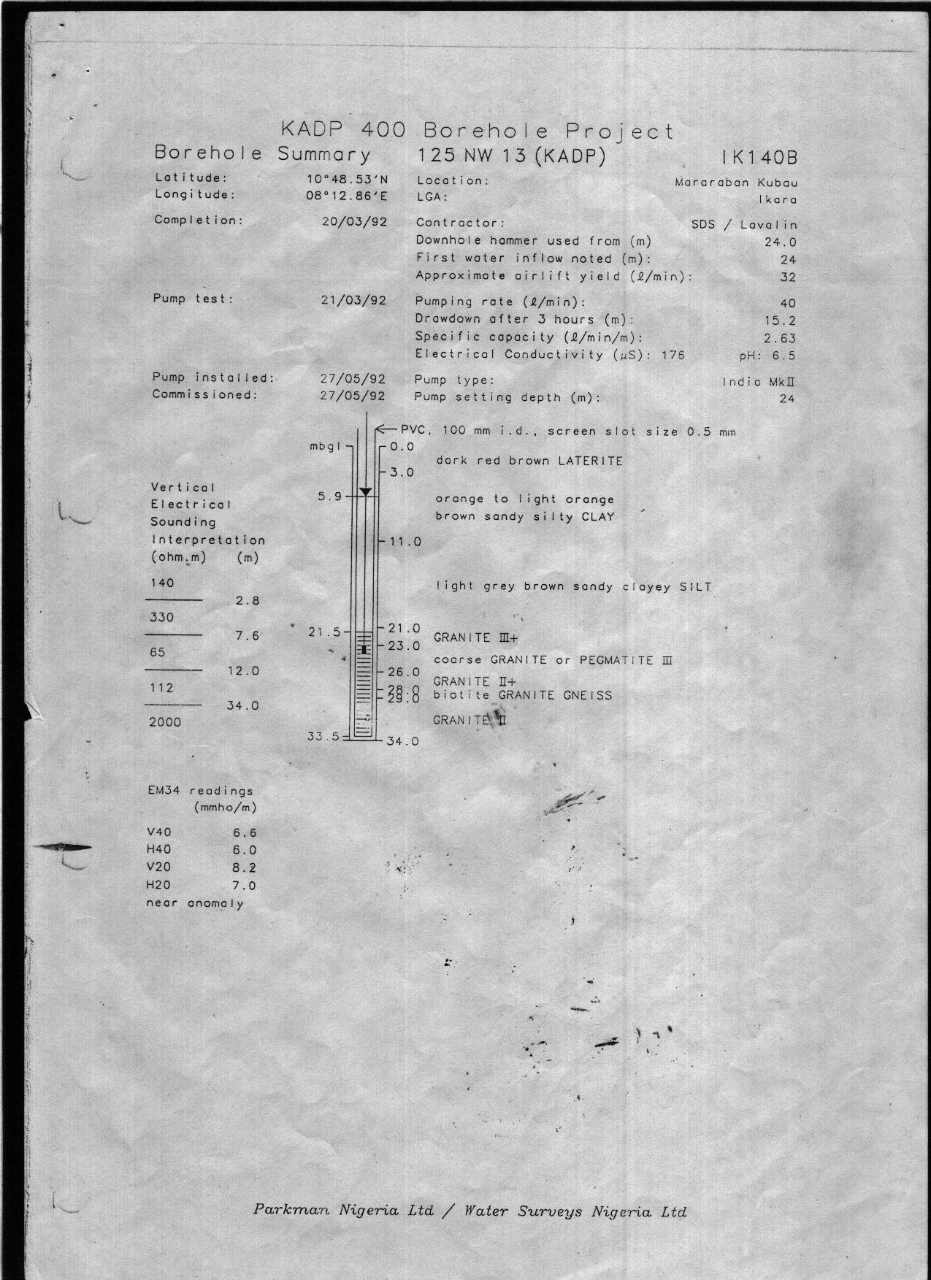
(BD 14)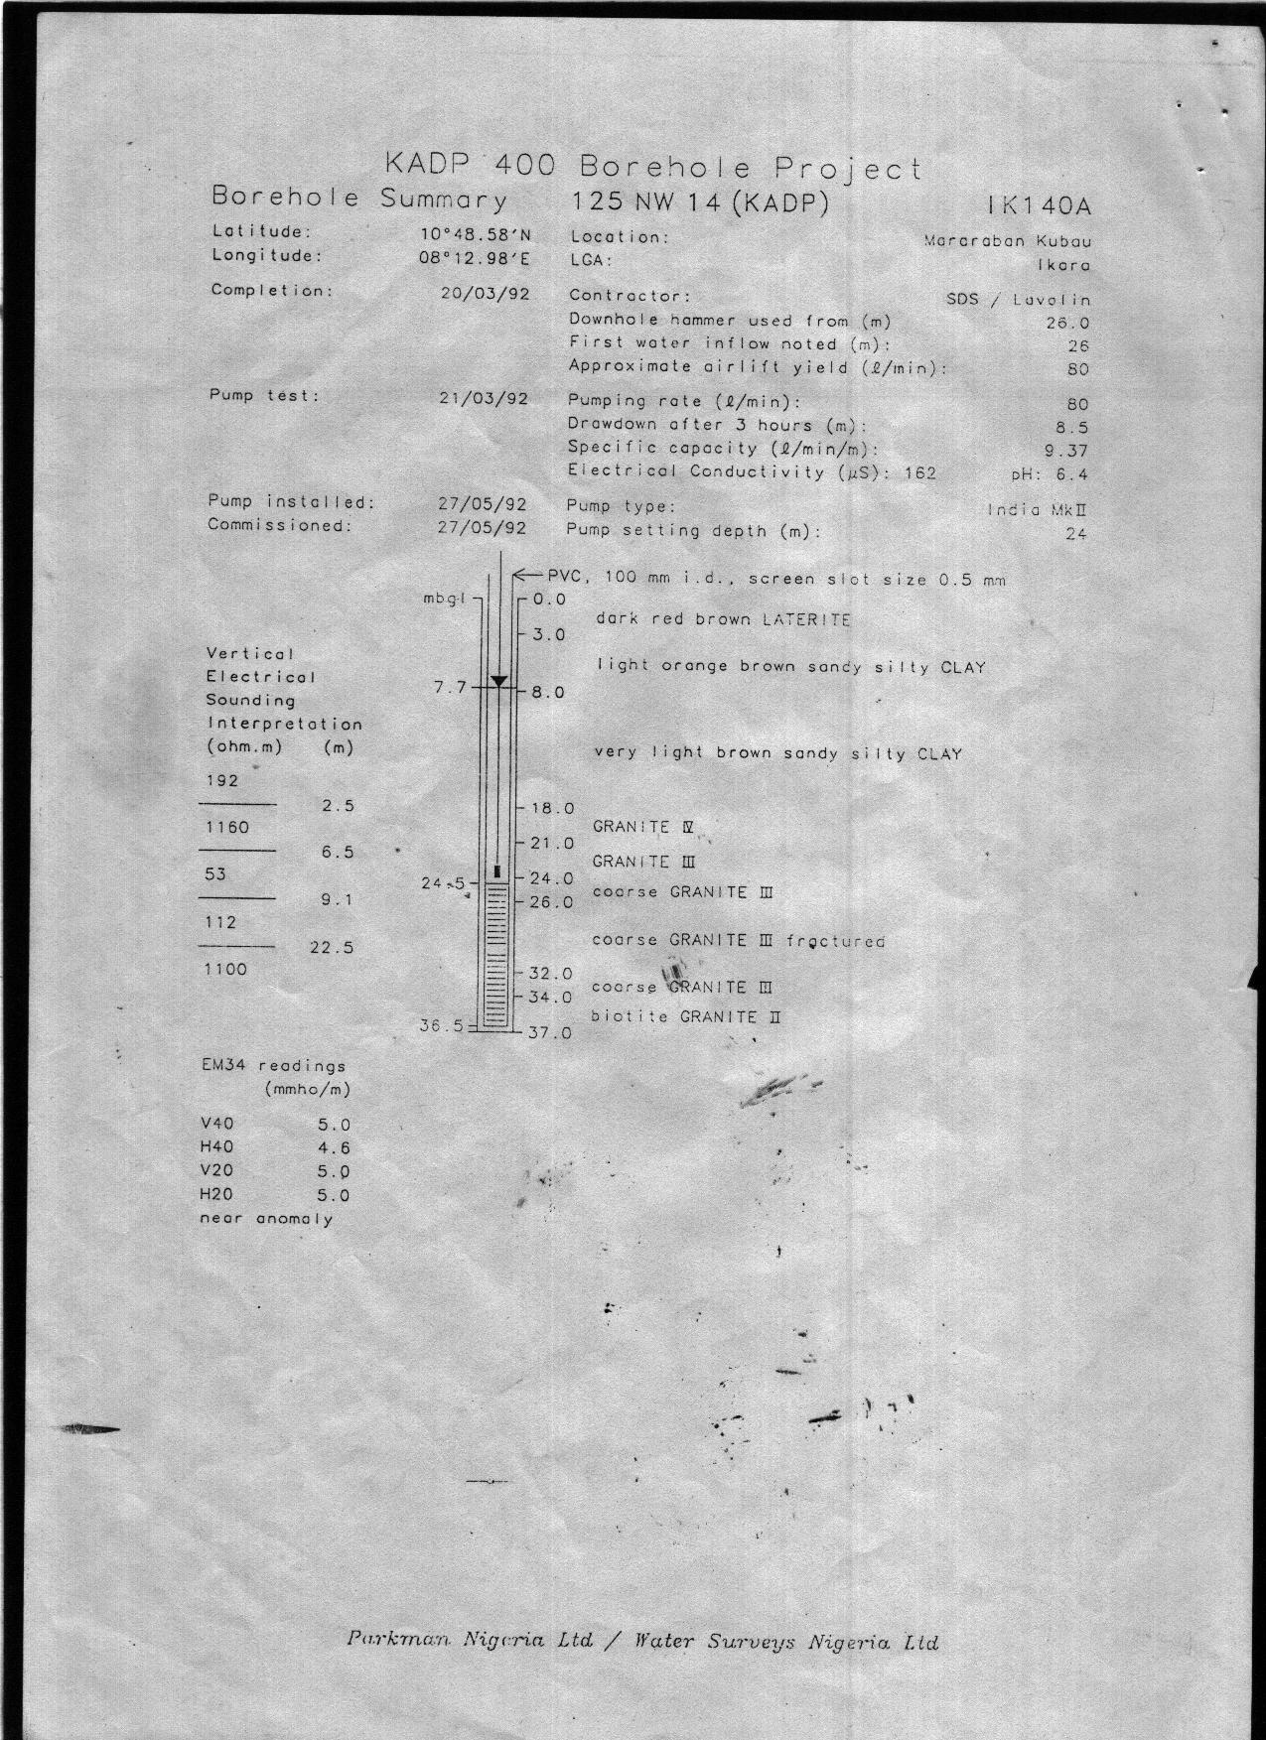
(BD 15)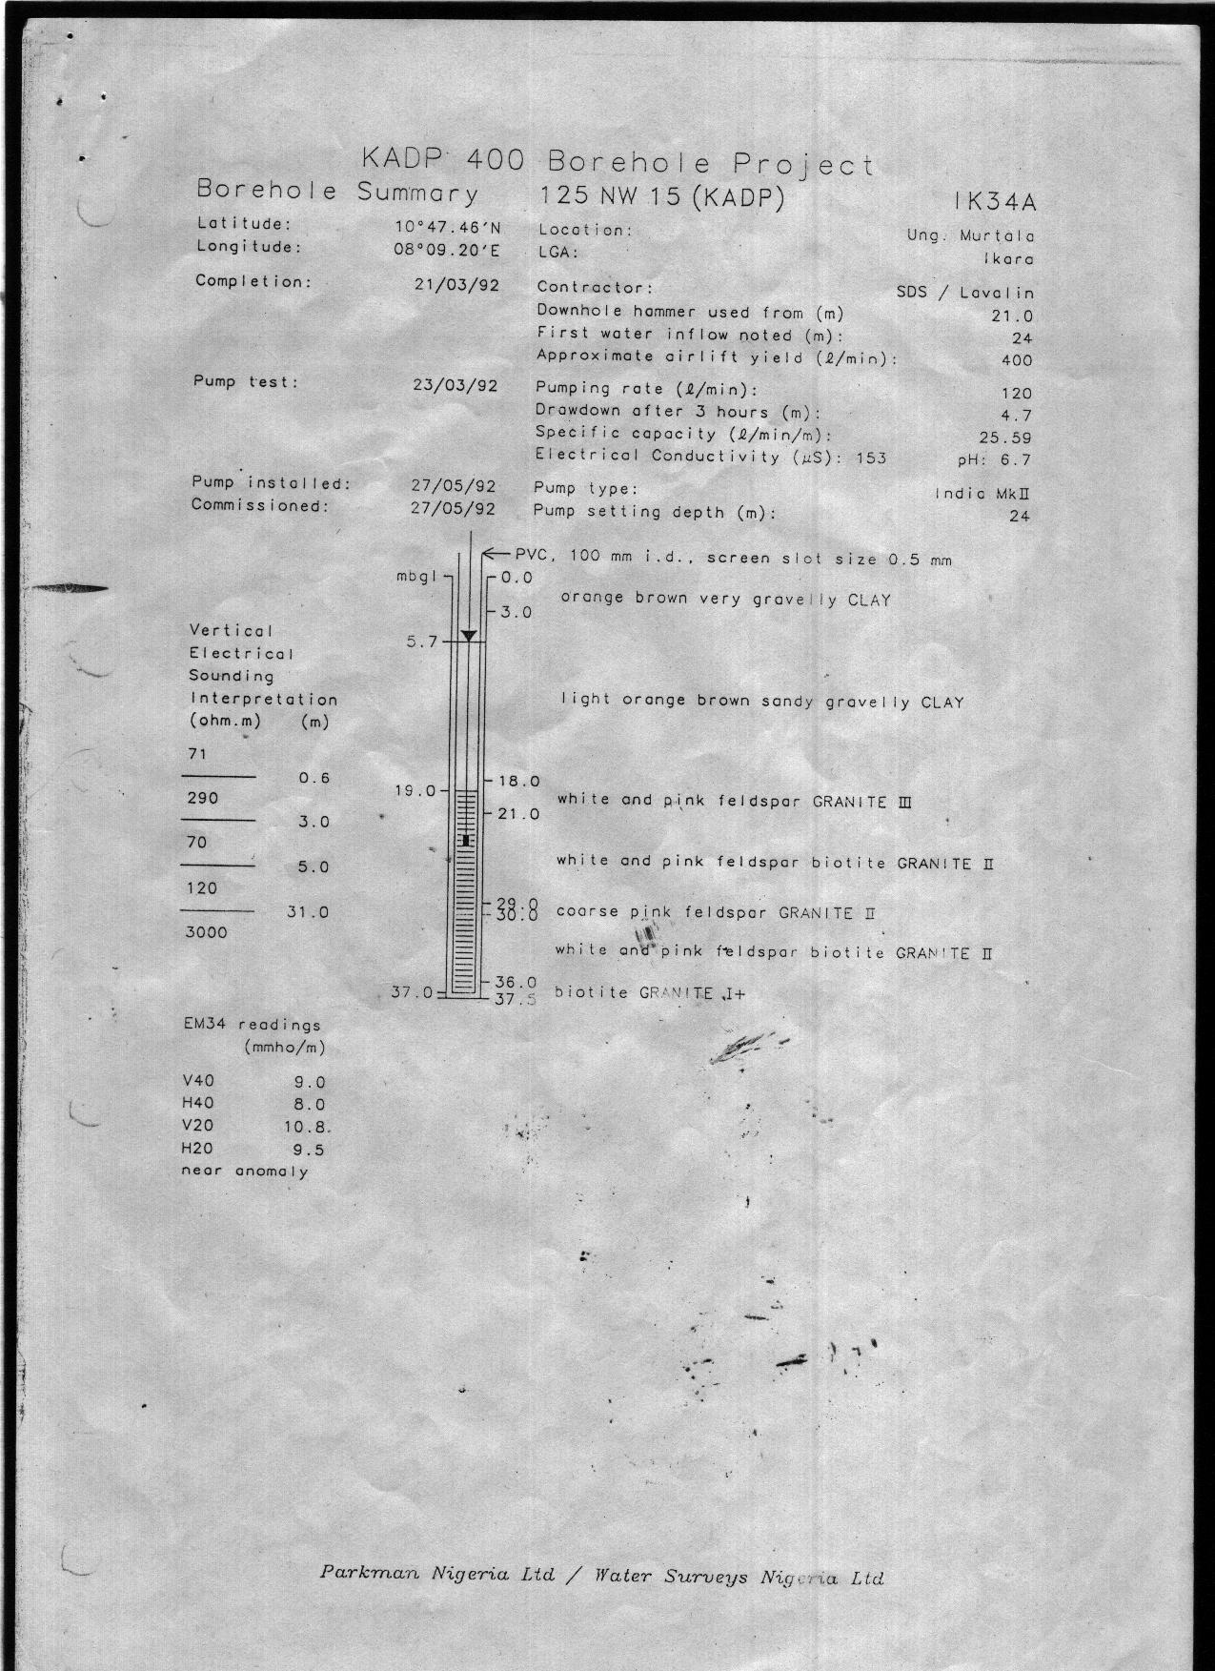
(BD 16)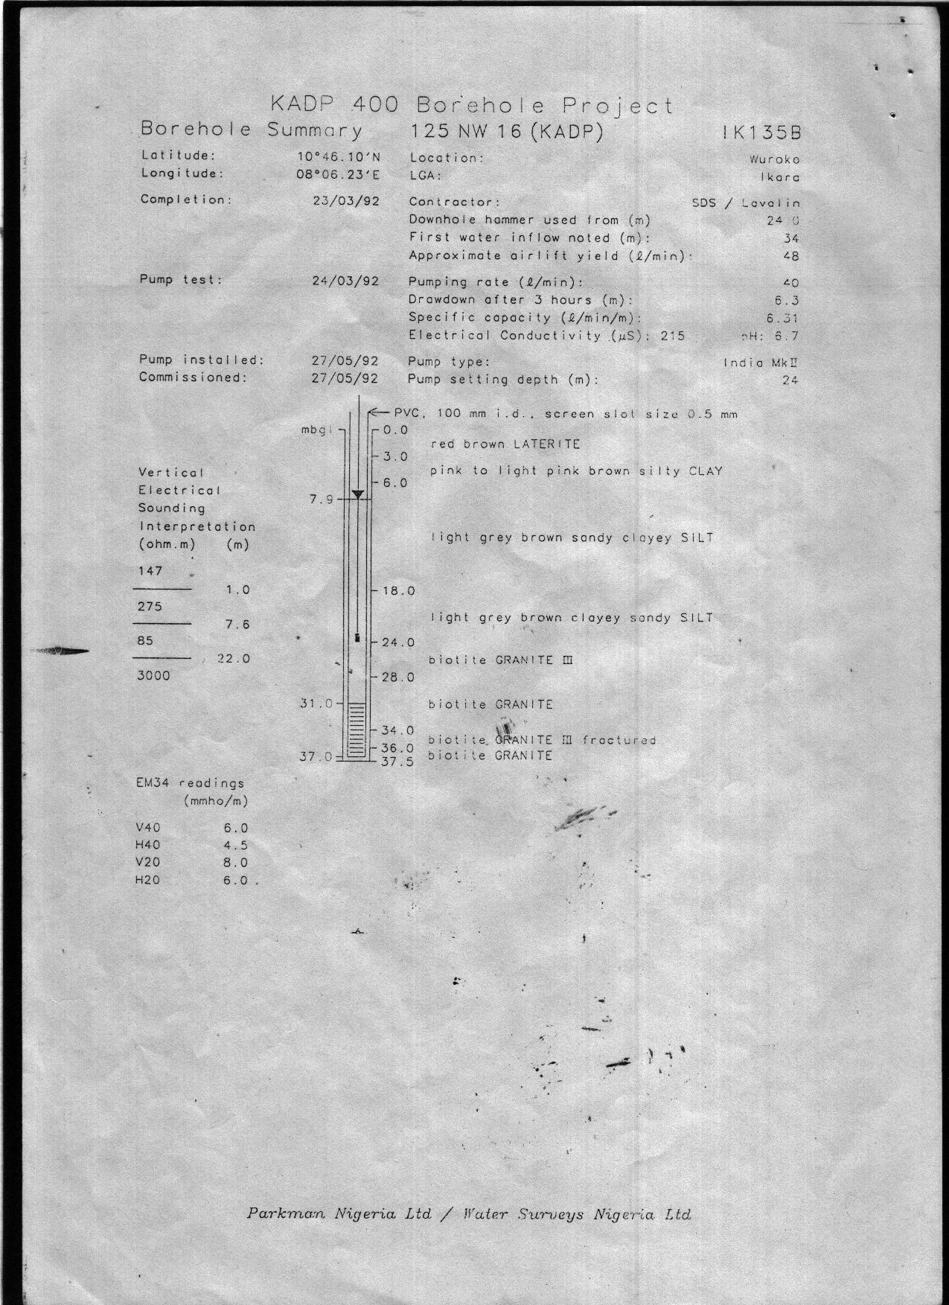
(BD 17)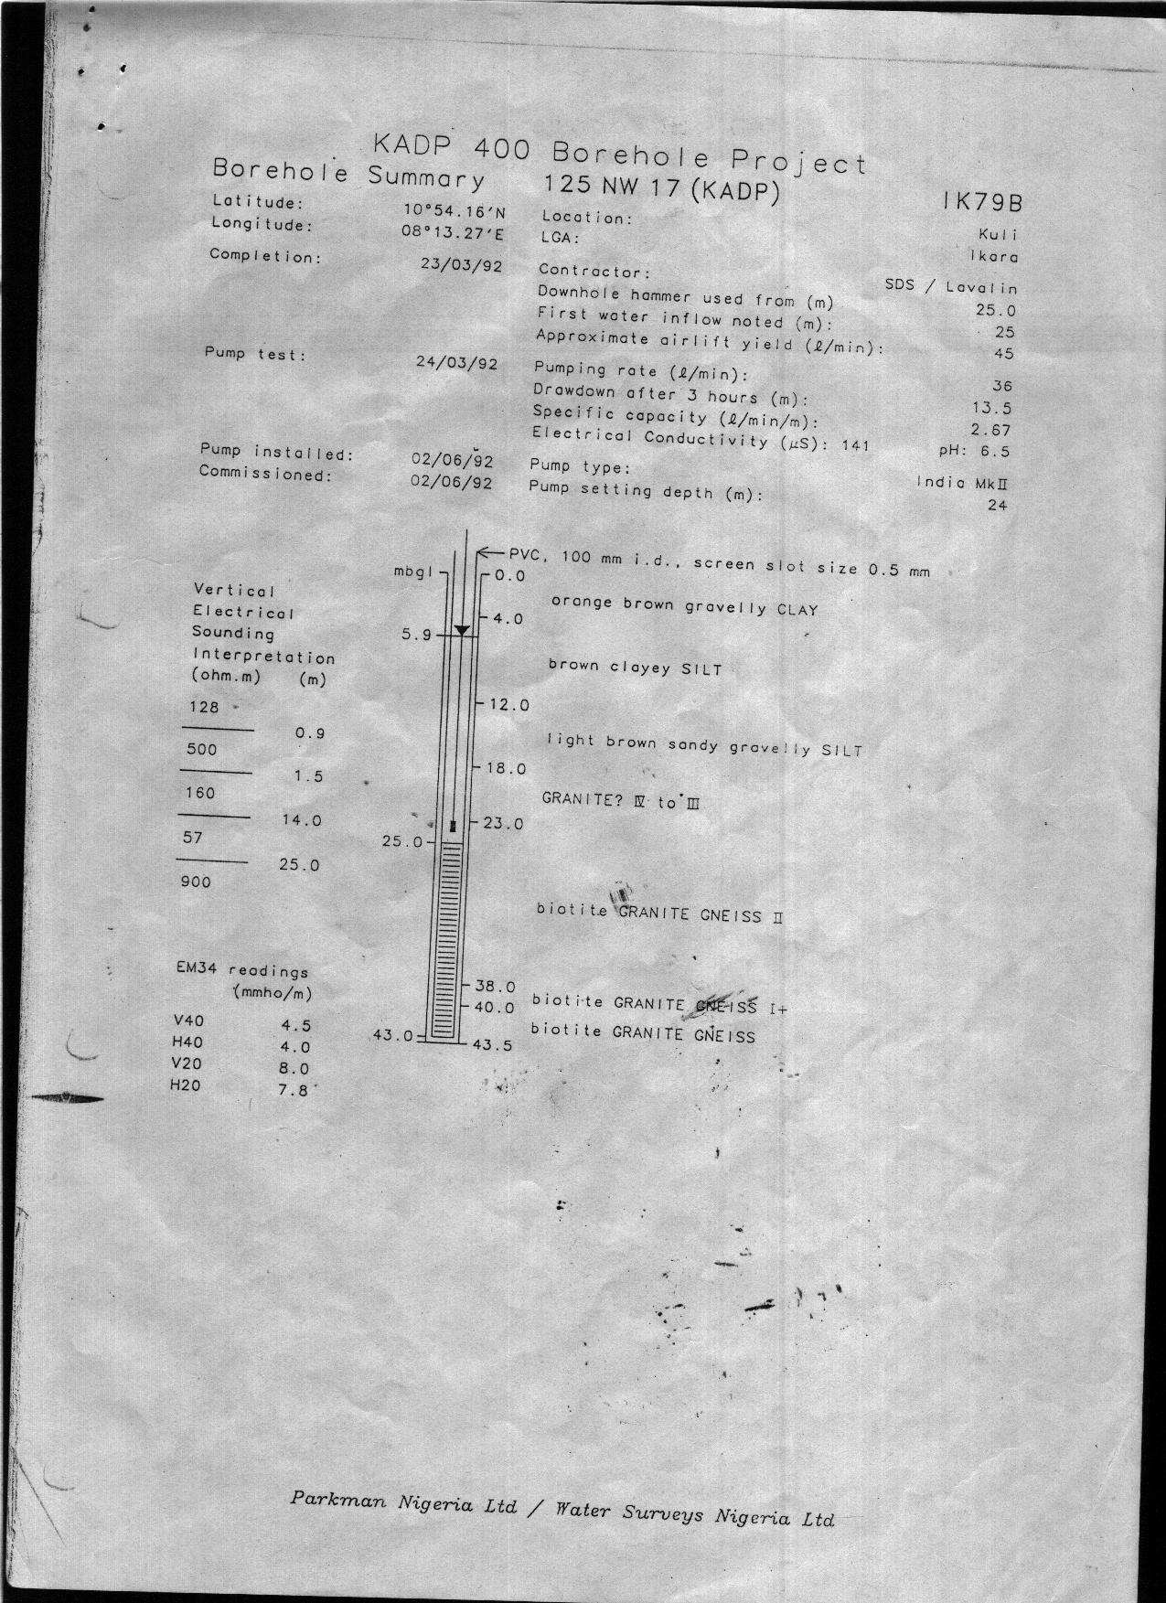
(BD 18)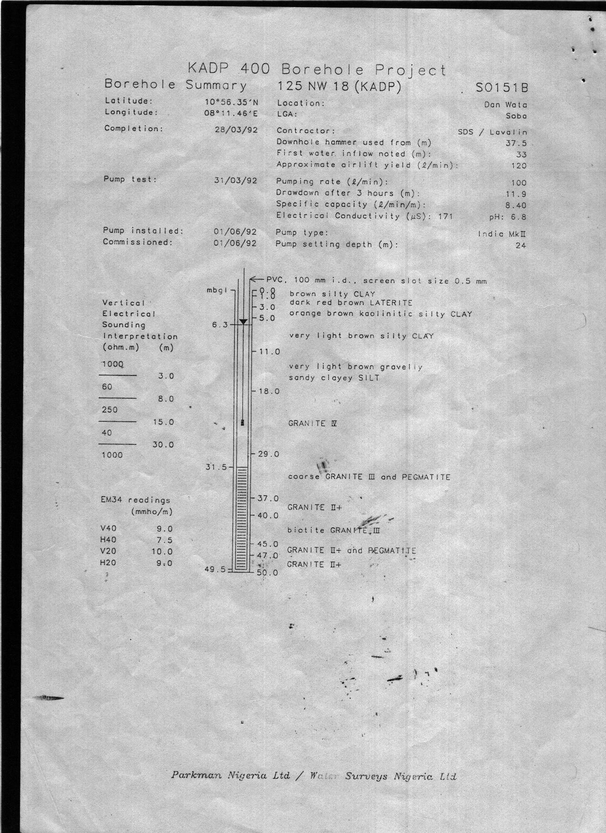
(BD 19)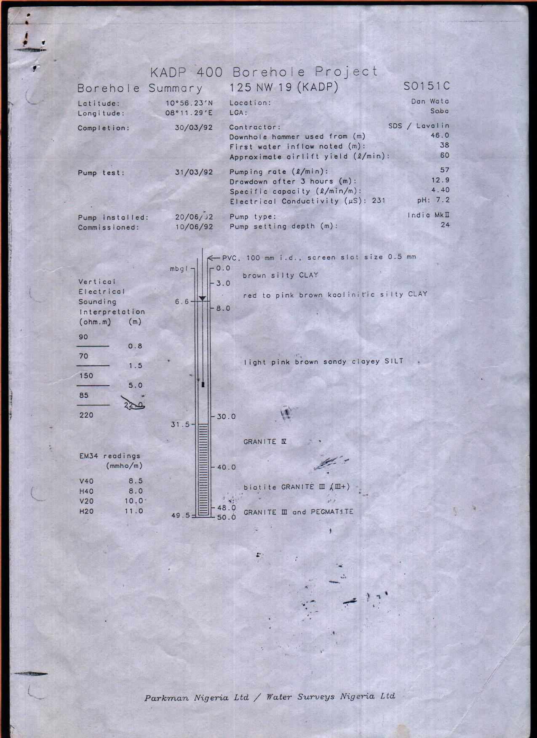
(BD 20)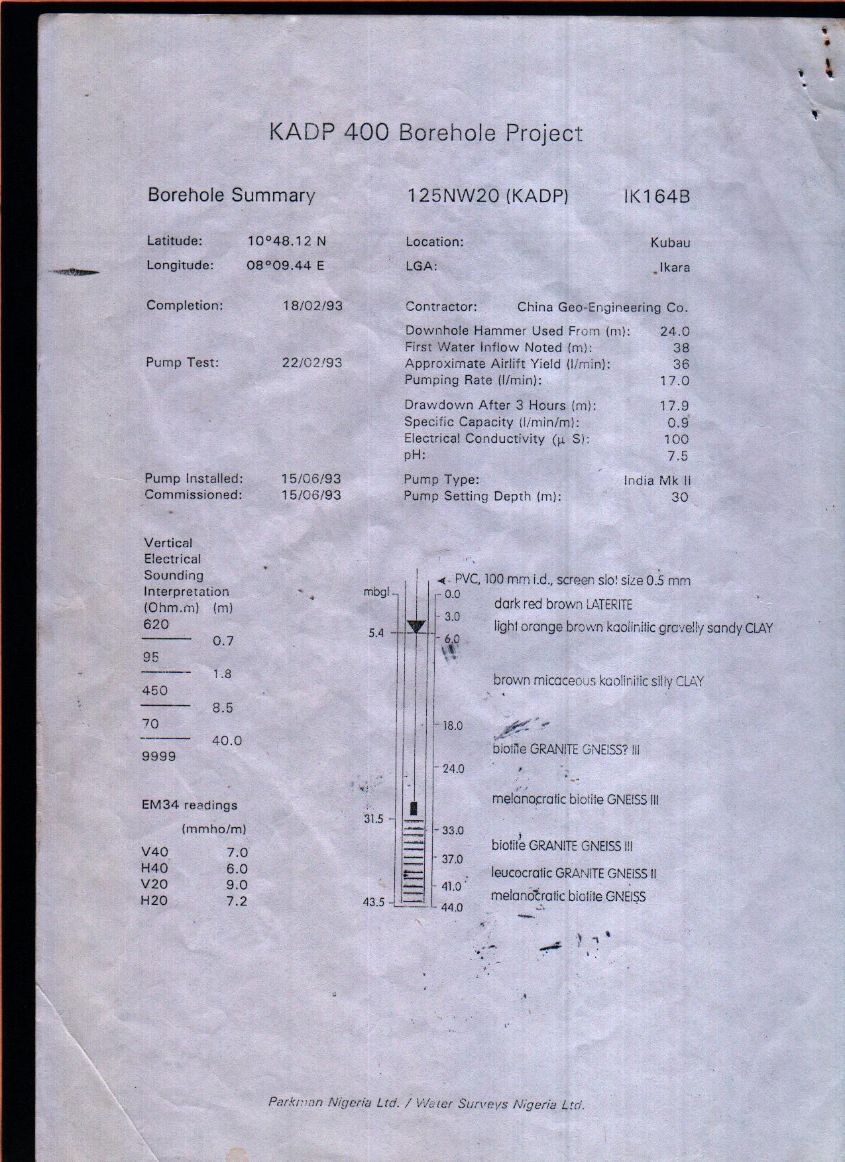
(BD 21)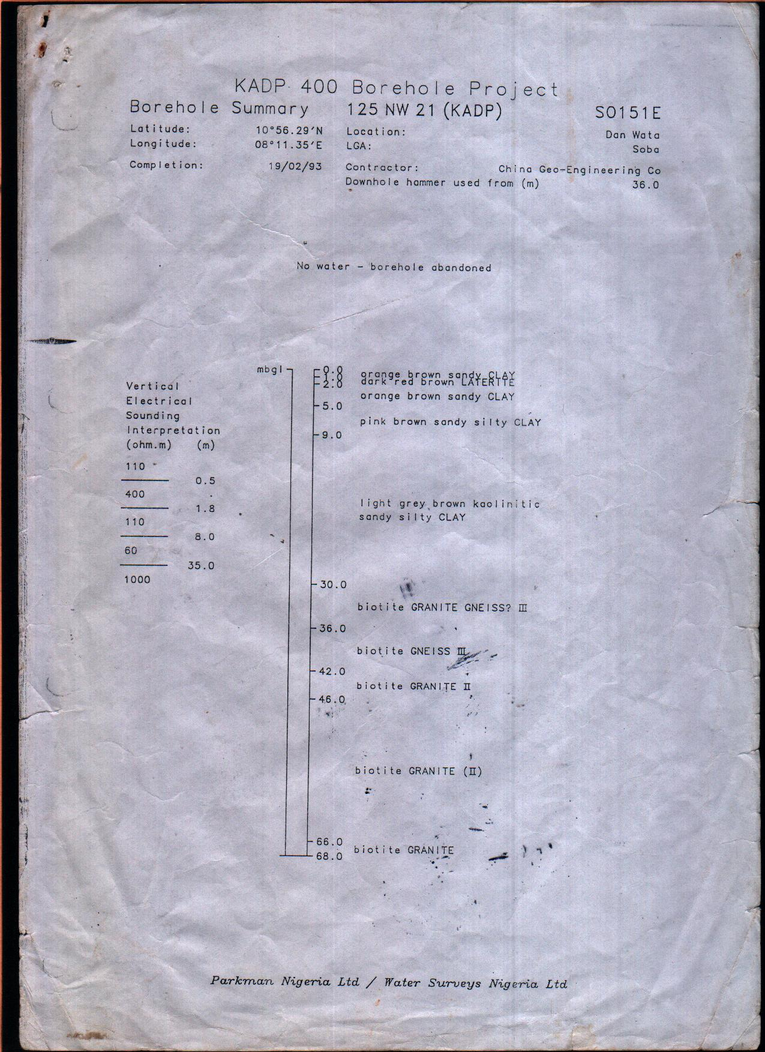
(BD 22)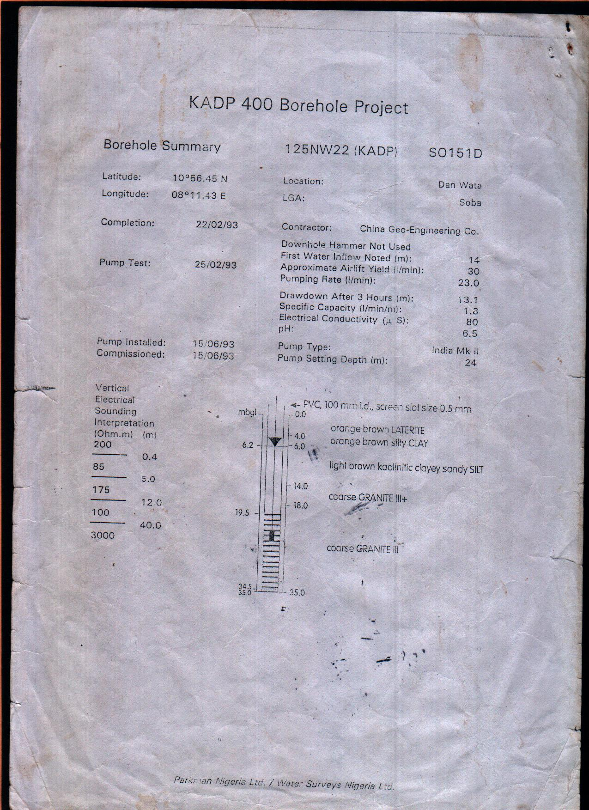
(BD 23)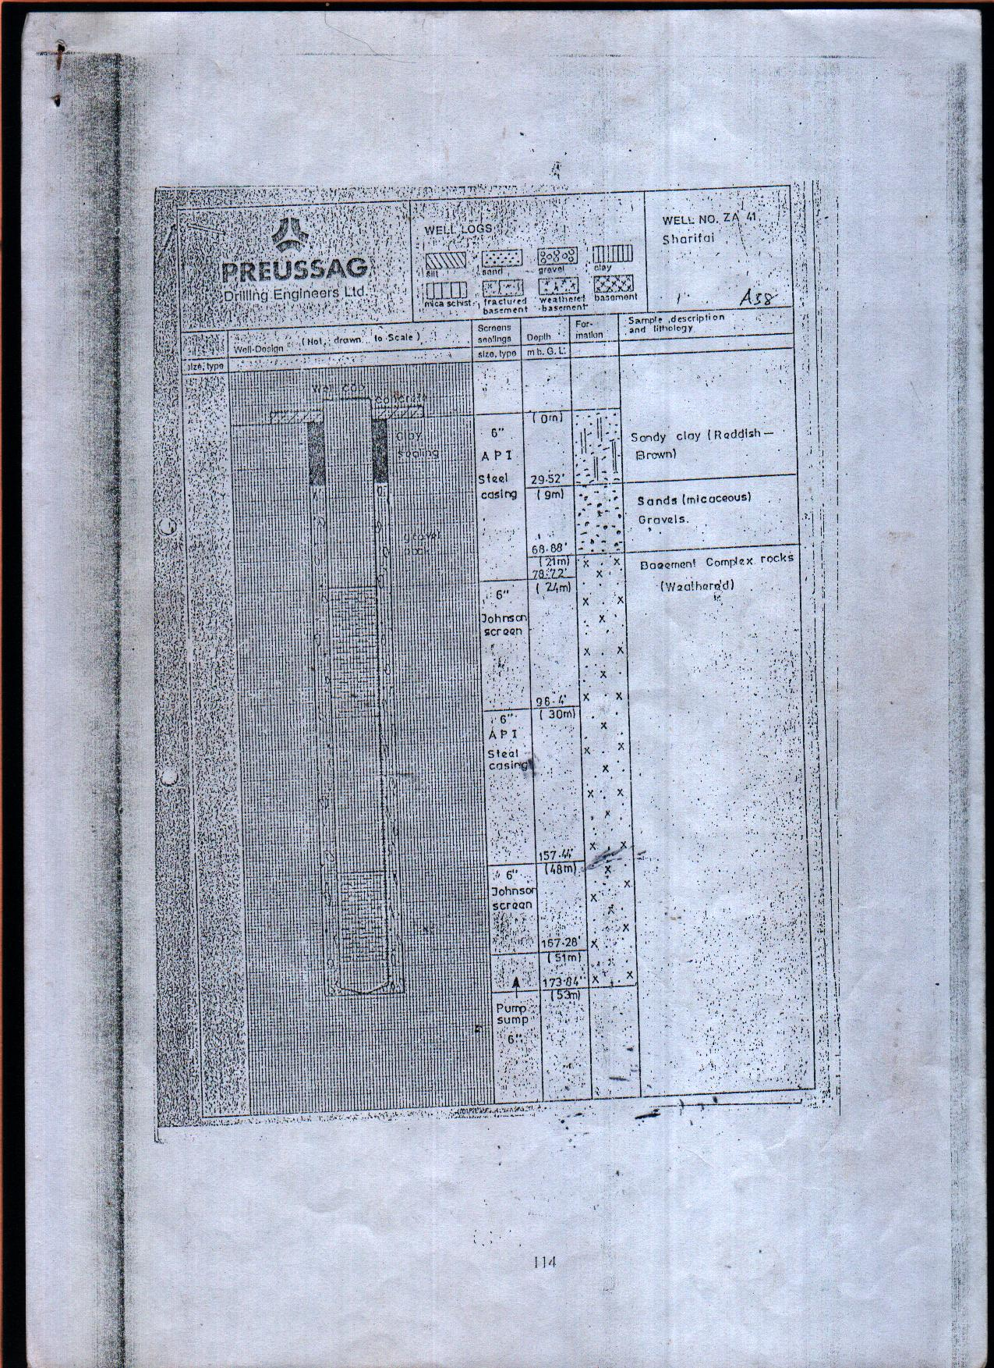
(BD 24)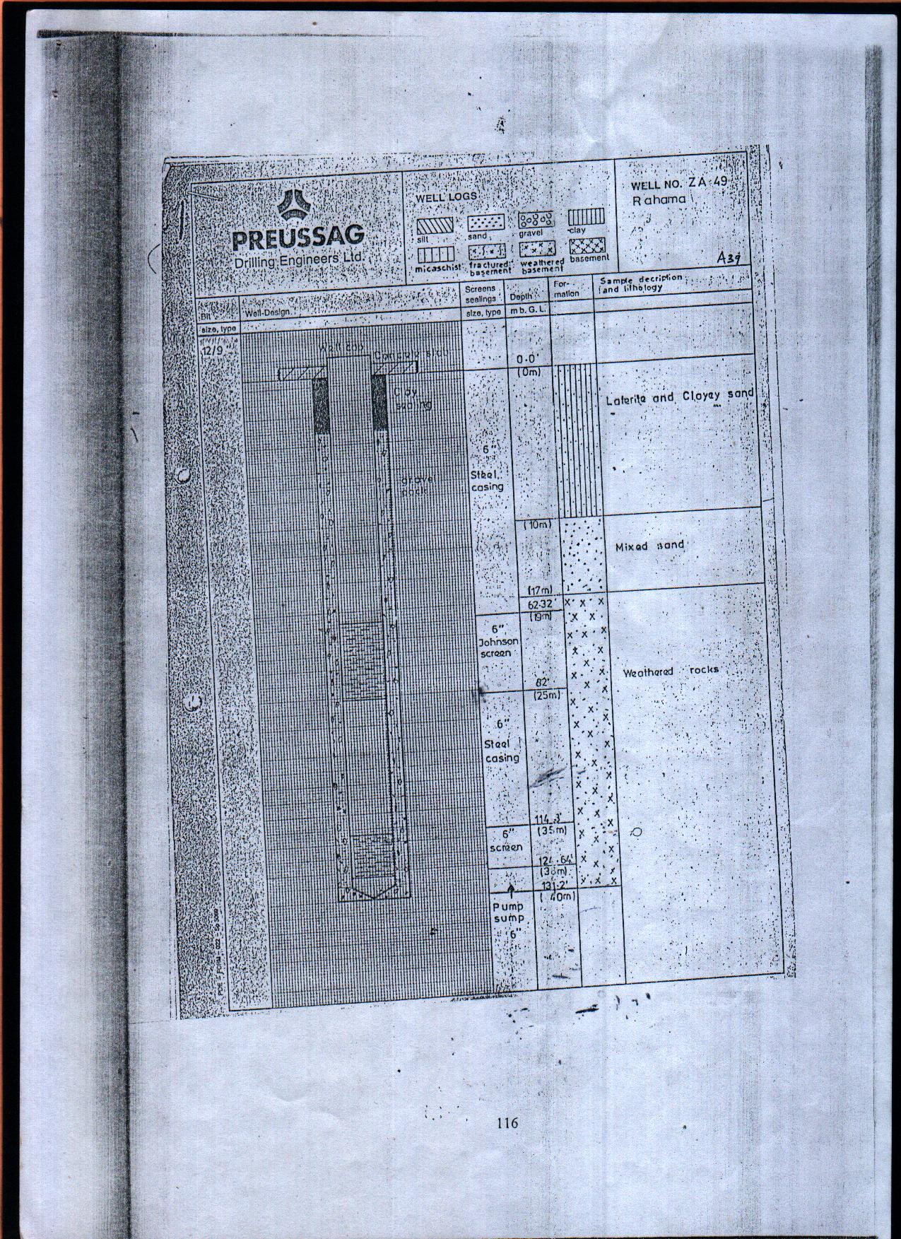
(BD 25)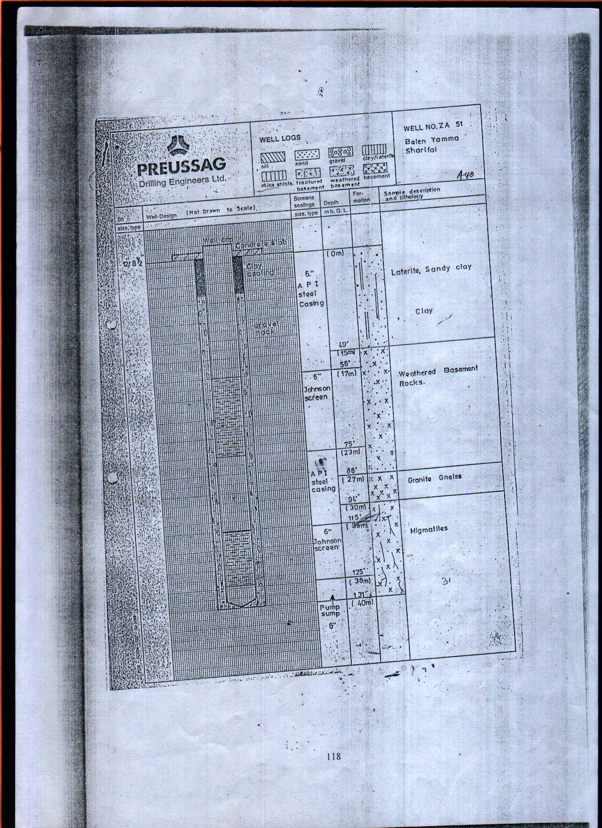
(BD 26)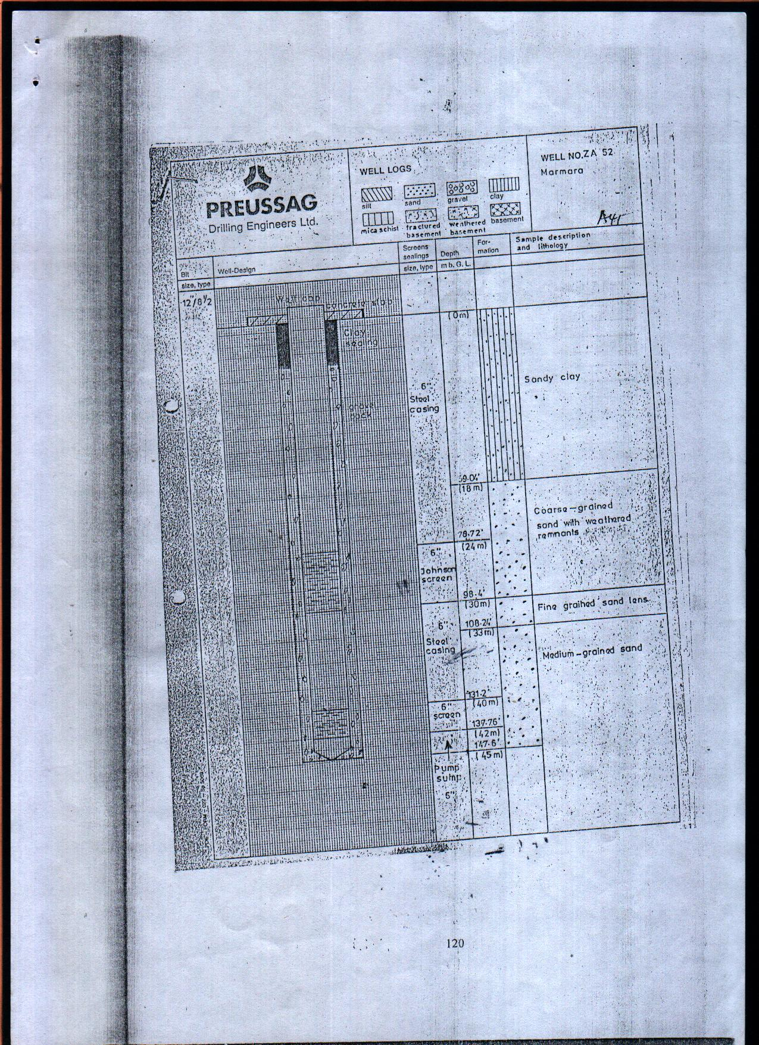
(BD 27)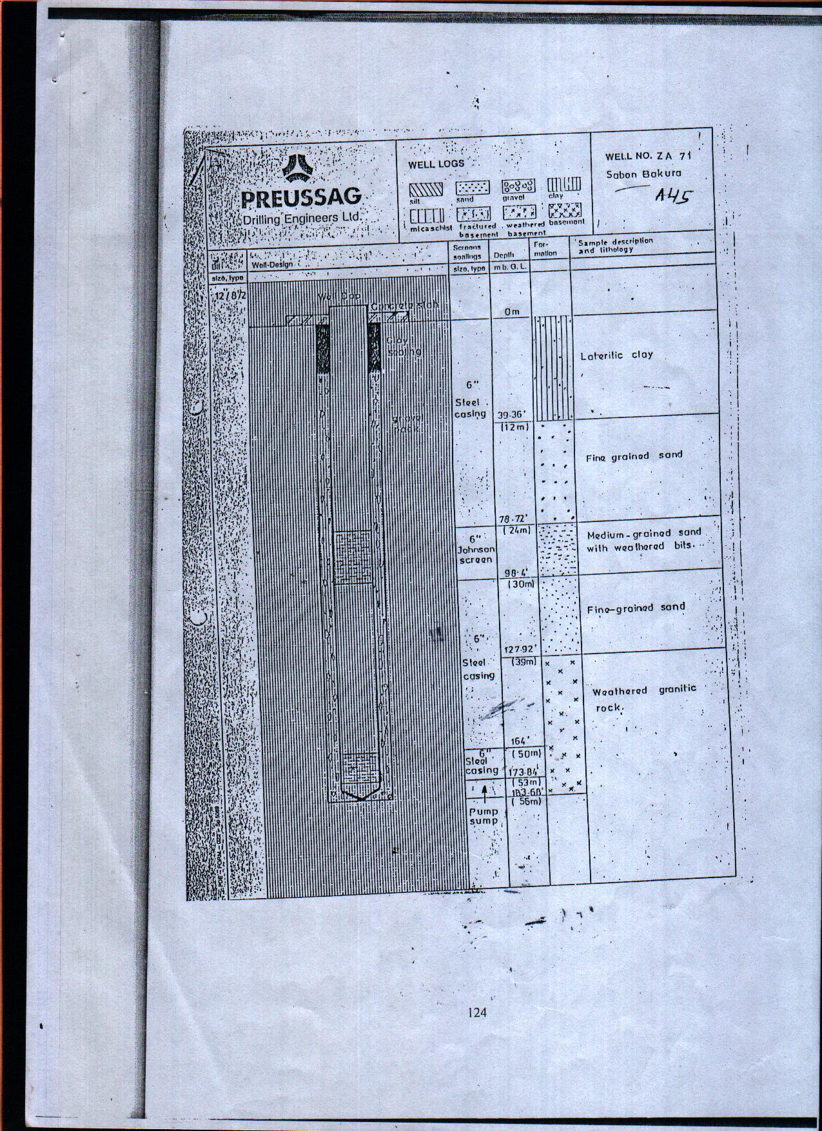
(BD 28)