Methods of Sharing Informal Information and the extent at which the Information is used by senior Administrators in Ahmadu Bello University Zaria-Nigeria
By
Hassan Usman PhD
Kashim Ibrahim Library
Ahmadu Bello University, Zaria.
Hassansamaru31@gmail.com
&
Hamza Ukashatu Musa PhD
hamzaukashat@gmail.com
Kashim Ibrahim Library
Ahmadu Bello University, Zaria.
Abstract
This study investigates the methods of sharing informal information by senior Administrators in Ahmadu Bello University Zaria and the extent at which the information is used. Informal information has been a way the senior Administrators used in sharing information among them informally. This information could be on appointment, admission, promotion, staff welfare, etc.
These were done through the formal way but unfortunately are not giving the senior Administrators the desired outcome in taking crucial decisions. The total number of senior Administrators used for the study were two hundred and one (201) which the entire population was used without sampling because the population is manageable it is not large enough. Self administered questionnaire was also used in order to get information from the respondents. Out of the two hundred and one questionnaires distributed to the respondents only one hundred and seventy four were duly filled and returned for further analysis. Chi-square was used to test the null hypothesis in order to identify the expected and observed frequency using cross tabulation. Further, an attempt has been made to highlight the findings of the study and a few suggestions were made based on the analysis of the data collected.
Keywords: Information, formal information, informal information, senior Administrators
Introduction
Information is the key for the survival of any organization be it public or private institution. Information is an asset, information gives guidance and direction, information give power and security, information is the heart and brain of any institution, no organization can be able to develop and achieve its objectives without valid information, neither formal nor informal information. The ever-changing information technologies (IT) of our time are redefining how we share information in the known traditional ways. The appropriate applications of IT can, in fact, enhance information sharing even in an informal setting.
Information sharing is usually the interconnection of information systems or telecommunication technologies to share information between entities such as groups, departments and organizations
Formal information system is used primarily for analysis, preparation and transfer of information. One of many tasks of managers is development of various types of presentation of the facts of any field of activity, reports, analyses, draft decisions. More on this topic: Management information system or Structure of strategic information system.

FORMAL INFORMATION SHARING
Formal information is the traditional and structured way of passing and exchanging ideas formally. It is also a process of collecting and presenting information in an organized format. It could be through meetings, letters, sometimes email, memos, notes, chatting or formal office discussions. Formal information can also be seen as a means of communication among senior administrators, in which it became a platform for them to meet and share ideas among themselves for proper decision making.
In the current information-driven and technologically based global economy, organizations are becoming increasingly dependent on the cumulative information of their employees, suppliers, customers, and other key stakeholders. An organization’s ability to share this information among organizational members is key to its competitive advantage (Bock, Zmud, Kim, & Lee, 2007; Brown & Duguid, 2000; Small & Sage, 2006). Information sharing is critical to an organization’s competitiveness and requires a free flow of information among members that is undistorted and up-to-date (Childhouse&Towill, 2003; Li&Lin, 2006; Moberg, Cutler, Gross, & Speh, 2002; Rahman, 2004; Tan, Lyman, & Wisner, 2002). Moberg et al. (2002) observe that informal information sharing is a key ingredient for organizations seeking to remain competitive. The understanding and practice of information sharing is becoming increasingly essential for organizations to stay competitive and boost profitability.

INFORMAL INFORMATION SHARING
In every human organization, apart from the formal information sharing that takes place in the offices, meeting rooms among others, informal information sharing takes place in the organization avenues. On the other hand, there are many avenues where informal information sharing takes place in organizational settings. Organizations have places like eateries, receptions, religious centres, union secretariat to mention but few. Information is shared among the members of that organization informally. The need to use the information to make a decision among the members of that organization is obvious. Information obtained through informal gatherings in the organizations help the members of such organizations to make various decisions socially, religiously, politically, economically and educationally. Brenkert, Dickson, Champ and Flores (2013) maintained that social interaction is an important source where information is acquired informally.
Through this avenue, the individuals that participate in the social interaction share their ideas, experience to other members of the group as the informal interaction takes place. Access to information is always easy and free when an individual involves himself or herself in the informal information sharing platforms. Daniels (2014) Genius (2015) and Gordon (2015) believed that sharing information among individuals through informal interaction leads to the acquisition of ideas, skills and experiences by such individuals that can help them to solve their problems. Generally, Informal information sharing is a daily occurrence where people meet and discuss issues unscheduled and unprogrammed. Human beings interact among themselves in the day time as well as in the night where information is shared among them informally (Corbett, 2014; Pfeil, 2014; Levy, 2015).
Human beings serve as the sources of information apart from sources such as books, internet, journals, dictionaries, newspapers to mention but few. Access to information through informal interaction among individuals is done wherever, whenever provided that the informal interaction takes place. Some people who are more experienced than the others inform the inexperienced individuals on how to do a particular task, how to solve a particular problem or what happened in a particular place that is worthy of knowing. In the human society, the interaction that people in such society involve themselves in through informal social interaction serves as the avenue where information is shared so as to enable such individuals to be aware of the happenings in such society. Carter (2014) and Tasmajian (2015) explained that human being develop skills, promote competencies and reinforce their already existing knowledge through informal information sharing where the information shared adds to that knowledge already residing in the human memory. Lets taken one example of library which is moderated according to IIS generation and recording content in KOTA Rajasthan namely BODHI Chai, Coffee , Kitab situated at Main Heart of City widely known as Aerodrome Circle. This is a joint where people gather from various part of the community and take coffee from their an informal interaction takes place where individuals share their knowledge, ideas, experience etc about certain issues that will be of great benefit to those who does not have such knowledge or information before. This joint has also serve as a means of getting useful information by Government and security agencies in order to be much aware about the condition of people living in that community. The IIS has no doubt a real source of information by many private and public organizations which the University is inclusive.
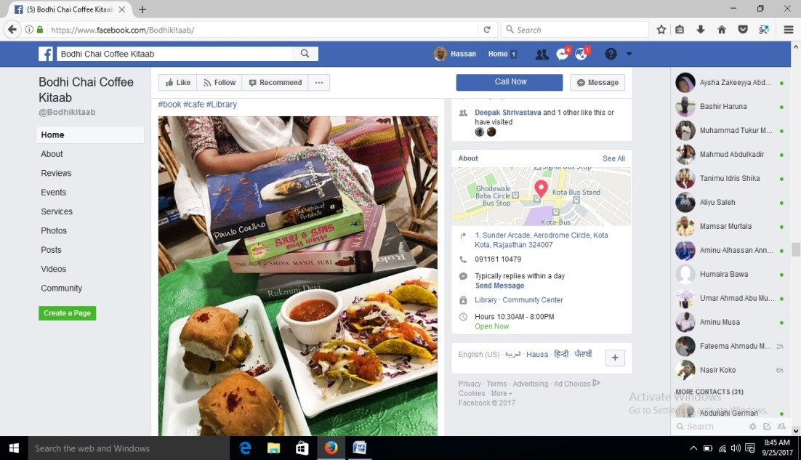
Photo Credit: facebook images
Infographics 1 :IIS at Bodhi Chai, Coffee, Kitab at Kota
Similarly, What i have observed during the visit of India there is nascent one creativity done by any one for IIS as Human Library than i have started to follow activities of Human library and i realise the importance as IIS concerns.
Although the concept of IIS is not new especially in the rural areas where their major source of information is the informal way but then, it has not been officialised. Due to the highly demanding information needs in most organizations, Universities in particular, the IIS became an option of gathering useful information that will be of great helpful to the University in helping the senior Administrators get useful and adequate information for better management of the University system.
The Human Library™ is designed to build a positive framework for conversations that can challenge stereotypes and prejudices through dialogue. The Human Library is a place where real people are on loan to readers. A place where difficult questions are expected appreciated and answered. So, this is the process of Informal Information Sharing because Human Resources meet without fear, without motive to discuss in real manner.
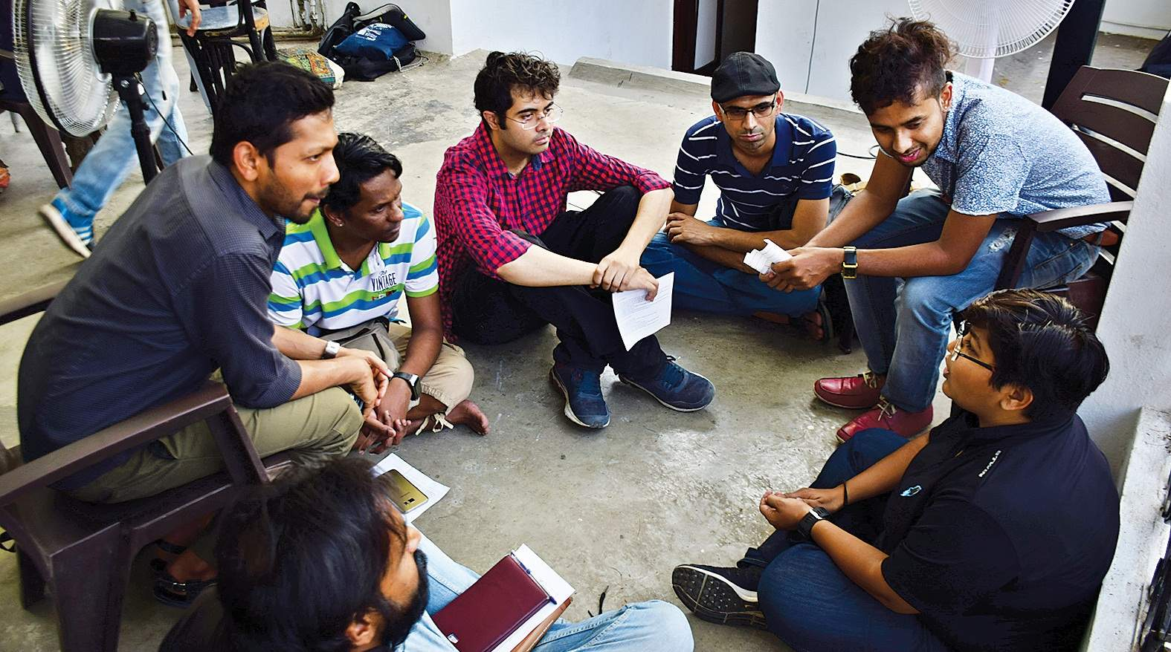
Photo Credit: facebook images
Infographics 2 :IIS at Human Library at Kota (Rajasthan ) INDIA.
Mohammed (2015) identified that information that is acquired through various means in which informal interaction is inclusive enables an individual to reinforce his or her already existing knowledge by adding value to it. This means information sharing through avenues other than formal ones is critical to the preparation and equipping individuals with the necessary skills of solving the societal problems. According to Todd (2013), Sloan and Mcphee (2013), information seeking in a given context occurs in the informal information sharing platform where a particular field in the human life is being discussed. For example, through informal information sharing, a political discussion can be the subject of the discussion where individuals that are involve in the interaction share their ideas on the local, national and international politics informally. This is because such forum may involve individuals that listen to radio frequently, those that read the newspapers regularly, those that watch television regularly, those that participate in social media interaction regularly and individuals that watch films regularly etc. These individuals share the information they acquire to their friends and associates through informal information sharing platforms.
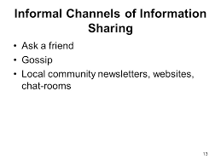
Photo Credit: Google Images
Infographics: 3 informal channels of information sharing
Looking at the above diagram it is clear and well defined that informal channel of communication is a local means of sharing information which everyone in a community can easily engages in. This kind of information is unstructured; unorganized compare to the formal way of sharing information. This has to do with person to person communication or group communication channel such as local community newsletters, websites and chat-rooms.
Informal information seems to be from rumor and gossip but can eventually be genuine information. Its great disadvantage is that the information needs to go through some process of verification before use or taking any further action, in most cases; the information will be communicated to you without identifying the source of the information or even hiding the identity of those who share the information. Unlike the formal information sharing where the informant is well known and has to follow the normal procedure of sharing any information to an individual or organization in such a way that whatever goes wrong he should be hold responsible. Informal systems may even be computerized. Informal information may be indirectly incorporated into an "official" system, reflected primarily as adjustments or modifications to formal information, or overtly relied upon and incorporated into the formal system. Informal information may affect decisions but otherwise never be documented or made known to others. Also, informal information may be in non-numeric form, and in fact, may be perceived by some managers as the antithesis to formally measured performance. Of particular relevance to this study is the implication that perceptions regarding certain characteristics or attributes of the information are indicative of the information's usefulness. Accordingly, the relative use of formal and informal information is likely to be influenced by perceptions regarding certain attributes of both the formal and informal information.
Objectives of the study
- To investigate how senior administrators are sharing the Informal information in Ahmadu Bello University, Zaria.
- To know the extent at which the senior administrators use informal information.
Hypotheses of the study
Ho1. The informal information shared and used by senior administrators for managing a university system does not depend on their offices.
Review of Literature
Conceptually, information is from the word “inform”. That is, telling someone about something he knows or does not know at all. A meaningful data and values that signifies understanding of real things is known as information.
Different scholars and literatures have defined information in different ways. Mohammed (2015) described information as basic ingredients in human life that direct and enlighten individual on the proper direction to follow and taking the right decision. Information can be used for personal use, organizational, educational, socio-economical, national and international development, it’s vital to the overall university academic development. Thus it has to be process, access, shared, store and manage for proper use and decision making. Therefore, the role of information for personal or organizational purposes can never be over emphasized. Of particular relevance to this study is the implication that perceptions regarding certain characteristics or attributes of the information are indicative of the information's usefulness. Accordingly, the relative use of formal and informal information is likely to be influenced by perceptions regarding certain attributes of both the formal and informal information. Subordinate managers have local information not available to senior managers because they are closer to the operations of their subdivisions. This information about conditions and opportunities will be withheld (called "information impactedness") unless senior managers offer sufficient rewards in the form of opportunities and Security. In order to induce the specialized learning, senior management must offer rewards and continuity. The communication of local information and the specialized learning become part of the performance history of the subordinate. Since performance measures are short-run in practice, informal information on long-run performance and local information sharing is necessary for performance evaluation.

However, information can be formal and informal means for disseminating message.
Formal Information Sharing
Formal information system is used primarily for analysis, preparation and transfer of information. One of many tasks of managers is development of various types of presentation of the facts of any field of activity, reports, analyses, draft decisions. More on this topic: Management information system or Structure of strategic information system.
Formal information is the traditional and structured way of passing and exchanging ideas formally. It is also a process of collecting and presenting information in an organized format. It could be through meetings, letters, sometimes email, memos, notes, chatting or formal office discussions. Formal information can also be seen as a means of communication among senior administrators, in which it became a platform for them to meet and share ideas among themselves for proper decision making.
Tasmajian (2015) showed that formal information sharing is the only reliable way every organization relied on in sharing or disseminating information. He also maintained that lack of other means or options to share information became a serious setback for most organizations as issues that need urgent attention were not attended to due to lack of available information to handle such issues. Sloan (2013) also is of the view that formal information sharing is the most organized and perfect way of sharing information. But he believed that if there would be other options of sharing information that will be best because nowadays most of the senior administrators are not satisfied with the formal way of sharing information as the information given to them is that which only suit them and their needs. There is need for them to get the actual information from the actual people in order to be guided properly and take the right decision.

Informal Information Sharing
Informal information system covers all areas of the organization that is not described by the formal organizational structure (organizational chart, procedures, work descriptions, organizational documentation). Any contact between employees, customers or suppliers which are not described in operational procedures enforced in the organization is a manifestation of the informal information system.
Informal information sharing is the casual way of sharing information with no customs or rules of etiquette involved. This is a platform in which individuals share or disseminate information among themselves without any appointment or procedure to share such information. Gordon (2015) believed that sharing information among individuals through informal interaction leads to the acquisition of ideas, skills and experiences by such individuals that can help them to solve their immediate problems.
Informal information may be indirectly incorporated into an "official" system, reflected primarily as adjustments or modifications to formal information, or overtly relied upon and incorporated into the formal system. Informal information may affect decisions but otherwise
never be documented or made known to others. Also, informal information may be in non-numeric form, and in fact, may be perceived by some managers as the antithesis to formally measured performance. Of particular relevance to this study is the implication that perceptions regarding certain characteristics or attributes of the information are indicative of the information's usefulness. Accordingly, the relative use of formal and informal information is likely to be influenced by perceptions regarding certain attributes of both the formal and informal information. Subordinate managers have local information not available to senior managers because they are closer to the operations of their subdivisions. This information about conditions and opportunities will be withheld (called "information impactedness") unless senior managers offer sufficient rewards in the form of opportunities and Security. In order to induce the specialized learning, senior management must offer rewards and continuity. The communication of local information and the specialized learning become part of the performance history of the subordinate. Since performance measures are short-run in practice, informal information on long-run performance and local information sharing is necessary for performance evaluation.

Methodology
The systems of the study emphasized on primary data. The Primary data is collected by means of questionnaire. Survey method was adopted for conducting this study as the population is not large enough it is manageable so the researchers used the entire population. The total numbers of senior Administrators are 201 from both faculties, Departments, Directors, Deputy Directors and Faculties and institutes secretaries. A self developed questionnaire consisting of 18 items each has been used to collect data from the senior Administrators to obtain the required data for the study. In all a total number of 201 questionnaires were distributed among all the senior Administrators. In all, 174 were duly filled and returned making 86.6% for further analysis.
Statistical Techniques
In the present study Chi-square was used to find out the informal information shared and used does not depends on offices. The essence is to bring out the expected and observed value to see whether it depend on office or not.
Analysis of the findings:
Methods of sharing Informal information amongst Senior Administrators in Ahmadu Bello University, Zaria
List of options | Deans |  |  | HODs |  |  | Directors/Deputies |  |  | Administrators
Medium of sharing informal information | N |  | % | N | % |  |  | N | % |  | N | %
Through face to face conversation | 12 | 100 |  | 61 |  | 95.3 |  | 28 | 96.6 |  | 36 | 100
Through phone call | 8 | 66.7 |  | 47 |  | 73.4 |  | 21 | 72.4 |  | 10 | 27.8
Through text messages | 10 | 83.3 |  | 55 |  | 85.9 |  | 14 | 48.3 |  | 3 | 8.3
Through Mail/Fax | 4 | 33.3 |  | 22 |  | 34.4 |  | 5 | 17.2 |  | 2 | 5.6
Through WhatsApp Application | 10 | 83.3 |  | 45 |  | 70.3 |  | 28 | 79.3 |  | 36 | 100
Through IMO Application | 2 | 16.7 |  | 16 |  | 25 |  | 1 | 3.4 |  | 1 | 2.8
Through Facebook application | 2 | 16.7 |  | 21 |  | 32.8 |  | 0 | 0 |  | 1 | 2.8
Through Tweeter Application | 0 | 0 |  | 18 |  | 28.1 |  | 0 | 0 |  | 2 | 5.6
Through informal Letter | 2 | 16.7 |  | 17 |  | 26.6 |  | 0 | 0 |  | 2 | 5.6

Fig 5 medium/channels used in communicating informal information among senior Administrators in Ahmadu Bello University

Result in table 4.1 Fig.1 revealed the types of methods used to share informal information among senior Administrators in Ahmadu Bello University Zaria that face to face conversation and whatsApp scores the highest frequency of 70% and 95% response score by the respondents. Whereas, email, imo application, facebook and informal letter score the least percentage of 33%, 16%, and 26% and response score respectively.
Further observation from the table has also shown that apart from the face to face and whatsApp the Deans, Directors and HODs also used phone call and Mails as a medium of sharing informal information among themselves with a high frequency of 66% and 72%. While the administrators (Deputy Registrars, faculty officers and institute secretaries) uses it with lower frequency of 27% and 10% response score respectively.
This has revealed that the reliable means of sharing informal information by the senior administrators in Ahmadu Bello University Zaria is obviously through face to face conversation and social media especially whatsApp. These media become the most widely used medium of communication among senior Administrators today.
The table also testified that other options given to the respondents such as facebook, Imo, informal letter are not frequently used by them this may be attributed due to lack of secrecy as most of the information shared through the informal way requires total privacy. And options like Imo application and tweeter are not familiar with many people that is why even the respondents do not indicate them as medium they used in sharing informal information. While facebook is widely used but it is evident that no confidentiality in using it as everyone can see your message without necessary being your friend on facebook.
Table 4.2 Extent of the Use of Informal Information Sharing among Senior Administrators in Ahmadu Bello University Zaria
Personal information | Faculty/Deans |  |  |  |  |  | Departments/HODs |  |  |  |  |  | Research Institutes and Centers/Directors and Deputy |  |  |  |  |  | Administrators(Deputy Registrar/ faculty officers and institute secretaries
 | Level of usefulness |  |  |  |  |  | Level of usefulness |  |  |  |  |  | Level of usefulness |  |  |  |  |  | Level of usefulness
 | Very Often |  | R |  | Not Often |  | Very Often |  | R |  | Not Often |  | Very Often |  | R |  | Not Often |  | Very Often |  | R |  | Not Often |  | Mean
 | N | % | N | % | N | % | N | % | N | % | N | % | N | % | N | % | N | % | N | % | N | % | N | %
Staff recruitment information | 11 | 83.3 | 3 | 25 | 39 | 61.0 | 43 | 67.2 | 11 | 17.2 | 10 | 15.6 | 24 | 82.8 | 5 | 17.2 | 0 | 0.0 | 29 | 80.6 | 7 | 19.4 | 0 | 0.0 | 3.3571
Management appointment information | 0 | 0 | 3 | 25 | 9 | 75 | 39 | 61.0 | 24 | 37.5 | 0 | 0 | 9 | 31.0 | 17 | 58.6 | 3 | 10.3 | 16 | 44.4 | 20 | 55.6 | 0 | 0.0 | 2.65
University council information | 3 | 25 | 0 | 0 | 9 | 75 | 32 | 50 | 32 | 49.2 | 0 | 0 | 0 | 00 | 26 | 89.7 | 0 | 0.0 | 0 | 0.0 | 26 | 72.2 | 10 | 27.8 | 2.0507
University Management Information | 0 | 0 | 0 | 0 | 12 | 100 | 22 | 34.4 | 16 | 25 | 16 | 25 | 3 | 10.3 | 20 | 69.0 | 6 | 20.7 | 7 | 19.4 | 20 | 55.6 | 9 | 25 | 1.8244
Senate decision information | 0 | 0 | 6 | 50 | 6 | 50 | 29 | 45.3 | 16 | 25 | 28 | 43.8 | 3 | 10.3 | 6 | 20.7 | 20 | 69.0 | 13 | 36.1 | 21 | 58.3 | 2 | 5.6 | 2.2866
Faculty board meeting | 0 | 0 | 3 | 25 | 9 | 75 | 15 | 23.4 | 16 | 25 | 24 | 37.5 | 0 | 0.0 | 0 | 0.0 | 26 | 89.7 | 15 | 41.7 | 10 | 27.8 | 11 | 30.6 | 1.9922
Promotion information | 6 | 50 | 6 | 50 | 0 | 0 | 11 | 17.2 | 27 | 42.2 | 16 | 25 | 16 | 55.2 | 0 | 0.0 | 10 | 34.5 | 22 | 61.1 | 9 | 25 | 5 | 13.9 | 2.0937
University financial information | 6 | 50 | 6 | 50 | 0 | 0 | 27 | 42.2 | 8 | 12.5 | 12 | 18.8 | 20 | 69.0 | 6 | 20.7 | 3 | 10.3 | 17 | 47.2 | 13 | 36.1 | 6 | 16.7 | 2.2983
Staff Academic performance information | 0 | 0 | 6 | 50 | 6 | 50 | 0 | 0.0 | 20 | 31.3 | 27 | 42.2 | 3 | 10.3 | 16 | 55.2 | 10 | 34.5 | 3 | 8.3 | 30 | 83.3 | 3 | 8.3 | 2.1129
Staff welfare information | 6 | 50 | 6 | 50 | 0 | 0 | 36 | 56.3 | 10 | 15.6 | 0 | 0.0 | 14 | 48.3 | 12 | 18.8 | 0 | 0.0 | 24 | 66.7 | 10 | 27.8 | 2 | 5.6 | 2.55
Security information | 0 | 0 | 3 | 25 | 9 | 75 | 20 | 31.3 | 0 | 0.0 | 26 | 40.6 | 8 | 27.6 | 12 | 18.8 | 0 | 0.0 | 18 | 50 | 13 | 36.1 | 5 | 13.9 | 2.3947
Internal political Information | 9 | 75 | 3 | 25 | 0 | 0 | 43 | 67.2 | 0 | 0.0 | 10 | 15.6 | 20 | 69.0 | 6 | 20.7 | 3 | 10.3 | 25 | 69.4 | 4 | 11.1 | 7 | 47.2 | 2.5461
External political information | 0 | 0 | 6 | 50 | 6 | 50 | 0 | 0.0 | 22 | 34.4 | 27 | 42.2 | 3 | 10.3 | 18 | 62.1 | 8 | 27.6 | 12 | 33.3 | 22 | 61.1 | 2 | 5.6 | 2.2063
Religious information | 9 | 75 | 3 | 25 | 0 | 0 | 52 | 81.3 | 10 | 15.6 | 0 | 0.0 | 27 | 93.1 | 2 | 6.9 | 0 | 0.0 | 28 | 77.8 | 8 | 22.2 | 0 | 0.0 | 2.7913
Health information | 0 | 0 | 8 | 66.6 | 4 | 33.3 | 14 | 21.9 | 0 | 0.0 | 31 | 48.4 | 12 | 41.4 | 10 | 34.5 | 7 | 24.1 | 4 | 11.1 | 28 | 77.8 | 4 | 11.1 | 2.2295
Student Academic information | 0 | 0 | 10 | 83.3 | 2 | 16.7 | 11 | 17.2 | 0 | 0.0 | 38 | 59.4 | 15 | 51.7 | 9 | 31.0 | 5 | 17.2 | 14 | 38.9 | 20 | 55.6 | 2 | 5.6 | 2.0873
Admission criteria/selection information | 6 | 50 | 6 | 50 | 0 | 0 | 54 | 84.4 | 0 | 0.0 | 10 | 15.6 | 22 | 75.9 | 2 | 6.9 | 5 | 17.2 | 28 | 77.8 | 4 | 11.1 | 4 | 11.1 | 2.5602
Student academic performance | 0 | 0 | 7 | 58.3 | 5 | 41.7 | 24 | 37.5 | 20 | 31.3 | 20 | 31.3 | 17 | 58.6 | 10 | 34.5 | 2 | 6.9 | 19 | 52.8 | 11 | 30.6 | 6 | 16.7 | 2.5531

Fig 7 Level of usefulness of informal information sharing among senior Administrators in Ahmadu Bello University Zaria
Result in table 5.11 Fig.7 shows high significance on the usefulness of the informal information sharing in managing a University system with mean score of 3.0 and above. It was clear from the table that informal information assists the senior Administrators in recruiting staff with mean score of 3.3571. The significance is not surprising because the findings in the previous table shows that staff recruitments are among the major contents in which the senior Administrators shared among themselves informally.
Table 5.10 equally shows that, the IIS have no effect on Managing a University system with the range of mean score of 2.0 -2.9. Thus, IIS have no effect on: Management appointment information; University council information; Senate decision information; promotion information; University financial information; staff academic performance; staff welfare; security information; internal political information; external political information; Religious information; health information; students academic information; admission criteria information and students academic performance respectively.
Furthermore, some informal information showed no significance of below 2.0 mean score on the management of the University studied include: University management information and Faculty board.
This indicates that IIS in the University studied were not frequently used in managing a university system. The reason for non use of some information might be attributed to lack of priority on the type of information needed in order to solve a particular problem.
Hypotheses testing Using Chi-square
Chi-Square Tests
 | Value | Df | Asymp. Sig. (2-sided)
Pearson Chi-Square | 374.528ª | 51 | .000
Likelihood Ratio | 389.014 | 51 | .000
Linear-by-Linear Association | .469 | 1 | .493
N of Valid Cases | 1290
a. 0 cells (0.0%) have expected count less than 5. The minimum expected count is 5.91.
From the result of this analysis, it is observed that the calculated chi-square is 374.528 with 51 degrees of freedom. Since the p-value of 0.000 is less than the level of significance of 0.05, we reject the null hypothesis and conclude that the use of informal information by senior administrators in Ahmadu Bello University, Zaria depends on office.

Summary of the Major Findings:
- Out of the available options listed to the respondents it has been observed that face to face conversation was the major method the senior Administrators used in sharing informal information with more than 85% response rate of the respondents.
B. Apart from the face to face it has also been revealed that the used other methods such as direct phone call, text messages, Mail and social media such as whatsapp application.
2. On the extent of the use of informal information sharing by the senior Administrators, it has been discovered that staff recruitment information and internal political information was the major information used by the senior Administrators. Thus, those other options were also used by the senior Administrators but not frequently.
3. The hypotheses that was formulated and tested showed that the null hypothesis was rejected and conclude that the use of informal information sharing by senior Administrators in Ahmadu Bello University Zaria depends on offices.
Conclusion and recommendation
In conclusion, it has been observed that informal information sharing among senior Administrators in Ahmadu Bello University Zaria is one of the sources applied in getting adequate and reliable information for better management of the University. Although the concept is not new, it has been the major sources of getting information by local communities and rural areas for many decades as most of them does not have modern media such as radio, TV, newspaper etc. the only relied on the informal information sharing where the experience once will tell the inexperience once on how to solve a particular problem or something that is worthy of knowing. But now most organizations has adopted this concept of gathering information informally so that they will have a true picture of what is going on in their organization.
It is also recommended that the concept should be highly encouraged in all organizations whether public or private. This is because those who were privilege to inform the top managers on what is going on in the organization were sometimes not telling the real situation for reason best known to them. If the senior Administrators will have their independent way of getting information apart from the formal way it will give them the opportunity to know the actual happening of that organization.

REFERENCES
Bock, G. W., Zmud, R. W., Kim, Y. G., & Lee, J. N. (2007). Behavioral intention formation in knowledgesharing:Examiningthe roles of extrinsic motivators, social-psychological forces, and organizational climate. Management Information Systems Quarterly, 29(1), 87–111. Retrieved March 30, 2017, from http://aisel.aisnet.org/misq/vol29/iss1/6/
Brenkert, H.S., Dickinson, K.L., Champ, P.A. and Flores, N. (2013). Social Amplification of Wildfire Risk: The Role of Social Interactions and Information Sources: Risk Analysis, 33(5), 800. Doi:10.1111/j.15396924.2012.01917.x.
Brown, J. S., & Duguid, P. (2000). The social life of information. Boston: Harvard Business School Press.
Carter, E.W. (2014). Promoting Social Competence and Peer Relationships for Adolescents with Autism Spectrum Disorders.
Childhouse, P., & Towill, D. R. (2003). Simplified material flow holds key to supply chain integration. OMEGA, 31(1), 17–27.
Corbett, S.J. (2014). Great Debating: Combining Ancient and Contemporary Methods of Peer Critique. Retrievedfromhttp://www.praxis.technorheteric.net/tikeindex.php?page=praxisWIKI%3AGreatDebating.
Daniels, E. (2014). Effects of Meaningful Peer Interactions for Non-native English Speaking Students.Retrieved from http://www.phys.org/news/2014-04-effects-meaningful-peer-interaction-no-native.html
Genius, S.K. (2015). The Transfer of Information through Word of Mouth is Powerful: Interpersonal Information Interactions. Information Research, 20(1), 1.Retrieved from http://www.information.net/ir/20-1/isicc29.html#.vsw-OIL8g7u. Accessed on 13/4/2015.
Gordon, P.B. (2015). Formal Learning Empowers the Teacher Informal Learning Empowers the Students. Retrieved from http://www.paulgordononbrown.com/2015/03/19/formal-learning-empowers-the-teacher-informal-learning-empowers-the-students.
Levy, A. (2015).Peer-to-Peer Learning and Student-Leadership. Retrieved from
http://www.urganarts.org/peer-to-peer-lerning-and-student-leadership.
Accessed on 16/4/2015.
Li, S., & Lin, B. (2006). Accessing information sharing and information quality in supply chain management. Decision Support Systems, 42(3), 1641–1656.
Moberg, C. R., Cutler, B. D., Gross, A., & Speh, T. W. (2002). Identifying antecedents of information exchange within supply chains. International Journal of Physical Distribution and Logistics Management, 32(9), 755–770.
Mohammed, Z. (2015). Information Dissemination, Access and Utilisation. A Paper Presented at the Lecture on Intelligent Information Systems, Resources and Services. Presented to the Postgraduate Diploma in Information Management Students, Department of Library and Information Science, Ahmadu Bello University, Zaria on 13 January, 2015.
Rahman, Z. (2004). Use of Internet in supply chain management: A study of Indian companies. Industrial Management and Data Systems, 104(1/2), 31–41.32 DOI: 10.1002/piq Performance Improvement Quarterly

Sloan, M. and Mcphee, K. (2013). Information Seeking in Context: Results of Graduate Students Interviews Partnership. The Canadian Journal of Library, Information Practice and Research 8(1), 2.
Small, C. T., & Sage, A. P. (2006). Knowledge management and knowledge sharing: A review. Information Knowledge Systems Management, 5(3), 153–169.
Tan, K. C., Lyman, S. B., & Wisner, J. D. (2002). Supply chain management: A strategic perspective. International Journal of Operations and Production Management, 22(6), 614–631.
Tasmajian, D. (2015). Socialization Skills Acquired by Elementary School Children.
Retrieved from http://www.kon.org/urc/tasmajian.html.
Todd, R.J.(2013). The Power of in the Impossible Principles of the Possible.Retrievedfromhttp://www.manitobaschoollibraries.ca/wp-content/uploads/2014/01/teacher-lib.pdf. Accessed on 11/3/2015.

